CLASSIFICATION OF SUBSTANCES

* Substances are either pure or impure. A pure substance is one which contains only one substance.
* An impure substance is one which contains two or more substances.
* A pure substance is made up of a pure solid, pure liquid or pure gas.
* A mixture is a combination of two or more pure substances which can be separated by physical means. The three states of matter in nature appear mainly as mixtures of one with the other.
* Common mixtures include:

1. **Solid-liquid mixture**

* Some solids dissolve in some other liquids.
* A **solvent** is a liquid in which another solid dissolves.
* A **solute** is a solid substance which dissolves in a solvent.
* A **solution** uniform mixture of a solute and a solvent.
* Water is referred as the **universal solvent** because it dissolves many solutes.
* A solute that dissolves in a solvent is said to be **soluble**.

**Solute + Solvent solution**

**Solute + Water Aqueous solution of solute**

**Examples**

1. Sodium chloride solution is a solution formed after dissolving sodium chloride in water.

2. Ammonia solution is a solution formed after dissolving ammonia gas in water.

3. Copper (II)sulphate solution is a solution formed after dissolving Copper(II) sulphate crystals in water.

1. **solid-liquid mixture which do not dissolve**

* Some solid substances do not dissolve in a liquid. They are said to be **insoluble** in the solvent .When an insoluble solid is put in liquid:

1. Some particles remain **suspended/floating** in the liquid to form a **suspension** /**precipitate**.
2. Some particles **sink/settle** to the bottom to form **sediments** after being allowed to stand.

An **insoluble** solid acquires the colour of the suspension/precipitate.

1. **Liquid-liquid mixtures**
2. **Immiscible liquids**

* Water and kerosene do not dissolve in each other hence the two liquids form layers.
* Water and kerosene do not form uniform mixture
* Kerosene is immiscible in Water.
* Immiscible mixtures do not form uniform mixtures. They form layers. The size of the particles of one liquid is almost equal to the particles of the other.
* The heavier particles settle at the bottom. The less dense particles settle on top.

1. **Miscible liquids**

* Ethanol and water form a uniform mixture.
* Ethanol is miscible in Water.
* Miscible mixture form uniform mixture. They do not form layers.

The particles of one liquid cannot occupy the spaces between the particles of the other. The heavier particles settle at the bottom. The less dense particles settle on top.

**d.. Solid-solid mixtures/Alloys**

* Before solidifying, some heated molten/liquid metals dissolve in another metal to form a uniform mixture of the two. On solidifying, a uniform mixture of the metals is formed. A uniform mixture of two metals on solidifying is called **alloy**.
* **Common alloys of metal.**

|  |  |  |
| --- | --- | --- |
| **Alloy name** | **Constituents of the alloy** | **Uses of the alloy** |
| Brass | Copper and Zinc | Making scews and bulb caps |
| Bronze | Copper and Tin | Making clock springs,electrical contacts and copper coins |
| Soldier | Lead and Tin | Soldering, joining electrical contacts because of its low melting points and high thermal conductivity |
| Duralumin | Aluminium, Copper and Magnesium | Making aircraft, utensils, windows frames because of its light weight and corrosion resistant. |
| Steel | Iron, Carbon ,Manganese and other metals | Railway lines, car bodies girders and utensils. |
| Nichrome | Nichrome and Chromium | Provide resistance in electric heaters and ovens |
| German silver | Copper, Zinc and Nickel | Making coins |

**METHODS OF SEPARATING MIXTURES**

Mixtures can be separated from applying the following methods:

**(a) Decantation**

Used to separate insoluble solid-liquid mixture. Sediments can be separated from a liquid by pouring out the liquid. This process is called **decantation.**

Example

Mixture of sand and water

Sand does not dissolve in water. Sand is denser than water and thus settles at the bottom as **sediment**. When poured out, the less dense water flows out.

**(b)Filtration**

Decantation leaves suspended particles in the liquid after separation.

Filtration is thus used instead of decantation.

Filtration is the method of separating insoluble mixtures/particles/solids from a liquid.

Explanation

A filter paper is **porous** which act like a fine sieve with very small **holes**. The holes allow smaller water particles to pass through but do not allow bigger soil particles. The liquid which passes through is called **filtrate**. The solid which do not pass through is called **residue**.

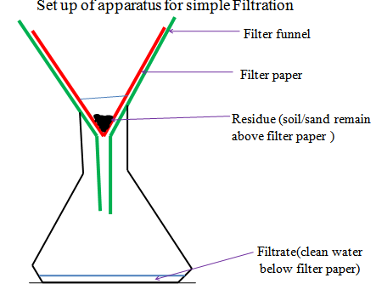

**(c)Evaporation**

Evaporation is a method of separating a solute/solid from its solution. This involves heating a solution (solvent and solute) to vaporize the solvent out of the solution mixture leaving pure solute/solid.

Explanation

Solid mixture of sand and common salt take the colours of the two.

On adding water, common salt dissolve to form a solution .

Vapourization/evaporation can take place even without heating.

This is the principle/process of drying wet clothes on the hanging line.

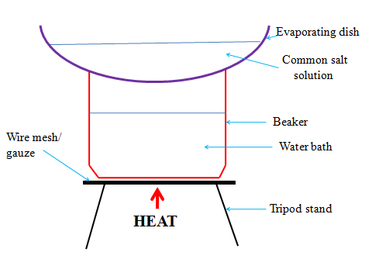

**(d) Distillation**

Distillation is an improved evaporation where both the solute and the solvent in the solution are separated /collected.

Distillation therefore is the process of separating a solution into constituent solid solute and the solvent.

It involves heating the solution to evaporate the solvent out. The solvent vapour is then condensed back to a liquid.

**Eg. To obtain copper(II)sulphate (VI) crystals and water from copper (II) sulphate(VI) solution.**

Observation

Copper (II)sulphate (VI) crystals dissolve in water to form a blue solution.  
On heating, colourless liquid is collected in the receiver.

Blue crystals are left in the flask.

(if gently heated further, the blue crystals turn to white powder)

Explanation

On heating blue Copper (II)sulphate (VI) solution, the colourless liquid solvent evaporate.

The liquid vapour/gas passes through the delivery tube to the liebig condenser.

The liebig condenser has a cold water **inlet** near the receiver and cold water **out** let.

This ensures efficient cooling. If the cold water **outlet/inlet** is reversed, the water circulation would be less efficient.

The water in the receiver would be warm.In the liebig condenser, the cold water, condenses the liquid vapour into liquid.

The condensed liquid collects in the receiver as **distillate**.

The solute of blue Copper (II)sulphate (VI) crystals is left in the flask as **residue**.

The purpose of pieces of broken porcelain/porous pot/glass/sand/ is to:

1. prevent bumping of the solution during boiling.
2. ensure smooth and even boiling.

Salty sea water can be made pure through simple distillation.

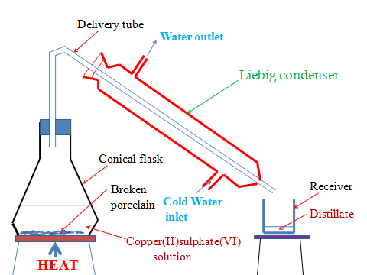

**(e)Fractional distillation**

Fractional distillation is an improved simple distillation used specifically to separate miscible mixtures with very **close /near** boiling points.

Fractional distillation involves:

(**i**)Heating the mixture in a conical/round bottomed /flat bottomed flask.

The pure substance with a lower boiling point and thus more volatile evaporates first.

e.g.

Pure ethanol has a boiling point of 78oC.Pure water has a boiling point of 100 oC at sea level/one atmosphere pressure.

When a miscible mixture of ethanol and water is heated, ethanol boils/ evaporates first because it is more volatile.

(**ii**)The conical/round bottomed /flat bottomed flask is connected to a long glass tube called **fractionating column**.

The purpose of the fractionating column is to offer areas of condensation for the less volatile pure mixture.

The fractionating column is packed with glass beads/broken glass/ porcelain/ shelves to increase the surface area of condensation of the less volatile pure mixture.

(**iii**)When the vapours rise they condense on the glass beads/broken glass /porcelain / shelves which become hot.

e.g.

(**iv**)The fractionating column is connected to a liebig condenser. The liebig condenser has a cold water inlet and outlet circulation.

The more volatile mixture that reach the top of the fractionating column is condenses by the liebig condenser into a receiver. It is collected as the first fraction.

(**v**)At the top of the fractionating column, a thermometer is placed to note/monitor the temperature of the boiling mixtures .

When one mixture is completely separated, the thermometer reading rises.

(**vi**)The second /subsequent fractions are collected in the receiver after noting a rise the mercury/alcohol level in the thermometer.

(vii)Each fraction collected should be confirmed from known physical/chemical properties/characteristic.

e.g.

Ethanol

Ethanol is a colourless liquid that has a characteristic smell .When it is put in a watch glass then ignited, it catches fire and burn with a blue flame.

Water

Water is a colourless liquid that has no smell/odour .When it is put in a watch glass then ignited, it does not catch fire.

Set up of apparatus

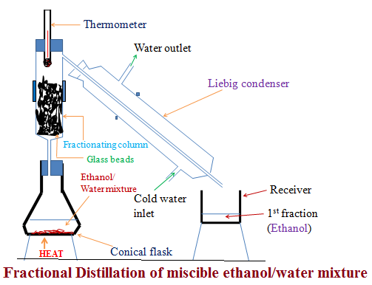

**Industrial application of Fractional distillation**

On a large scale,fractional distillation is used:

**(i)**In fractional distillation of crude oil in an oil refinery.

**(ii)**In fractional distillation of air.

**(f)Separation of immiscibles (Using a separating funnel)**

Two or more liquids that form layers on mixing are immiscible. Immiscible mixture arrange themselves according to their densities

i.e The denser liquid sink to the bottom. The less dense liquid floats on the denser one. Immicible mixtures can be separated from each other by using a **separating funnel**.

Explanation

Water and paraffin are immiscible. Water is denser than paraffin. When put in a separating funnel, paraffin float on water. On opening the tap, water runs out. A mixture of water and paraffin at the junction of the two is discarded. It is not pure.

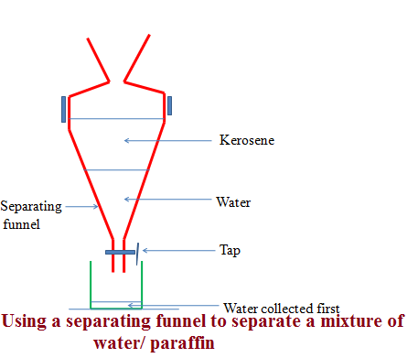

**(g)Sublimation/deposition**

Some solids on heating do not melt to a liquid but change directly to a gas. The process by which a solid changes to a gas is called **sublimation**. The gas cools back and changes directly to a solid. The process by which a gas changes to a solid is called **deposition.** Sublimation and deposition therefore are the same but opposite processes.

GAS

Sublimation Deposition

SOLID

Some common substances that undergo sublimation/ deposition include:

(i)Iodine (ii)Carbon(IV)oxide (iii)Camphor (iv) ammonium chloride (v)Iron(III)chloride (vi)Aluminium(III)chloride

(vii) benzoic acid

If a mixture has any of the above as a component, then on heating it will change to a gas and be deposited away from the source of heating.

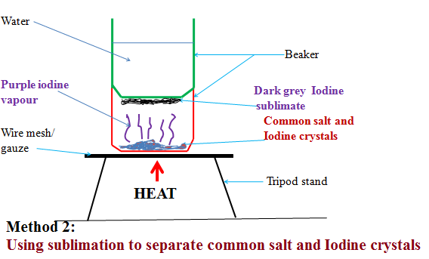

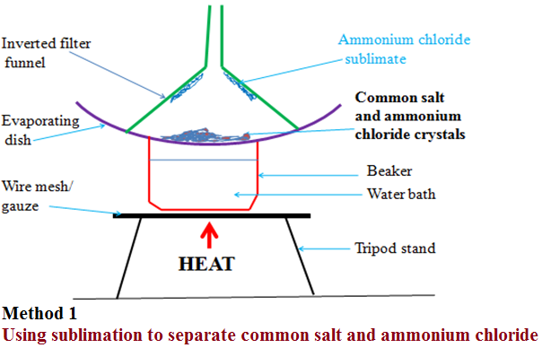

Explanation

(i)On heating a mixture of ammonium chloride and common salt, a white fumes of ammonium chloride is produced. The white fumes solidify as white sublimate on the cooler parts. Common salt remains as residue.

Chemical equation:

Ammonium chloride **solid** Ammonium chloride **gas**

NH4Cl(**s**) NH4Cl(**g**)

(ii)On heating a mixture of Iodine and common salt, a purple fumes of Iodine vapour is produced. The purple fumes solidify as dark grey sublimate on the cooler parts. Common salt remains as residue.

Chemical equation:

Iodine **solid** Iodine **gas**

I2(**s**) I2 (**g**)

**(h)Chromatography**

Chromatography is a method of separating components of a solution mixture by passing it through a medium where the different components move at different rates. The medium through which the solution mixture is passed is called **absorbent material**.

Paper chromatography is a method of separating coloured dyes by using paper as the absorbent material.

Since dyes are insoluble/do not dissolve in water, ethanol and propanone are used as suitable solvents for dissolving the dye.

Practically, a simple paper chromatography involve placing a dye/material on the absorbent material, adding slowly a suitable soluble solvent on the dye/material using a dropper, the solvent spread out on the absorbent material carrying the soluble dye away from the origin.

The spot on which the dye is initially/originally placed is called **baseline**. The farthest point the solvent spread is called **solvent front**.

The farthest a dye can be spread by the solvent depend on:

(i) density of the dye-the denser the dye, the less it spread from the basely ne by the solvent.

(ii) Stickiness of the dye-some dyes sticks on the absorbent material more than other thus do not spread far from baseline.

**Experiment: To investigate the colours in ink**

Procedure

**Method 1**

Place a filter paper on a an empty beaker. Put a drop of black/blue ink in the centre of the filter paper. Wait for about one minute for the ink drop to spread. Using a clean teat pipette/dropper add one drop of ethanol/propanone. Wait for about one minute for the ink drop to spread further. Add about twenty other drops of ethanol waiting for about one minute before each addition. Allow the filter paper to dry.

**Experiment: To investigate the colours in ink**

Procedure

**Method 2**

Cut an 8 centimeter thin strip of a filter paper. At about 3cm on the strip, place a drop of ink. Place the filter paper in a 10cm length boiling tube containing 5cm3 of ethanol. Ensure the cut strip of the filter paper just dips into the ethanol towards the ink mark. Cover the boiling tube. Wait for about twenty minutes. Remove the boiling tube and allow the filter paper to dry.

Set up of apparatus

Method 1

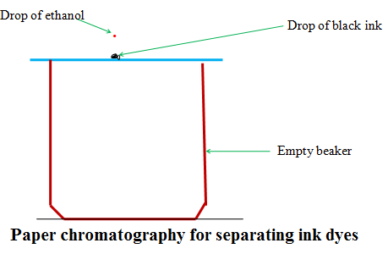

Set up of apparatus

Method 2

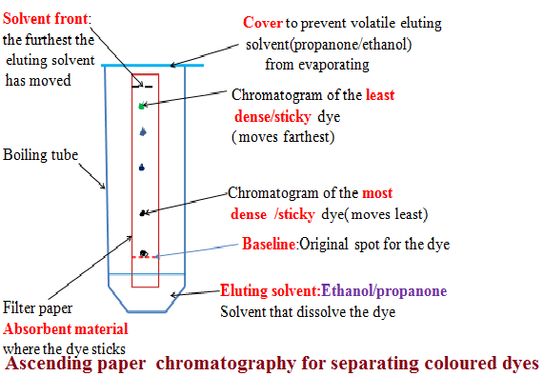

Explanation

When a drop of ink is placed on an absorbent material it sticks. On adding an eluting solvent, it dissolves the dye spread out with it. The denser and sticky pure dye move least. The least dense/sticky pure dye move farthest. A pure dye will produce the same chromatogram/spot if the same eluting solvent is used on the same absorbent material. Comparing the distance moved by a pure dye with a mixture ,the coloured dyes in a mixture can be deduced as below:

**Example 1**

The chromatogram of pure dyes A, B ,C and a dye mixture D is shown below Determine the pure dyes present in D. On the diagram show:

(i)the solvent front

(ii)baseline

(iii)the most soluble pure dye

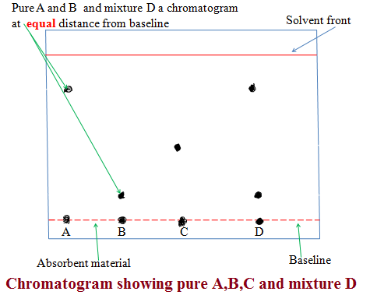

**(i) Solvent extraction**

Solvent extraction is a method of separating oil from nuts/seeds. Most nuts contain oil. First the nuts are crushed to reduce their size and increase the surface area. A suitable volatile solvent is added. The mixture is filtered. The filtrate solvent is then allowed to crystallize leaving the oil/fat. If a filter paper is rubbed/smeared with the oil/fat, it becomes translucent. This is the test for the presence of oil/fat.

**Experiment: To extract oil from Macadamia nut seeds**

Procedure

Crush Macadamia nut seeds form the hard outer cover .Place the inner soft seed into a mortar. Crush(add a little sand to assist in crushing).

Add a little propanone and continue crushing. Continue crushing and adding a little propanone until there is more liquid mixture than the solid. Decant/filter. Put the filtrate into an evaporating dish. Vapourize the solvent using solar energy /sunlight. Smear/rub a portion of the residue left after evaporation on a clean dry filter paper.

Observation /Explanation

Propanone dissolve fat/oil in the macadamia nuts. Propanone is more volatile(lower boiling point)than oil/fat. In sunlight/solar energy, propanone evaporate/vapourize leaving oil/fat(has a higher boiling point).Any seed like corn, wheat , rice, soya bean may be used instead of macadamia seed. When oil/fat is rubbed/ smeared on an opaque paper, it becomes translucent.

**(j) Crystallization**

Crystallization is the process of using solubility of a solute/solid to obtain the solute/solid crystals from a saturated solution by cooling or heating the solution.

A crystal is the smallest regular shaped particle of a solute. Every solute has unique shape of its crystals.

Some solutions form crystals when heated. This is because less solute dissolve at higher temperature. Some other solutions form crystals when cooled. This is because less solute dissolve at lower temperature.

**Experiment; To crystallize copper(II)sulphate(VI)solution**

Procedure:

Place about one spatula full of hydrated copper sulphate(VI) crystals into 200cm3 of distilled water in a beaker. Stir. Continue adding a little more of the hydrated copper sulphate (VI) crystals and stirring until no more dissolve. Decant/filter. Cover the filtrate with a filter paper. Pierce and make small holes on the filter paper cover. Preserve the experiment for about seven days.

Observation/Explanation

Large blue crystals formed

When hydrated copper(II)sulphate crystals are placed in water, they dissolve to form copper(II)sulphate solution. After some days water slowly evaporate leaving large crystals of copper(II)sulphate. If the mixture is heated to dryness, small crystals are formed.

**Physical/Temporary and Chemical changes**

A physical/temporary change is one which **no new** substance is formed and is **reversible** back to original.

A chemical/permanent change is one which **a new** substance is formed and is **irreversible** back to original.

The following experiments illustrates physical and chemical changes

**(a)Heating ice**

Place about 10g of pure ice in a beaker. Determine its temperature.Record it at time “0.0” in the table below. Heat the ice on a strong Bunsen flame and determine its temperature after every 60seconds/1minute to complete the table below:

|  |  |  |  |  |  |  |  |  |  |
| --- | --- | --- | --- | --- | --- | --- | --- | --- | --- |
| Time/minutes | 0 | 1 | 2 | 3 | 4 | 5 | 6 | 7 | 8 |
| Temperature (oC) | -2 | 0 | 0 | 40 | 80 | 90 | 95 | 95 | 96 |

Plot a graph of time against Temperature(y-axes)

Explain the shape of your graph

**Melting/freezing/fusion/solidification** and **boiling /vaporization /evaporation** are the two physical processes.

Melting /freezing point of pure substances is fixed /constant.

The boiling point of pure substance depend on **external** atmospheric **pressure**.

Melting/fusion is the physical change of a **solid** to **liquid**.

Freezing is the physical change of a **liquid** to **solid**.

Melting/freezing/fusion/solidification are therefore two **opposite** but **same** reversible physical processes i.e

A (**s**) A(**l**)

Boiling/vaporization/evaporation is the physical change of a **liquid** to **gas**.

Condensation/ liquidification is the physical change of **gas** to **liquid**.

Boiling/vaporization/evaporation and condensation/ liquidification are therefore two **opposite** but **same** reversible physical processes i.e

B (**l**) B(**g**)

Practically

(i) Melting/liquidification/fusion involves **heating** a solid to **weaken** the strong bonds holding the solid particles together.

Solids are made up of very strong bonds holding the particles **very close** to each other (**Kinetic Theory of matter**).

On heating these particles gain energy/heat from the surrounding heat source to form a liquid with **weaker** bonds holding the particles close together but with some degree of **freedom**.

(ii)Freezing/fusion/solidification involves cooling a liquid to reform /rejoin the very strong bonds to hold the particles **very close** to each other as solid and thus lose their degree of **freedom** (**Kinetic Theory of matter**).

Freezing /fusion / solidification is an **exothermic** (**-**∆H)process that require particles holding the liquid together to lose energy to the surrounding.

(iii)Boiling/vaporization/evaporation involves **heating** a liquid to completely **break/free** the bonds holding the liquid particles together.

Gaseous particles have high degree of **freedom** (**Kinetic Theory of matter**).

Boiling /vaporization / evaporation is an **endothermic** (**+**∆H) process that require/absorb energy from the surrounding.

(iv)Condensation/liquidification is **reverse** process of boiling /vaporization / evaporation.

It involves gaseous particles losing energy to the surrounding to form a liquid.