**EFFECT OF AN ELECTRIC CURRENT ON SUBSTANCES**

* Some solid substances conduct an electric current while others do not conduct.
* A conductor is a substance which allows an electric current to pass through them.
* Non-conductors are those substances which do not allow an electric current to pass through them.
* Metals are good conductors of heat and electricity while non-metals are non-conductors of heat and electricity.
* When a piece of Magnesium metal is connected in a set up below and a switch closed, the bulb lights indicating that all metallic substances allow an electric current to pass through them.

* Metals conduct electricity because of the presence of delocalized (free) electrons in their structures.
* Graphite is the only non-metal which conducts an electric current.
* Ionic compounds, molecular compounds (sugar) do not conduct electricity when in solid state.

NB/ solid substances do not undergo any observable change when they conduct electricity.

***Effect of an electric current on substances in molten state.***

**Definition of terms**

* **Anode** is the positively charged electrode in which electrons leave the electrolyte. Oxidation takes place here.
* **Cathode i**s the negatively charged electrode in which the electrons enter the electrolyte. Reduction takes place here.
* **An electrode** is a solid conductor through which electrons leave or enter **the** electrolyte.
* **Electrolyte** is a substance which conduct an electric current when in molten state or aqueous state and is decomposed by the electric current. Ionic compounds are good examples of electrolytes.
* **Non-electrolytes** are substances which do not conduct an electric current when in molten state or aqueous state and thus are not decomposed by the electric current.

***To investigate the conductivity of lead (II) bromide in molten state***

Lead (II) bromide does not conduct electricity in solid state but conduct when in molten state. To investigate the conductivity of Lead (II) bromide, the set up below is used.

Cathode

Anode

Molten Lead (II) briomide

Bulb

Carbon electrode

(a) Write an ionic equation for the reaction that occurred at the cathode

* Solid lead (II) bromide does not conduct electricity because the ions are not free; are firmly held together by electrostatic forces thus cannot move.
* Melting weakens the forces of attraction enabling the ions to be free (move freely or become mobile).
* The mobile ions in the molten lead (II) bromide are responsible for conductivity of the electric current.

***NB***/ Sugar, sulphur, wax lack charged particles (ions) and free electrons and that is why they do not conduct electricity both in solid and in molten state.

**Summary**

|  |  |  |
| --- | --- | --- |
| Substance | Type of structure | observation |
| 1. lead (II) bromide  2. lead (II) iodide  3. lead (II) chloride  4. sugar  5. sulphur | - ionic compound  - ionic compound  - ionic compound  - molecular  - non metallic | -Bulb lights when in molten  -Bulb lights when in molten  -Bulb lights when in molten  -Bulb do not light when in molten |

***To investigate electrical conductivity of substances in aqueous solutions***

Solutions of ionic compounds also conduct an electric current because in solution the ions are free to move carrying an electric current.

Solutions of acids, bases and salts are ionic compounds and thus they all have mobile ions which enable them to conduct electricity.

Solutions of sugar, urea (molecular substances) do not conduct electricity because they are molecular substances and their solutions do not have ions.

Bulb

Graphite rods

Substance to be tested

Beaker

* The bulb lights when the switch is closed and the ionic substance used is soluble in water.
* The bulb does not light when sugar, urea is used.

**Electrolysis**

**Electrolysis** is the process of decomposing an electrolyte by passing an electric current through it.

**To investigate the products formed when electricity is passed through molten lead (II) bromide**

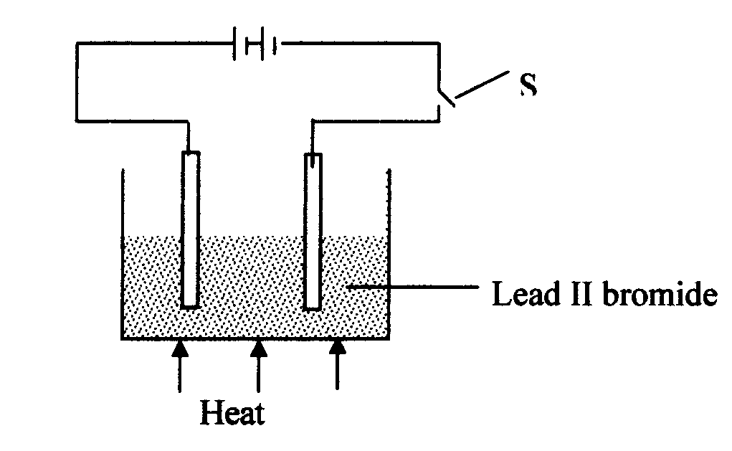

SWITCH

**Observations**

**Anode:** a red brown vapor is produced at the anode. The anode is positively charged and the bromide ions (anions) are attracted to in where they lose electrons to form bromine vapor.

**2Br-(aq)  Br2  + 2e-**

**Cathode:** Grey beads of lead metal are formed and deposited at the cathode. The cathode is negatively charged and the lead (II) ions are attracted towards it where they gain electrons to form lead metal.

Pb2+(aq) + 2e- Pb(s)

Grey

The cathode increases in size because of the deposition of lead metal on it.

NB/ Thus the products formed are:

1. Cathode : lead metal
2. Anode : bromine gas.

* ***Binary electrolyte*:** is an electrolyte which contain only one type of cations and one type of anions.

**Application of electrolysis**

1. **Extraction of metals eg. Na,Mg, Al by electrolysis by electrolysis of their molten compounds**
2. **Purification of metals**
3. **Electroplating of metals to improve appearance and prevent corrosion.**
4. **Manufacture of pure chemicals such as NaOH, Cl2 , H2**