**INTRODUCTION TO RADIOCTIVITY**

* Radioactivity is the spontaneous disintegration/decay of an unstable nuclide.
* A nuclide is an atom with definite mass number (number of protons and neutrons), atomic number and definite energy.
* Radioactivity takes place in the nucleus of an atom unlike chemical reactions that take place in the energy levels involving electrons.
* A nuclide is said to be stable if its neutron: proton ratio is equal to one (n/p = 1)
* All nuclide therefore try to **attain n/p = 1** by undergoing radioactivity.
* All **unstable** nuclides naturally try to attain nuclear **stability** with the production of:

1. **alpha(α) particle decay**

The alpha (α) particle has the following main characteristic:

1. is **positive**ly charged(like protons)
2. has mass number **4** and atomic number **2** therefore equal to a charged Helium atom ( **42He2+)**
3. Have very **low** penetrating power and thus can be stopped /blocked/shielded by a thin sheet of **paper.**
4. Have **high** ionizing power thus cause a lot of **damage** to living cells.
5. a nuclide undergoing α-decay has its mass number **reduced** by **4** and its atomic number **reduced** by **2**
6. **Beta (β) particle decay**

The Beta (β) particle has the following main characteristic:

1. is negatively charged(like electrons)
2. has no mass number and atomic number negative one(-1) therefore equal to a fast moving electron (**0 -1e**)
3. Have medium penetrating power and thus can be stopped /blocked/shielded by a thin sheet of aluminium foil.
4. Have medium ionizing power thus cause less damage to living cells than the particle.
5. a nuclide undergoing β -decay has its mass number **remain** the same and its atomic number **increase** by **1**
6. **Gamma (y) particle decay**

The gamma (y) particle has the following main characteristic:

1. Is **neither** negatively charged (like electrons/beta) nor positively charged (like protons/alpha) therefore **neutral**.
2. Has no mass number and atomic number therefore equal to **electromagnetic waves**.
3. Have very **high** penetrating power and thus can be stopped /blocked/shielded by a thick block of lead.
4. Have very **low** ionizing power thus cause less damage to living cells unless on prolonged exposure.
5. A nuclide undergoing y -decay has its mass numberand its atomic number **remain** the **same**.

**Penetrating power of radiations from a radioactive nuclide.**

* The sketch diagram below shows the **penetrating power** of the radiations from a radioactive nuclide.

**Radioactive nuclide sheet of paper aluminium foil thick block of lead**

**(Radiation source) (block α-rays) (block β-rays) block y-rays)**

**α-rays β-rays y-rays**

**Effect of magnetic field**

* The sketch diagram below illustrates the effect of **magnetic field** on the three radiations from a radioactive nuclide.

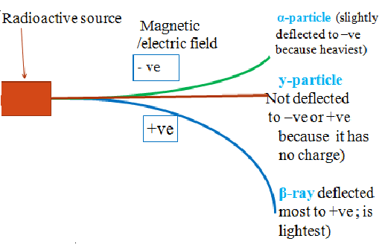

Example

Radioactive disintegration/decay **naturally** produces the stable 20682Pb nuclide /isotope of lead. Below is the 238 92 U natural decay series. Identify the particle emitted in each case

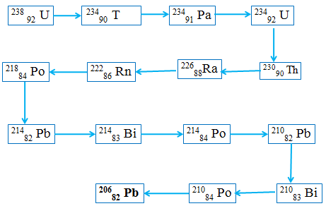

1. Write the nuclear equation for the disintegration from:
2. 238 92 U to 23490 T

**238 92 U 23490 T + 4 2 He 2+**

**238 92 U 23490 T + α**

1. 238 92 U to 222 84 Rn

**238 92 U 22284 Rn + 4 4 2 He 2+**

**238 92 U 22284 Rn + 4α**

1. 230 90 Th undergoes alpha decay to222 86 Rn. Find the number ofα particles emitted. Write the nuclear equation for the disintegration.

Working

**230 90 Th** 222 86 Rn **+ x 4 2 He**

**Method 1**

**Using mass numbers**

**230 = 222 + 4 x => 4 x = 230 - 222 = 8**

**x = 8 / 4 = 2 α**

**Using atomic numbers**

**90 = 86 + 2 x => 2 x = 90 - 86 = 4**

**x = 4 / 2 = 2 α**

**Nuclear equation**

**230 90 Th 222 86 Rn + 2 4 2 He**

1. 214 82 Pb undergoes beta decay to214 84 Rn. Find the number ofβ particles emitted. Write the nuclear equation for the disintegration.

Working

214 82 Pb214 84 Rn **+ x 0 -1 e**

**Using atomic numbers only**

**82 = 84 - x => -x = 82 - 84 = -2**

**x = 2** β

**Nuclear equation**

214 82 Pb214 84 Rn **+ 2 0 -1 e**

1. 238 92 U undergoes beta and alpha decay to206 82 Pb. Find the number ofβ andαparticles emitted. Write the nuclear equation for the disintegration.

Working

238 92 U206 82 Pb **+ x 0 -1 e + y 4 2 He**

**Using Mass numbers only**

**238 = 206 + 4y => 4y = 238 - 206 = 32**

**y = 32 = 8 α**

**4**

**Using atomic numbers only and substituting the 8 α(above)**

238 92 U 206 82 Pb + 8 4 2 He + x 0 -1 e

92 = 82 + 16 + - x

= 92 – (82 + 16) = - x

**x = 6 β**

Nuclear equation

238 92 U206 82 Pb **+ 6 0 -1 e + 8 4 2 He**

1. 298 92 U undergoes alpha and beta decay to214 83 Bi. Find the number of **α** and β particles emitted. Write the nuclear equation for the disintegration.

Working

298 92 U210 83 Bi **+ x 4 2 He + y 0 -1 e**

**Using Mass numbers only**

**298 = 214 + 4x => 4x = 298 - 214 = 84**

**y = 84 = 21 α**

**4**

**Using atomic numbers only and substituting the 21 α (above)**

238 92 U 214 83Bi + 21 4 2 He + y 0 -1 e

92 = 83 + 42 + - y

=> 92 – (83 + 42) = - x

**x = 33 β**

**Nuclear equation**

**298 92 U 210 83 Bi +21 4 2 He +33 0 -1 e**

**NUCLEAR FISSION AND NUCLEAR FUSION**

* Radioactive disintegration/decay can be initiated in an industrial laboratory through two chemical methods:

a) Nuclear **fission**

b) Nuclear **fusion.**

**a) Nuclear fission**

* Nuclear fission is the process which a fast moving neutron bombards /hits a heavy unstable nuclide releasing lighter nuclide, three daughter neutrons and a large quantity of energy.
* Nuclear fission is the basic chemistry behind nuclear bombs made in the nuclear reactors.

**b) Nuclear fusion**

* Nuclear fusion is the process which smaller nuclides join together to form larger / heavier nuclides and releasing a large quantity of energy.
* Very high temperatures and pressure is required to overcome the repulsion between the atoms.
* Nuclear fusion is the basic chemistry behind solar/sun radiation.

**HALF LIFE PERIOD (t1/2)**

* The half-life is the time taken for a radioactive nuclide to spontaneously decay/ disintegrate to **half** its **original** mass/ amount.
* It is usually denoted **t 1/2**.
* The rate of radioactive nuclide disintegration/decay is **constant** for each nuclide.

NB/ The **less** the half life the **more unstable** the nuclide /element.

* The half-life period is determined by using a Geiger-Muller counter (**GM tube**)

**Examples**

1. **A radioactive substance gave a count of 240 counts per minute but after 6 hours the count rate were 30 counts per minute. Calculate the half-life period of the substance.**

If t 1/2  = x

then 240 --x-->120 –x-->60 –x--->30

From 240 to 30 =3x =6 hours

x = t 1/2 = ( 6 / 3 )

= **2 hours**

1. **The count rate of a nuclide fell from 200 counts per second to 12.5 counts per second in 120 minutes. Calculate the half-life period of the nuclide.**

If t 1/2  =x

then

200 --x-->100 –x-->50 –x--->25 –x--->12.5

From 200 to 12.5 =4x =120 minutes

=>x = t 1/2 = ( 120 / 4 )

= **30 minutes**

1. **Calculate the mass of nitrogen-13 that remain from 2 grams after 6 half-lifes if the half-life period of nitrogen-13 is 10 minutes.**

If t 1/2  = x then:

2 --**x**-->1 –**2x**-->0.5 –**3x**--->0.25 –**4x**-->0.125–**5x**--->0.0625–**6x**--->0.03125

After the 6th half life **0.03125 g** of nitrogen-13 remain.

**Decay curve**

A graph of activity against time is called **decay curve.**

A decay curve can be used to determine the half-life period of an isotope since activity decrease at equal time interval to half the original

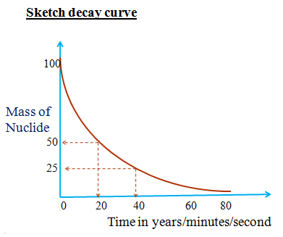

1. From the graph show and determine the half-life period of the isotope.

From the graph t 1/2 changes in activity from:

( 100 – 50 ) => ( 20 – 0 ) = **20** minutes

( 50 – 25 ) => ( 40 – 20 ) =  **20** minutes

Thus t ½= **20 minutes**

1. Why does the graph tend to ‘O’?

**Smaller particle/s will disintegrate /decay to half its original.**

**There can never be ‘O’/zero particles**

**CHEMICAL AND NUCLEAR REACTIONS**

Nuclear and chemical reaction has the following **similarities**:

1. -both involve the **subatomic** particles; electrons, protons and neutrons in an atom
2. -both involve the subatomic particles trying to make the atom more **stable**.
3. – both involve **energy** transfer/release/absorb from/to the environment.

Nuclear and chemical reaction has the following **differences**:

|  |  |
| --- | --- |
| Nuclear reactions | Chemical reactions |
| 1. Involve protons and neutrons in the nucleus of an atom. 2. Nuclear reactions form a new element. 3. Involve production of large quantity of heat/energy. 4. The rate of decay/ disintegration of the nuclide is independent of physical conditions (temperature/pressure /purityp/article size) | -Mainly involve outer electrons in the energy levels an atom.  -Chemical reactions do not form new elements  -produce or absorb small quantity of heat/energy  -The rate of a chemical reaction is dependent on physical conditions (temperature/pressure/purity/particle size/ surface area) |

**APPLICATION AND USES OF RADIOCTIVITY.**

The following are some of the fields that apply and use radioisotopes;

a) **Medicine: -**Treatment of cancer to **kill** malignant tumors through **radiotherapy.**

-**Sterilizing** hospital /surgical instruments /equipments by exposing them to gamma radiation.

**b) Agriculture:**

If a plant or animal is fed with radioisotope, the metabolic processes of the plant/animal are better understood by **tracing** the route of the radioisotope.

**c) Food preservation:**

X-rays are used to kill bacteria in **tinned** food to last for a long time.

**d) Chemistry:**

To study **mechanisms** of a chemical reaction, one reactant is **replaced** in its structure by a radioisotope e.g.

During esterification the **‘O’** joining the ester was discovered comes from the **alkanol** and not alkanoic acid.

During photosynthesis the **‘O’** released was discovered comes from **water**.

**e) Dating rocks/fossils:**

The quantity of **14C** in living things (plants/animals) is **constant.**

When they die the fixed mass of 14C is t**rapped** in the cells and **continues** to decay/disintegrate.

The half-life period of 14C is 5600 years .

Comparing the mass of 14C in l**iving** and **dead** cells, the age of the dead can be determined.

DANGERS OF RADIOCTIVITY.

* All rays emitted by radioactive isotopes have ionizing effect of changing the genetic makeup of living cells.
* Exposure to theses radiations causes chromosomal and /or genetic mutation in living cells.
* Living things should therefore not be exposed for a long time to radioactive substances.
* One of the main uses of radioactive isotopes is in generation of large cheap electricity in nuclear reactors.
* Those who work in these reactors must wear protective devises made of thick glass or lead sheet.

Accidental leakages of radiations usually occur

In 1986 the Nuclear reactor at Chernobyl in Russia had a major explosion that emitted poisonous nuclear material that caused immediate environmental disaster

In 2011, an earthquake in Japan caused a nuclear reactor to leak and release poisonous radioactive waste into the Indian Ocean.

* The immediate and long term effects of exposure to these poisonous radioactive waste on human being is of major concern to all environmentalists.

**SAMPLE REVISION QUESTIONS**

1. The figure below shows the behaviour of emissions by a radioactive isotope x. Use it to answer the question follow

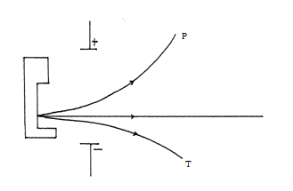

(a) Explain why isotope **X** emits radiations. (1mk)

**-is unstable //has n/p ratio greater/less than one**

(b) Name the radiation labeled **T** (1mk)

**alpha particle**

(c) Arrange the radiations labeled **P** and **T** in the increasing order of ability to be deflected by an electric filed. (1mk)

**T -> P**

1. a) Calculate the mass and atomic numbers of element B formed after 21280X has emitted three beta particles, one gamma ray and two alpha particles.

**Mass number**

**= 212 – (0 beta+ o gamma + (2 x 4 ) alpha = 204**

**Atomic number**

**= 80 – (-1 x3) beta + 0 gamma + (2 x 2 )) alpha =79**

b) Write a balanced nuclear equations for the decay of 21280X to B using the information in (a) above.

**21280X 20479B + 242He + 3 0-1e + y**

**3. Identify the type of radiation emitted from the following nuclear equations.**

(i) 146C 147N + ………

**β - Beta**

1. 11H + 10n 21H + ……

**y -gamma**

(iii) 23592U 9542Mo + 13957La + 10n +……

**7 β – seven beta particles**

1. 23892U 23490Th + … …

**α-alpha**

1. 146C +  11H 157N + ……

**y-gamma**

1. X grams of a radioactive isotope take 100 days to disintegrate to 20 grams. If the half-life period isotope is 25 days, calculate the initial mass X of the radio isotope.

**Number of half-lifes = ( 100 / 25 ) = 4**

**20g -----> 40g ----> 80g-----> 160g -----> 320g**

**Original mass X = 320g**

1. **A radioactive isotope X2 decays by emitting two alpha (a) particles and one beta (β) to form 214 83Bi**

**(a)Write the nuclear equation for the radioactive decay**

21286X -> 214 83Bi + 242He + 0-1e

**(b)What is the atomic number of X2?**

86

**(c) After 112 days, 1/16 of the mass of X2 remained. Determine the half life of X2**

**1—x-> 1 /2 –x-> 1 /4 –x-> 1 /8–x-> 1 /16**

**Number of t 1 /2 in 112 days = 4**

**t 1 /2 = 112 = 28 days**

**4**

**5. Radium has a half-life of 1620 years.**

(i) What is half-life?

**The half-life period is the time taken for a radioactive nuclide to spontaneously decay/ disintegrate to half its original mass/ amount**

b) If one milligram of radium contains 2.68 x 10 18 atoms ,how many atoms disintegrate during 3240 years.

**Number of half-lifes = ( 3240 / 1620 ) = 2**

**1 mg ---1620---> 0.5mg ---1620----> 0.25mg**

**If 1mg -> 2.68 x 1018 atoms**

**Then 0.25 mg -> ( 0.25 x 2.68 x 1018 ) = 6.7 x 1017**

**Number of atoms remaining = 6.7 x 1017**

**Number of atoms disintegrated =**

**(2.68 x 1018 - 6.7 x 1017 )**

**= 2.01 x 1018**

**6. a)State two differences between chemical and nuclear reactions(2mks)**

(i) Nuclear reactions mainly involve protons and neutrons in the nucleus of atom.Chemical reactions mainly involve outer electrons in the energy levels an atom.

(ii) Nuclear reactions form a new element. Chemical reactions do not form new elements

(iii) Nuclear reactions mainly involve evolution/production of large quantity of heat/energy. Chemical reactions produce or absorb smaller quantity of heat/energy.

(iv)Nuclear reactions are accompanied by a loss in mass /mass defect.

Chemical reactions are not accompanied by a loss in mass.

(v)Rate of decay/ disintegration of nuclide is independent of physical conditions. The rate of a chemical reaction is dependent on physical conditions of temperature/pressure/purity/particle size/ surface area

**b)Below is a radioactive decay series starting from 21483 Bi and ending at 20682 Pb. Study it and answer the question that follows**.

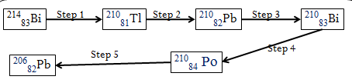

**Identify the particles emitted in steps I and III (2mks)**

I - **α-particle**

III -  **β-ray**