**SULPHUR AND ITS COMPOUNDS**

* Is a non-metallic element.
* Has atomic number 16 and electronic configuration of 2:8:6 hence belongs to group 6
* It occurs naturally as an element in deposits in USA, and Italy
* Also occurs in combined states as ***sulphides*** and ***sulphates*** e.g. gypsum, (CaSO4•2H2O) and copper pyrites (CuFeS2)

**Extraction of sulphur deposits**

* Is extracted by the **Frasch process.**

**FRASCH PROCESS**

* The process is based on low melting point of sulphur which ranges between 113ºC and 119ºC.
* It is used to mine sulphur from underground where it exists as free element.
* In the process three concentric pipes are sunk to the bottom of sulphur deposit.

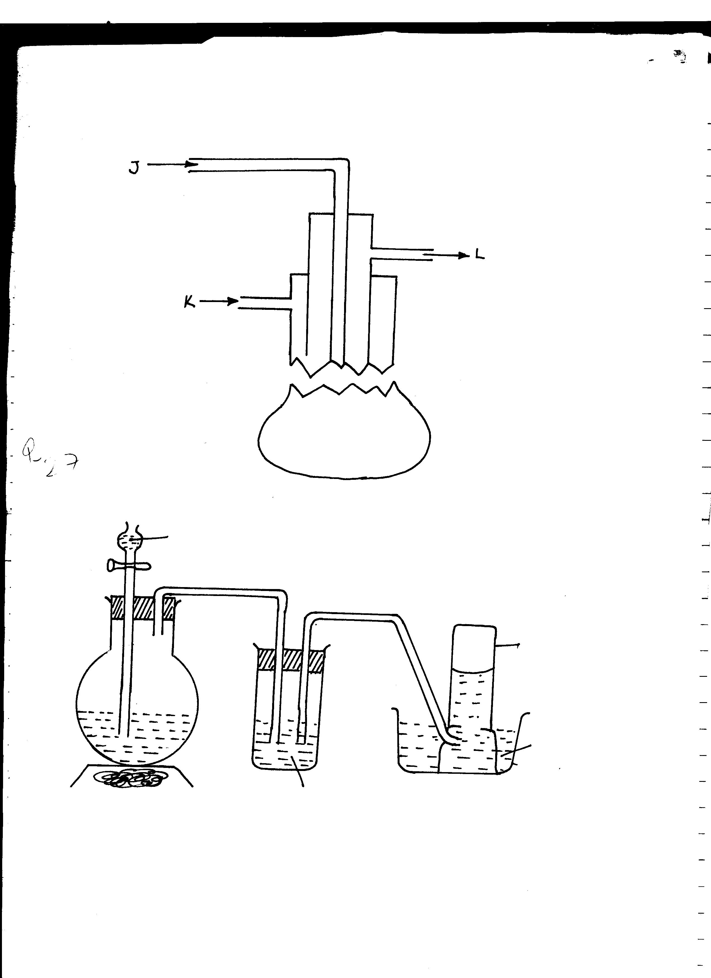

**J**

**K**

**L**

* These concentric pipes have different functions:

1. **The outer pipe** contains superheated water (160ºC -180ºC) and under pressure of 10atmospheres.

* The high pressure ensures water remains in liquid state even at that temperature. Superheated water is used to melt sulphur.
* Sulphur melts at 113ºC. Molten sulphur is heavier than the hot water, it thus floats.

1. Hot compressed air at a pressure of about 15 atmospheres is forced through **the innermost pipe** with diameter of 2cm. It aerates the molten sulphur forming froth and reduces its density.

* The high pressure forces the sulphur-water mixture up through the middle pipe.

1. **The middle pipe** carries the molten sulphur into tanks where sulphur solidifies to form yellow solids.

* Sulphur obtained this way is about 99.5% pure.
* Frasch process needs:
* a lot of energy and
* Access to large volumes of water.
* **The Frasch method of extracting sulphur is possible because:**
* Sulphur deposits are located near the earth surface.
* Sulphur has a low melting point.
* **Open mining is not applicable because:**
* Sulphur lies under layers of quick sand
* In the deposits there are poisonous gases prodused.

**Allotropes Of Sulphur**

* Rhombic sulphur/alpha (α) sulphur/octahedral sulphur
* Monoclinic sulphur/beta (β) sulphur/prismatic sulphur
* The two allotropes consist of the **S8** structures. They only differ in the way they are packed in the crystal.
* The two allotropes are inter- convertible with changing temperature.
* Other forms of sulphur include:

1. **Plastic sulphur**

* Is prepared by heating sulphur until it boils and the boiling sulphur poured in beaker of cold water. Long plastic threads of sulphur are formed.

1. **Amorphous sulphur**

* Is prepared by saturating distilled water with hydrogen sulphide. The solution is exposed to air and a powder of sulphur is formed

**2H2S(aq) + O2 (g) 2H2O(l) + 2S(s)**

1. **Colloidal sulphur**

* Is prepared by reacting dilute HCl with dilute sodium thiosulphite (Na2S2O3)

**Na2S2O3 (aq) + 2HCl (aq) 2NaCl (aq) + H2O (l) + SO2 (g) + S(s)**

**The differences in the properties of the two main allotropes are shown below;**

|  |  |
| --- | --- |
| **Rhombic sulphur** | **Monoclinic sulphur** |
| Octahedral yellow crystals | Prismatic (needle like yellow- brown crystals ) or hexagonal prism |
| Stable below 96ºC. slowly changes to monoclinic above 96ºC | Stable between 96ºC and 119ºC. changes slowly to rhombic below 96ºC |
| Melting point is 113ºC | Melting point is 119ºC |
| Density of 2.1g/cm3 | Density of 1.98g/cm3 |

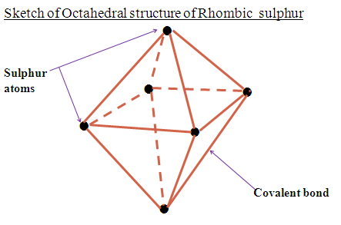

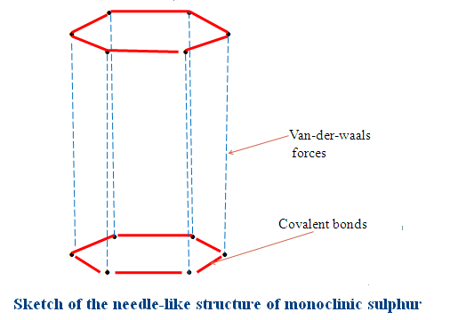

* The two allotropes are soluble in carbon disulphide and methylbenzene. They are all insoluble in water.
* Temperature 96 ºC is known as **transition temperature**. This is the temperature at which one allotrope changes to another.

**Physical properties of sulphur.**

* Is a yellow non-metallic element, brittle, crystalline solid. The shape of sulphur is as shown below.

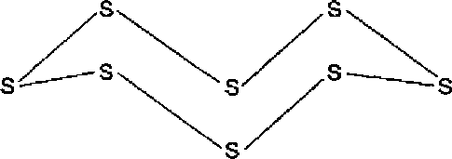

* It has a faint characteristic smell, but no taste.
* Sulphur is insoluble in water
* Sulphur is highly soluble in carbon (IV) sulphide and methylbenzene. It is sparingly soluble in alcohol and ether.
* It has a boiling point of about 114ºC.
* Occurs in a number of allotropic forms; two of which are crystalline, rhombic and monoclinic.

**Action of heat on sulphur**

* A molecule of sulphur exists as puckered ring of eight atoms joined by covalent bonds as S8.

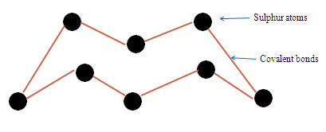

* At 113ºC, yellow sulphur melts to clear pale yellow liquid which flows easily.

On further heating, at about 150ºC, it becomes red-brown and very viscous. The red – brown flows slowly. This is because the S8 rings break into S8 chain that join together to form very long chains made of over 100000 atoms of Sulphur.

* The long chains **entangle** each other reducing their mobility and hence increase their viscosity.

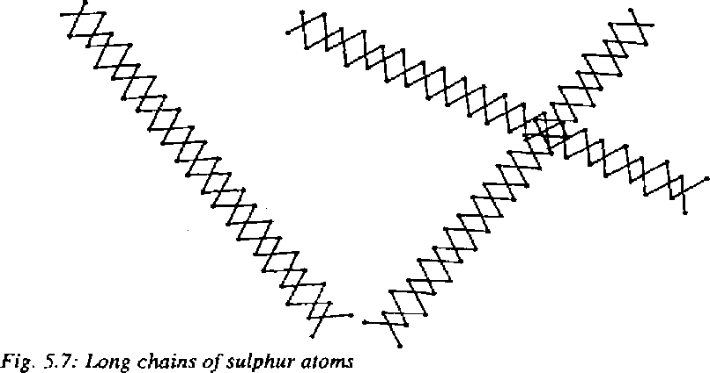

* Above 160ºC the liquid darkens further and becomes almost black. Its viscosity reduces. This is because the long chains are broken to shorter and less entwined chains.
* At 444 ºC, sulphur boils to form brown vapours consisting of S8, S6 and S2 which easily form yellow sublimate (flowers of sulphur) on cold surface.
* If boiling sulphur is poured in cold water, a brown rubbery material called **plastic sulphur;** which is a form of sulphur, not allotrope because allotropes must be crystalline.
* **Summary on action of heat on sulphur:**

|  |  |
| --- | --- |
| Observation on heating | Explanation/structure of Sulphur |
| Solid sulphur  Heat to 113oC Amber yellow liquid  Heat to 160oC Liquid darkens  Heat to 444oC Liquid boils to brown vapour  Cool to room temperatureYellow sublimate  (Flowers of Sulphur) | Puckered S8 ring  Puckered S8 ring in liquid form (low viscosity/flow easily)  Puckered S8 ring break/opens then join to form long chains that entangle (very high viscosity/very low rate of flow)  Mixture of S8 ,S6 ,S2 vapour  Puckered S8 ring |

**Chemical properties of sulphur.**

1. Sulphur burns in air or oxygen with a blue flame to form sulphur (IV) oxide.

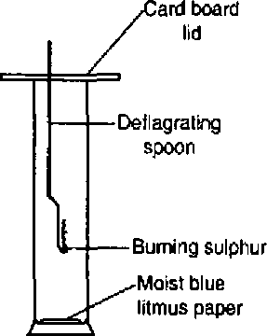

**S(s) + O2 (g) SO2 (g)**

* In excess oxygen, sulphur (VI) oxide is formed.

**2S(s)  + 3O2 (g) 2SO3 (g)**

1. **Sulphur combines with some element to form sulphides**.

* E.g. when iron is mixed with sulphur and heated strongly, an exothermic reaction occurs in which iron (II) sulphide is formed.
* Once the reaction starts, the mixture continues to glow because the heat evolved is able to sustain the reaction.

**Fe(s) + S(s) FeS(s)**

**(Black)**

* Hot powdered copper also reacts with sulphur to form copper (I) sulphide.

**Cu(s) + S(s) Cu2S(s)**

**(Black)**

* Sulphur also combines with some non-metals, at high temperature, such as carbon and hydrogen to form non-metallic sulphides.

**C(s) + S(s)  CS2 (s)**

**H2 (g) + S(s) H2S (g)**

These two products are highly poisonous.

1. **Sulphur is oxidized by hot concentrated sulphuric (VI) acid to sulphur (IV) oxide.**

**S(s) + H2SO4 (l) 3SO2 (g) + 2H2O (l)**

1. **Sulphur is oxidized by hot concentrated nitric (V) acid to form sulphuric (VI) acid.**

* The presence of sulphate ions (SO42-) is tested by adding solution of barium chloride or barium nitrate. Formation of a white precipitate (Barium sulphate) shows that the solution has sulphate ions.

**S(s) + 6 HNO3 (aq) H2SO4 (aq) + 6NO2 (g) + 2H2O (l)**

N/B Dilute acids have no effect on sulphur. Sulphur is only oxidized by hot concentrated acids; nitric and sulphuric (VI) acid. Concentrated hydrochloric acid is not an oxidizing agent and thus does not react with sulphur.

**Uses of sulphur**

* In manufacture of sulphuric (VI) acid
* As a fungicide to kill fungi that cause diseases and sulpha-drugs.
* Making sulphur dyes which are used for dyeing cotton
* Used in vulcanization of rubber (Hardening). Sulphur is heated together with rubber making rubber tough, harder and less sensitive to temperature
* In manufacture of bleaching agent (Calcium hydrogen sulphite) used to bleach wood pulp in paper industry.
* Making of important chemicals like carbon (IV) sulphide.
* Manufacture of gunpowder, fireworks and matches

**Revision Practice**

1. **The diagram below represents the extraction of sulphur by Fraschs process. Use it to answer the questions that follow.**

L

N

M

Sulphur

**(a)Name the substances that passes through:**

**M** Superheated water at 170oC and 10 atmosphere pressure

**L** Hot compressed air

N Molten sulphur

**(b)What is the purpose of the substance that passes through L and M?**

M- Superheated water at 170oC and 10 atmosphere pressure is used to melt the sulphur

L- Hot compressed air is used to force up the molten sulphur.

**(c) The properties of the two main allotropes of sulphur represented by letters A and B are given in the table below. Use it to answer the questions that follow.**

|  |  |  |
| --- | --- | --- |
|  | **A** | **B** |
| **Appearance** | **Bright yellow** | **Pale yellow** |
| **Density(gcm-3)** | **1.93** | **2.08** |
| **Melting point(oC)** | **119** | **113** |
| **Stability** | **Above 96oC** | **Below 96oC** |

**I.What are allotropes?**

* Different forms of the same element existing at the same temperature and pressure without change of state.

**II. Identify allotrope:**

1. Monoclinic sulphur

B . Rhombic sulphur

**III. State two main uses of sulphur.**

-Manufacture of sulphuric(VI)acid

-as fungicide

-in vulcanization of rubber to make it harder/tougher/ stronger

-manufacture of dyes /fibres

**(d)Calculate the volume of sulphur (IV) oxide produced when 0.4 g of sulphur is completely burnt in excess air.(S = 32.0 ,I mole of a gas occupies 24 dm3 at room temperature)**

Chemical equation

S(s) + O2(g) SO2(g)

Mole ratio S: SO2 = 1:1

**Method 1**

32.0 g of sulphur -> 24 dm3 of SO2(g)

0.4 g of sulphur -> 0.4 g x 24 dm3 = **0.3 dm3**

32.0 g

**Method 2**

Moles of sulphur used= Mass of sulphur => 0.4 = 0.0125 moles

Molar mass of sulphur 32

Moles of sulphur used = Moles of sulphur(IV)oxide used=>0.0125 moles

Volume of sulphur(IV)oxide used = Moles of sulphur(IV)oxide x volume of one mole of gas =>0.0125 moles x 24 dm3 = **0.3 dm3**

**OXIDES OF SULPHUR**

1. Sulphur (IV) oxide (SO2)
2. Sulphur (VI) oxide (SO3)

**SULPHUR (IV) OXIDE**

* It can be prepared in the lab by the following ways:

1. **Reacting copper with hot concentrated sulphuric (VI) acid.**

* The mixture is heated the solution to become hot, the gas is evolved.

**Cu(s) + H2SO4 (l) CuSO4 (aq) + 2H2O (l) + SO2 (g)**

* There is no reaction when the solution is not hot.
* The gas produced is passed through concentrated sulphuric (VI) acid to dry it and collected by downward delivery because it is denser than air.

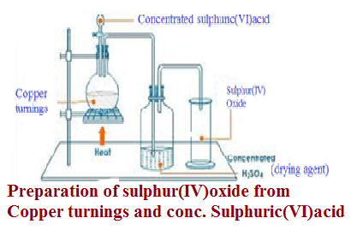

1. **From sodium sulphite**

* Is prepared by action of dilute hydrochloric acid on sodium sulphite.

**Na2SO3 (s) + 2HCl (aq) 2NaCl (aq) + 2SO2 (g) + H2O (l)**

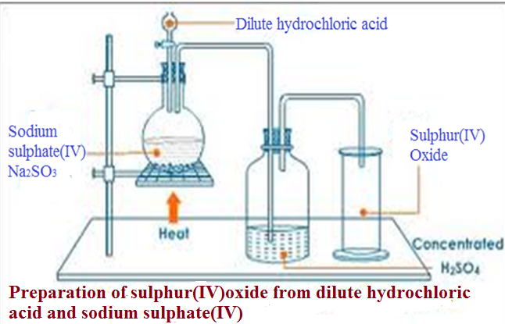

* Heat is not necessary, but if the reaction is slow, heat may be supplied.
* Nitric (V) acid is not used because it is a strong oxidizing agent which can oxidize the sulphite to sulphate
* The gas jar is confirmed to be full when the orange potassium chromate (VI) paper turns green.
* These experiments should be carried in a fume chamber because sulphur (IV) oxide is poisonous.
* To prepare a solution of sulphur (IV) oxide in water, the gas is not dried and is directly bubbled into water using an inverted funnel to prevent sucking back.
* Other ways of preparing sulphur (IV) oxide include:

1. Heating sulphur in air

**S(s) + O2 (g) SO2 (g)**

1. Burning of sulphides in air

**4FeS2(s) + 11O2 (g) 2Fe2O3 (s) +8SO2 (g)**

**Physical properties of sulphur (IV) oxide**

* It is a colourless gas
* It has an irritating choking smell
* It is easily liquefied at low pressure (3atmos)
* It is denser than air
* Is highly soluble in water forming acidic solution

**Chemical properties of sulphur (IV) oxide**

1. Acidic Properties of Sulphur (IV) Oxide

* When moist a blue litmus paper is dropped into a test-tube containing sulphur (IV) oxide, it turns red
* The gas has no effect on dry litmus. The gas dissolves in water to form a weak diabasic acid sulphuric (IV) which is responsible for the change in colour of the moist litmus.

1. **Reaction with alkalis**

* The sulphur (IV) oxide (SO2) reacts with dilute sodium hydroxide solution to form a salt and water and the reaction is neutralization.
* Two types of salts may be formed namely sulphites and hydrogen sulphites. The sulphites are formed when all the replaceable hydrogen ions from the acid are displaced by a metallic ion.

**SO32-(aq)+ 2NaOH(aq)  Na2SO3(aq) + 2H2O(l)**

**HSO32-(aq)+ NaOH(aq)  NaHSO3(aq)+ 2H2O(l)**

* Hydrogen sulphites are formed when only one of the hydrogen ions is displaced in a metallic ion.

1. Bleaching Action of Sulphur (IV) Oxide

* Sulphur (IV) oxide bleaches by reduction. It combines first with moisture forming sulphuric (IV) acid which then reduces the dye to a colorless product.
* The dye contains active (nascent) oxygen which causes the color. This active oxygen in the dye reacts with the sulphuric (IV) acid to form a colourless material.
* Oxygen in the air, especially in the presence of sunlight may replace the oxygen removed from the material during bleaching and thus restore the original color. This explains why old newspapers printed on newsprint turns brown.

**[Dye + O] + SO32-(aq)  SO42-(aq) + Dye**

**colored colorless**

1. Reducing Action of Sulphur (IV) Oxide

* Sulphur (IV) oxide is a strong reducing agent. The reducing action only occurs in the presence of water contained in the aqueous solutions.

1. Acidified potassium chromate (VI) turns from orange to green when sulphur (IV) oxide is bubbled through the solution.

The dichromate ion, Cr2072- is reduced to chromium (III) ion, Cr3+.

**3SO2(g) + Cr2O72- (aq) + 2H+(aq) 3SO3(aq) + 2Cr3+ + H2O(l)**

This is the usual test for sulphur (IV) oxide.

1. Sulphur (IV) oxide turns acidified potassium manganate (VII) solutions from purple to colourless,

**5SO2 (g) + 2MnO4-(aq) + 2H2O(1) 5SO42-(aq) + 2Mn2+(aq) + 4H+(aq)**

(purple) (colorless)

* The purple manganate ion is reduced to colorless manganese (II), Mn2+ ion.

1. Red-brown acidified bromine water is decolourised forming hydrobromic acid.

**2H2O(l) + Br2 (aq)  + SO2(g) HBr(aq) + SO42-(aq) +H+(aq)**

1. When sulphur (IV) oxide gas is bubbled through concentrated nitric (v) acid, brown fumes of nitrogen (IV) oxide are given off.

**2HNO3(aq) + SO2(g) 2NO2(g) + H2SO4(aq)**

* The nitric (V) oxide is reduced to nitrogen (IV) oxide.

1. Sulphur (IV) oxide reduces yellow iron (III) ion, (Fe3+) to pale green iron (II) ion (Fe2+)

**2Fe3+(aq) + 2H2O(l) + SO2(g)  2Fe2+(aq) + SO42-(aq)  + 4H+(aq)**

yellow pale green

1. Acidified hydrogen peroxide is reduced to water.

**H2O2(l) + H2O(l) + SO2(g) SO42-(aq)  + 2H+(aq) + H2O(l)**

**NB**/ In each of the reducing actions sulphur (IV) oxide, sulphate S042- ion is formed. When a solution of barium chloride is added to the mixture, a white precipitate is formed indicating the presence of sulphate ion.

1. **Reaction with oxygen**

* When a burning splint is lowered into a test-tube containing sulphur (IV) oxide gas, it is put off.
* The gas does not bum. However, when a mixture of dry sulphur (IV) oxide and dry oxygen is passed over heated vanadium (V) oxide (or platinized asbestos) at 400 - 500°C the two gases react and sulphur (VI) oxide, S03 is formed.
* The vanadium (V) oxide is a catalyst. This is an important reaction in the large scale manufacture of sulphuric (VI) acid.

1. **Oxidising Action of Sulphur (IV) Oxide**

* When burning magnesium is lowered into a gas jar of sulphur (IV) oxide, white fumes of magnesium oxide and yellow deposit of sulphur are formed. The magnesium continues to bum for some time because the heat from burning magnesium decomposes the sulphur (IV) oxide to sulphur and oxygen. Magnesium combines with oxygen to form magnesium oxide.

**SO2 S + O2**

2 Mg + **O2 2MgO**

* Sulphur (IV) oxide acts as an oxidising agent supplying oxygen to magnesium.
* When a gar jar of dry hydrogen sulphide gas is inverted over a test-tube containing dry sulphur (IV) oxide, there is no observable change. When a few drops of water are added into each gas jar and the mixture shaken, a yellow deposit of sulphur will be produced.

**2H2S(g) + 4SO2(g) 3S(s) + 2H2O(l)**

* The reaction only takes place when the gases are moist. Sulphur (IV) oxide acts as an oxidising agent, supplying oxygen to hydrogen sulphide.

**What is the test for sulphate and sulphite ions?**

* When barium chloride is added to a solution containing sulphate and sulphite ions, a white precipitate is formed
* On adding dil. Hydrochloric acid:
* The ppt remains insoluble in the dilute acid indicate the presence of sulphate (S042-) ions. Barium sulphate is formed.
* The white precipitate if it dissolves in dilute acid (with the production of a colorless gas which turns filter paper soaked in acidified orange potassium chromate (VI) from orange to green) indicate the presence of sulphite (S032-) ions.

**Uses of SO2**

1. Raw material in the manufacture of sulphuric acid
2. Manufacture of calcium hydrogen sulphate, a bleaching agent used in pulp and paper industry.
3. As fumigant
4. As a preservative in jams and fruit juices

**LARGE SCALE MANUFACTURE OF SULPHURIC (VI) ACID – CONTACT PROCESS**

* The raw materials are:

1. Sulphur
2. Air
3. catalyst

* The major steps involved in preparation include:

1. **Production and purification of sulphur (IV) oxide.**

It can be obtained when:

* Sulphur is burnt in air to form sulphur (IV) oxide.

**S(s) + O2 (g) SO2 (g)**

* Sulphide ores are burnt in oxygen

**CuS(s) + O2 (s) Cu(s) + SO2 (g)**

* Hydrogen sulphide is burnt in air

**2H2S(g) + O2 (g) 2SO2 (g) + 2H2O(g)**

* The sulphur (IV) oxide gas obtained has impurities such as:

1. dust particles
2. arsenic oxide

* These impurities are removed to avoid “poisoning” (reducing the efficiency) of the catalyst. The mixture of air and sulphur (IV) oxide gas is passed through purifiers and cleaners to remove dust particles.
* Iron (III) oxide solution is also sprayed to remove arsenic oxide.

1. **Catalytic oxidation of sulphur (IV) oxide to sulphur (VI) oxide.**

* The mixture is taken to heat exchanger where it is heated to optimum temperature of about 450ºC and pressure of about 3atmospheres.
* Sulphur (IV) oxide is reacted with excess oxygen in presence of ***finely divided vanadium (V) oxide or platinum-asbestos catalyst*** to convert it to sulphur (VI) oxide, SO3.

**2SO2 (g) + O2 (g) 2SO3 (g) + Heat**

* However platinum-asbestos is:
* expensive,
* cancer causing
* Easily poisoned.
* This reaction is highly exothermic and thus the gas formed is taken back to the heat exchanger to regulate the temperature to optimum 450ºC.
* This gas is not be dissolved directly in water because the reaction is highly exothermic and the heat produced boils the acid to produce fine droplets of sulphuric acid in air.

**SO3 (g) + H2O(l) H2SO4 (aq)**

1. **Conversion of sulphur (VI) oxide to sulphuric (VI) acid**

* The cool sulphur (VI) oxide is then absorbed in concentrated sulphuric (VI) acid in the absorption chamber, where oleum, H2S2O7 (fuming sulphuric acid) is produced.

**SO3 (g) + H2SO4 (l) H2S2O7 (l)**

* Sulphuric (VI) acid is obtained by diluting oleum with water.

**H2S2O7 (l) + H2O (l) 2H2SO4 (l)**

**Z**

SO2

Dust precipitator

Drying tower

X

Concentrated H2SO4

Sulphur

Step 1

air

SO2

air

Pure SO2

air

SO3

Step 3

Step 4

Concentrated H2SO4

Step

SO3

Convertor

Y

Y

**Pollution control in Contact process**

Pollutants include:

1. Sulphur (IV) oxide
2. Sulphur (VI) oxide
3. Vanadium
4. Arsenic

* The sulphur (IV) oxide gas which is not converted to sulphur (VI) oxide gas is a pollutant.
* Thus the exhaust gases are passed through chimneys lined with calcium hydroxide which controls the amount of sulphur (IV) oxide released to the atmosphere.

**Ca(OH)2 (aq) + SO2 (g)  CaSO3 (aq) + H2O(l)**

This is known as **Scrubbing the gas.** Filters fitted with strong alkalis may also be installed to remove traces of the acid and exhaust gases.

**CONCENTRATED SULPHURIC(VI) ACID**

* It is a colorless oily liquid
* It a density of 1.84g/cm3 when pure
* Soluble in water. Its reaction with water is highly exothermic, which causes hot acid to be scattered from the container. Thus the acid is always added to water and never water to acid because in the latter case, water is quickly vaporized to steam and splashes out with droplets of the corrosive acid

**H2SO4 (l) SO3 (g) + H2O(l)**

* The high boiling point is due to hydrogen bonding in the structure.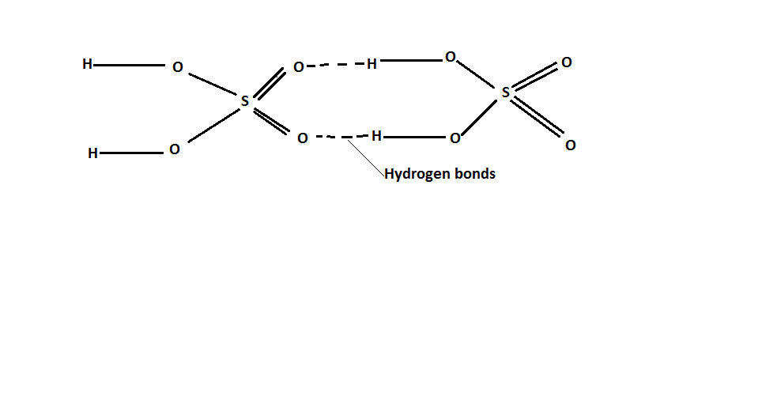
* It had no effect on litmus papers
* It does not conduct electricity
* Pure concentrated sulphuric (VI) acid is not ionized. It is a covalent compound.

**Chemical properties of sulphuric (VI) acid**

**Concentrated sulphuric VI acid**

1. **It is highly hygroscopic** i.e. it readily absorbs water vapor from air or moisture from substances. This is why it is used as a drying agent to dry gases in the lab.
2. **As a dehydrating agent.**

* The acid readily removes chemically combined water from hydrated salts.

**CuSO4•5H2O (s)  Conc H2SO4 CuSO4 (s) + 5H2O(l)**

**(Blue crystals) (White powder)**

* It is capable of removing elements of water (Hydrogen and oxygen) E.g. it dehydrates sucrose (Sugar), ethanol, methanoic acid and ethanedioic acid (Oxalic acid).

**C12H22O11 (aq) Conc H2SO4 12C(s) + 11H2O(l)**

**(Sugar) (Black mass)**

**HCOOH (l) Conc H2SO4 CO(g) + H2O(l)**

**(Methanoic acid)**

**C2H5OH(l) Conc H2SO4 C2H4 (g) + H2O(l)**

**(Ethanol) 160ºC (Ethene)**

**C6H10O5 (s) Conc H2SO4 6C(s) + 5H2O(l)**

**(Cellulose)**

* Clothes, wood and paper are mainly made up of cellulose. They are charred and form black mass of carbon when concentrated sulphuric (VI) acid is poured on them
* A dehydrating agent is a chemical that is capable of removing chemically bonded water or elements of water from a compound.

1. **As an oxidizing agent.**

* Hot, concentrated sulphuric (VI) acid is a strong oxidizing agent. It oxidizes all metals except gold and platinum which are lower in the reactivity series.

**Cu(s) + 2H2SO4 (l) CuSO4 (aq) + 2H2O(l) + SO2 (g)**

**Zn(s) + 2H2SO4 (l) ZnSO4 (aq) + 2H2O(l) + SO2 (g)**

* It can also oxidize non – metals such as sulphur and carbon.

**S(s) + 2H2SO4 (l) 3SO2 (g) + 2H2O(l)**

**C(s) + 2H2SO4 (l) CO2 (g) + 2H2O(l) + 2SO2 (g)**

1. **Reactions with salts / displacement reaction**

* It displaces more volatile acids from their salts because it is less volatile.
* Study the table below showing a comparison in boiling points of the three mineral acids

|  |  |  |
| --- | --- | --- |
| Mineral acid | Relative molecula mass | Boiling point(oC) |
| Hydrochloric acid(HCl) | 36.5 | 35.0 |
| Nitric(V)acid(HNO3) | 63.0 | 83.0 |
| Sulphuric(VI)acid(H2SO4) | 98.0 | 333 |

**Which is the least volatile acid? Explain**

Sulphuric(VI)acid(H2SO4) because it has the largest molecule and joined by Hydrogen bonds making it to have the highest boiling point/least volatile.

**KNO3 (s) + H2SO4 (l) HNO3 (g) + KHSO4 (s)**

**NaCl(s) + H2SO4 (l) HCl(g) + NaHSO4 (s)**

**Dilute sulphuric acid**

1. **Reaction with metals to form a salt and hydrogen gas.**

* Does not react with metals lower than hydrogen in the reactivity series

Mg(s) + H2SO4(aq) MgSO4(aq) + H2(g)

**Mg(s) + 2H+(aq) Mg2+ (aq) + H2(g)**

Zn(s) + H2SO4(aq) ZnSO4(aq) + H2(g)

**Zn(s) + 2H+(aq) Zn2+ (aq) + H2(g)**

Fe(s) + H2SO4(aq) FeSO4(aq) + H2(g)

**Fe(s) + H+(aq) Fe2+ (aq) + H2(g)**

1. **React with carbonates to form salt, carbon IV oxide and wate.**

* The reaction of sulphuric acid with magnesium carbonate and lead carbonate stops after a while because the insoluble magnesium and lead sulphates are formed which coat the carbonate from further in contact with the acid.

ZnCO3(s) + H2SO4(aq) --> ZnSO4(aq) + H2O(l) + CO2(g)

**ZnCO3(s) + 2H+(aq) --> Zn2+ (aq) + H2O(l) + CO2(g)**

CuCO3(s) + H2SO4(aq) --> CuSO4(aq) + H2O(l) + CO2(g)

**CuCO3(s) + 2H+(aq) --> Cu2+ (aq) + H2O(l) + CO2(g)**

1. **React with alkalis and bases to form a salt and water**

ZnO(s) + H2SO4(aq) --> ZnSO4(aq) + H2O(l)

MgO(s) + H2SO4(aq) --> MgSO4(aq) + H2O(l)

CuO(s) + H2SO4(aq) --> CuSO4(aq) + H2O(l)

2NaOH(aq) + H2SO4(aq) --> Na2SO4(aq) + H2O(l)

OH-(aq) + H+(aq) --> H2O(l)

2NH4OH(aq) + H2SO4(aq) --> (NH4)2SO4(aq) + H2O(l)

2KOH(aq) + H2SO4(aq) --> K2SO4(aq) + H2O(l)

**Uses Of Sulphuric (Vi) Acid**

* Manufacture of fertilizers like ammonium sulphate

**NH3 (g) + H2SO4 (aq) (NH3)2SO4 (s)**

* Manufacture of detergents like sulphonic acid salts.
* Manufacture of plastics and other synthetic fibres like rayon
* Manufacture of dyes and paints
* Cleaning metal surfaces before coating with a protective metals (Pickling) during electroplating.
* Used in lead acid accumulators

**HYDROGEN SULPHIDE**

* Is a gaseous compound of hydrogen and sulphur.
* It is highly poisonous.

**Preparation of hydrogen sulphide gas**

* Reaction between dilute hydrochloric acid and iron (II) sulphide.

**FeS(s) + 2HCl(aq) FeCl2 (aq) + H2S(g)**

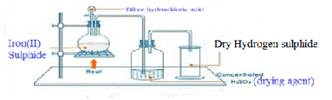

* The gas is collected over warm water because it dissolves in cold water. The gas can be dried by passing it through a U-tube packed with anhydrous calcium chloride.
* It is not dried using concentrated sulphuric (VI) acid because the gas would be oxidized to sulphur.

**3H2S (g) + H2SO4 (l)  4S(s) + 4H2O (l)**

* Phosphorus (V) oxide can also be used dry the gas.

**Physical properties of hydrogen sulphide gas**

* Is a colourlesss gas
* Has a smell of a rotten egg
* It is highly poisonous.
* It is highly soluble in cold water but less soluble in warm water
* It is denser than air hence can be collected by downward delivery

**Chemical properties of hydrogen sulphide gas**

1. **Reaction with water**

* It dissolves in water to form a weak acidic solution of hydrogen sulphide, H2S (aq)

**H2S(aq) H2OH2S(aq)**

**Or**

**H2S(aq) 2H+(aq) + S2-(aq)**

* The solution turns blue litmus red
* When alkalis are added to the solution, hydrogen sulphides and sulphides are formed.

**2NaOH(aq) + H2S(aq) 2H2O(aq) + Na2S(aq)**

**NaOH(aq) + H2S(aq) NaHS(aq) + H2O(aq)**

1. **Reaction with oxygen**

It burns in air with a **pale** **blue flame**. In limited supply of air, sulphur and water are formed.

**2H2S(g) + O2(g) 2S(s) + 2H2O(l)**

In excess air, sulphur (IV) oxide and water are formed.

**2H2S(g) + 3O2(g) 2SO2(g) + 2H2O(g)**

1. **Reactions of hydrogen sulphide as a reducing agent**

* It is a strong reducing agent and is readily oxidized to sulphur, which is precipitated as a yellow solid.

1. It reduces red-brown bromine water to form colourless hydrogen bromide solution.

**Br2(aq) + H2S(g) 2HBr(aq) + S(s)**

(Red-Brown) (Colourelss)

1. It reduces yellow solution of iron (III) ions to pale green iron (II) ions.

**H2S(g) + 2FeCl3 (aq) 2FeCl2(aq)  + 2HCl(aq) + S(s)**

1. It reduces purple potassium manganate(VII) to colourless manganate (II) ions

**2MnO4-(aq) + 5H2S(g) + 6H+(aq) 2Mn2+(aq) + 8H2O(aq) + 5S(s)**

**(Purple) (Colourless)**

1. It reduces acidified orange chromate (VI) ions to green chromium (III) ions

**Cr2O72-(aq) + 3H2S(g) + 8H+(aq) 2Cr3+(aq)  + 7H2O(l) + 3S(s)**

1. It reduces hydrogen peroxide to water and a yellow precipitate is formed.

**H2O2 (aq) + H2S­(g) 2H2O(l) + S(s)**

1. It reduces dilute nitric (V) acid to brown fumes of nitrogen (IV) oxide and pale yellow sulphur is deposited.

2**HNO3 (aq) + H2S(g) 2NO2 (g) + 2H2O(l) + S(s)**

1. It reduces sulphuric (VI) acid to sulphur

**H2SO4(aq) + 3H2S(g)  4S(s) + 4H2O(l)**

**NB/ all the reactions of hydrogen sulphide as a reducing agent forms a deposit of yellow sulphur.**

1. **Reaction with aqueous metallic ions**

Insoluble sulphides are precipitated when the gas is passed into solutions of most metal ions.

**Cu2+(aq) + S2-(aq) CuS(s)**

(Black precipitate)

**Zn2+(aq) + S2-(aq) ZnS(s)**

**(White precipitate)**

**Fe2+(aq) + S2-(aq) FeS(s)S**

**(Black precipitate)**

**Pb2+(aq ) + S2-(aq) PbS(s)**

**(Black precipitate)**

**TOXICITY OF HYDROGEN SULPHIDE**

Hydrogen sulphide combines with haemoglobin in the blood in much the same way as carbon (II) oxide and hydrogen cyanide molecules do. It thus stops oxygen from reaching the cells causing poisoning.

N/B: Eggs contains sulphur compounds and iron compounds. When an egg is over boiled, the iron reacts with sulphur forming iron (II) sulphide which is seen as a black lining on the egg yolk.

Sulphur compounds are added to cooking gas so that we can smell the gas in case of a leak

1. **Study the flow chart below and answer the questions that follow.**

Iron

Compound

T

Gas U + FeCl2(aq)

Heat HCl(aq)

Sulphur

1. Name (i) Compound T

FeS – Iron (II) Sulphide.

(ii)H2S – Hydrogen Sulphide.

1. Give a chemical test that you could use to identify gas U.

Hydrogen Sulphide turns moist Lead (II) acetate paper black, forming Lead II Sulphide.

(CH3COO)2 Pb(aq) + H2S(g) 2HOOCH3(aq) + PbS(s)

1. **(i) List down different types of amorphous sulphide.**

* Plastic Sulphur
* Colloidal Sulphur

(ii) State three other uses of sulphur in industries.

* Manufacture of Sulphuric acid
* In the manufacture of matches and gun powders.
* In the production of important chemicals such as carbon disulphide (CS2) and calcium hydrogen Sulphite (Ca (HSO3)2. The latter is used in the paper industry.

(iii) When a sample sulphur is heated, the changes represented in the flow diagram below are observed.

# Sulphur

Yellow

Solid at

300C

# P

Amber liquid very Mobile at 1130C

# Q

dark red, highly

viscous at 1160C

R

dark red liquid very mobile at 4000C

1. Explain why P and R are very mobile while Q is viscous.

* Because P and R have S8, S6 and S4 rings while Q has long chains of Sulphur atoms.

1. What would be observed if the black liquid at 4000C was poured in a thin continuos stream into a beaker containing cold water?

* Long, elastic, light yellow ribbons of plastic sulphur are formed.

1. When solid sulphur is heated, it melts and becomes mobile, then viscous then mobile again on further heating. Explain this observation in terms of the structures of sulphur.

* The S8 Sulphur molecules become individual S8 Sulphur molecules during melting making the liquid mobile. The molecules break open, join to form long chains which get entangled, making the liquid viscous. The chains break, and straighten out. The molecules break into individual sulphur atoms during boiling making the liquid mobile again.

1. What changes would you observe when powdered roll sulphur is heated in a test tube to just below its boiling point?

* Sulphur melts at 1130C to give a mobile (runny) amber liquid. As the temperature rises the liquid darkens and at about 1800C it becomes very viscous (thick). If the temperature is increased still further the liquid once more becomes mobile.

1. Describe how you would prepare two allotropic forms of Sulphur. Make sketches to show the difference in crystal structure.

**Rhombic (alpha or octahedral) sulphur**

* Dissolve some powdered sulphur in carbon disulphide (CS2). Filter any excess sulphur using a dry filter paper and collect the filtrate in a water glass and place it in a fume cupboard. Carbon disulphide will evaporate and crystals of rhombic sulphur are formed. Carbon disulphide vapours are highly inflammable and poisonous.
* After the carbon disulphide has evaporated bright yellow crystals of rhombic sulphur form. Throughout no heating is required.

**Monoclinic (beta or prismatic) sulphur**

* Some powdered sulphur is added to 20cm3 methylbenzene (toluene) or dimethylbenzene (xylene) in a small beaker. The mixture is warmed slowly in a water bath at 313 k(400C) heated with a small flame.
* More powdered sulphur is added if necessary until no more dissolves. The solution is slowly cooled and monoclinic crystals which are pale yellow and needle-like are formed.

1. **The flow chart below shows how sulphuric acid is produced on a large scale.**

Gas A Gas A

Oleum

Dilution

Chamber

Solid B Gas C SO3

Burner Reaction E

chamber

Product

Liquid D

1. Identify
2. Gas B – Sulphur
3. Gas C – Sulphur dioxide, SO2
4. Liquid D – Water
5. Substance E – H2SO4
6. Gas A – Air (oxygen)
7. (i) What catalyst is used in the reaction chamber?

Vanadium (IV) Oxide

(ii) Write an equation for the reaction taking place in this chamber.

2SO2(g) + O2(g) 2SO3(g)

1. What would you observe if concentrated sulphuric acid is added to.

(i) Cane sugar

* Sugar will get dehydrated and a black carbon remains, a smelling of sulphur dioxide is also noticed.
* The hydrogen and oxygen are removed by the concentrate sulphuric acid.

C12H22O11 -11H2O 12C + heat

* Heat is also generated and thus reduces some sulphuric acid to sulphur dioxide.

1. Copper sulphate crystals.

* The blue copper sulphate crystals gradually turn white as they become anhydrous, loosing their water of crystallisation.

CuSO4.5H2O -5H2O CuSO4

Blue White

1. **Sulphuric acid is manufactured on large scale by the contact process.**
2. What factors should be considered when siting a plant to manufacture sulphuric acid?

* Availability and cost of raw materials.
* Availability of transport.
* Environmental factors.
* Availability of market.

1. Name the raw materials required.

* Oxygen
* Sulphur

1. State the conditions in the contact process.

* Catalyst vanadium pentoxide
* Temperature of 4000 – 5000C

1. (i) How concentrated sulphuric acid prepared?

* By diluting the Oleum with water

H2S2O7(l) + H2O(l) 2H2SO4(l)

(ii) How is the unchanged sulphur dioxide removed from the system.

* By absorbing it using calcium hydroxide solution.

1. According to Le-chatelier’s principle, what conditions should be adopted in the contact process in order to obtain the maximum yield of sulphur trioxide?

* The conversion of sulphur dioxide to sulphur trioxide is an exothermic process hence a yield of sulphur trioxide is favoured by a reasonably low temperature.
* Also the reaction proceeds by a decrease in volume. Hence an increase in pressure should increase the yield of sulphur dioxide.

1. Describe briefly a simple laboratory test you use to differentiate between sulphite, sulphate and thiosulphate given the following;

2M Barium chloride solution, dilute hydrochloric acid, filter paper dipped in potassium dichromate and the necessary apparatus.

* To the solution under-test, add barium chloride solution followed by a few drops of dilute hydrochloric acid, test and gas produced using filter paper dipped in acidified potassium dichromate. If a sulphate is present, there will be a faint white precipitate on adding Barium chloride solution and on adding dilute hydrochloric acid, fumes of a pungent gas which turns a filter dipped in acidified potassium dichromate solution from yellow orange to green is produced (SO2). No precipitate of sulphur is formed.
* If sulphate is present, on adding barium chloride solution followed by hydrochloric acid, a thick white precipitate that is insoluble in dilute hydrochloric acid is formed (BaSO4)
* If a thiosulphate is present (S2O32-) on adding barium chloride solution, a white precipitate (BaS2O3) is formed and on adding dilute hydrochloric, a white or cream precipitate of sulphur is formed and a colourless gas with a pungent smell and which turns acidified potassium dichromate paper from yellow orange to green is formed (SO2).

1. **Why concentrated sulphuric acid used as a drying agent.**

* It has a water loving acid owing to its dehydrating properties hence it is used to dry those gases which don’t react with it.

1. **Why does a burning magnesium ribbon continue burning in sulphur dioxide gas.**

* When burning magnesium is lowered in a jar of sulphur dioxide the heat from the magnesium decomposes the sulphur dioxide into a yellow specks.