WATER AND HYDROGEN
WATER
- Water is a compound of hydrogen and oxygen.
- It is the most abundant compound on Earth’s surface covering about 70% of the planet.
- In nature it exists in three states; solid, liquid and gaseous.
- Pure water is tasteless, odorless, nearly colorless with a hint of blue
- It’s known as a universal solvent because it can dissolve most substance and because of this, it’s rarely pure in nature

WATER AS PRODUCT OF BURNING ORGANIC MATTER
Water vapor is one of the products when organic matters undergo combustion. Carbon (IV) oxide is another product. Organic matter consists of mainly hydrogen and carbon.
During combustion, carbon is oxidized to carbon (IV) oxide and hydrogen is oxidized to water. Compounds that contain hydrogen and carbon only are called hydrocarbons
They include:
- Kerosene
- Petrol
- Diesel
- Candle

Describe an experiment to show that water and carbon (IV) oxide are products of burning a candle in air
- Set up the apparatus as shown below
- Light the candle and turn on the pump
- Allow the candle to burn for about 15min
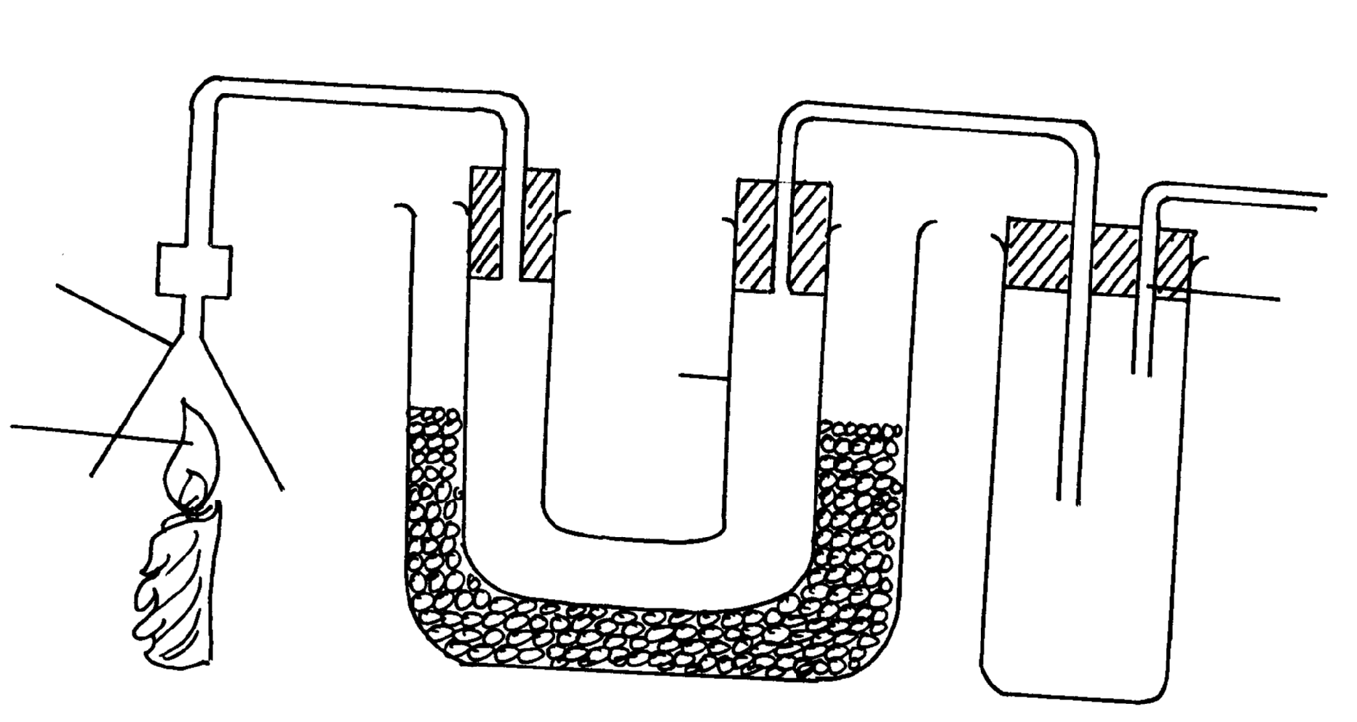
- Observe and record what happens in tube A and B.
Funnel
Candle flame
Tube A
Tube B
Ice and salt mixture
Boiling tube
Calcium hydroxide solution
Gases to suction pump

The contents of test tube A is divided in to two portions. To one portion, anhydrous copper (ii) sulphate or blue cobalt (ii) chloride paper is added.
- Candle wax burns in air to a colorless liquid and a colorless gas.
- The colorless liquid turns white anhydrous copper (II) sulphate to blue and anhydrous blue cobalt (II) chloride paper to pink. The two test confirms that the colorless liquid is water.

Anhydrous copper (II) sulphate + water hydrated copper (II) sulphate
(white) (blue)
Anhydrous Cobalt (II) chloride + water hydrated Cobalt (II) chloride
(blue) (pink)
The colorless gas formed forms a white precipitate with lime water (calcium hydroxide) and hence the gas is carbon (II) oxide
EXPLANATION
The colorless liquid is water. The hydrogen in the candle is oxidized to water by oxygen.
The carbon in the candle was oxidized also to carbon (IV) oxide
This shows that candle is a hydrocarbon.
N/B
- Ice cold water was used to condense the water vapor
- The aspirator provides a sucking force that draws the gaseous products (water vapor and carbon (IV) oxide produced).
- All hydrocarbons burn in air to form water and carbon (II) oxide gas as the only products.
Candle wax + oxygen water + carbon (II) oxide gas
CHEMICAL PROPERTIES OF WATER
- Reaction with metals
- Some metals react with cold water to produce a metal hydroxide and hydrogen gas. Such metals are said to be highly reactive. Examples include potassium, sodium, lithium and calcium.
Metal + Water Metal hydroxide + hydrogen gas
- While others react with steam to form metal oxide and hydrogen gas
Metal + Steam Metal oxide + hydrogen gas

EXP: TO INVESTIGATE HOW METALS REACT WITH COLD WATER
- Sodium metal
- Cut a small piece of sodium metal, the size of a rice grain.
- Drop it into a trough containing cold water. Record your observations.
- Test the solution in the trough using pieces of red and blue litmus papers. Record your observations
Observations and discussion
When a piece of sodium is placed in water:
- It floats and melts into a silvery ball.
- It floats because it has a lower density (0.968g/cm³) than that of water (1g/cm³).
- It melts because the reaction is exothermic and the heat produced is strong enough to melt the sodium (low melting point of 98° C)
- It darts on the surface of the cold water as it produces a hissing sound.
- The resulting solution turns red litmus blue showing the solution is alkaline/basic. The alkaline solution is sodium hydroxide.
- If a large piece of sodium is used, the heat produced is so strong that make the hydrogen gas produced to ignite into a yellow-orange flame (the flame of sodium metal)

N/B Hydrogen gas burns with a blue flame. The yellow-orange flame is because of impurities of sodium vapors.
- Other metals which react in the same manner include potassium and lithium.
When a small piece of potassium is dropped in cold water, it melts into a silvery ball and moves about rapidly on the surface of water. The reaction is exothermic and the hydrogen produced ignites spontaneously. The flame produced is lilac/violet/purple due to the presence of potassium vapor during the reaction.
Sodium + Water sodium hydroxide + hydrogen gas
Potassium + Water potassium hydroxide + hydrogen gas
Lithium + Water Lithium hydroxide + hydrogen gas
- Calcium metal
It has a higher density than water and thus sinks in water. The reaction is similar to that of lithium but less rapid. The boiling tube is used to collect the gas evolved in the set up below. The solution formed is tested using blue and red litmus papers.

- A gas that burns with a ‘pop’ sound is collect in the boiling tube. The gas is hydrogen.
- An alkaline solution of calcium hydroxide is formed. A white suspension/precipitate is observed because calcium hydroxide is slightly soluble in water.
- The solution turns red litmus paper blue because the solution is basic.
Calcium + Water Calcium hydroxide + hydrogen gas
- Magnesium
Magnesium reacts with atmospheric oxygen to form a coating layer of magnesium oxide. It is first removed before reacting it with water.
Magnesium reacts very slowly when placed in cold water. If left for some time, then hydrogen is evolved slowly and the solution becomes slightly alkaline.
Magnesium + Water Magnesium hydroxide + hydrogen gas
NB/ Zinc and iron do not react with cold water

- Reaction of metals with steam
Place clean, wet sand in a boiling tube. Clean a piece of magnesium ribbons about 6cm long and make it into a spiral coil. Place it in the middle of the boiling tube and arrange the apparatus as shown.
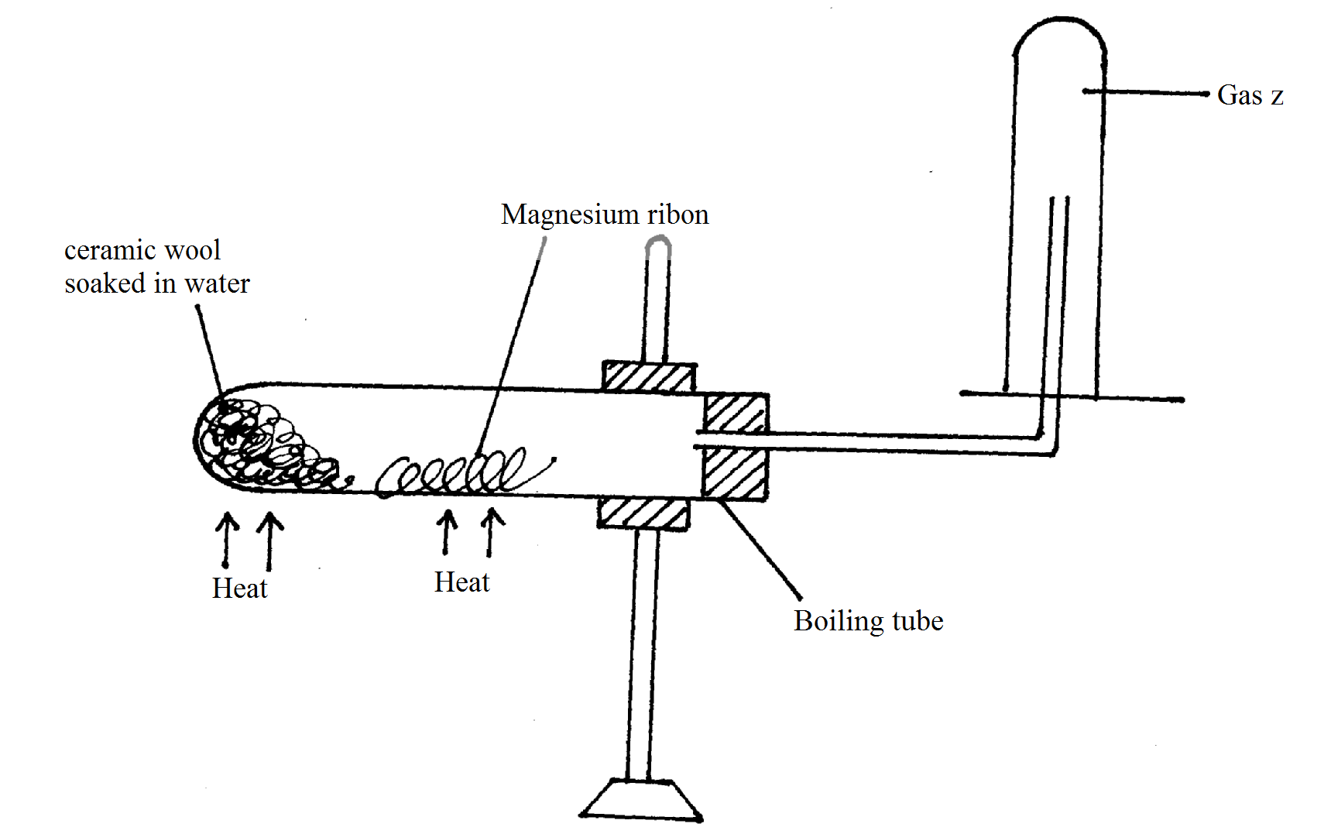
Heat the magnesium strongly and warm the wet sand gently as you continue heating the magnesium. Observe what happens. Remove the delivery tube before you stop heating. Test the gas produced using a burning splint. Record your observations.
Repeat the experiment using zinc powder and iron filings.

Observations and discussion
- Wet sand is warmed to generate steam, which reacts with the metal
- The magnesium ribbon glows brightly and a white solid remains in the boiling tube. A gas is collected which burns a ‘pop’ sound in air.
Magnesium + Steam magnesium oxide + hydrogen gas
Mg(s) + H₂O(g) MgO(s) + H₂(g)

The white solid is magnesium oxide and the gas is hydrogen
- Zinc does not burn in steam but it glows. Zinc reacts with steam to form a yellow powder of zinc oxide when hot, which turns white on cooling. The gas produced is hydrogen.
Zinc + Steam Zinc oxide + Hydrogen gas
(grey) Yellow -hot
White –cold
Zn(s) + H₂O(g) ZnO(s) + H₂(g)
- Iron also glows to form a black residue of an oxide called tri-iron tetra oxide and hydrogen gas
Iron + Steam Tri-iron tetra oxide + hydrogen gas
(grey) (black)
2Fe(s) + 4H₂O(g) Fe₃O₄(s) + 4H₂(g)
- Aluminium reacts with steam but quickly forms a layer of aluminium oxide which is impervious. This layer coats/masks the metal preventing further reaction.
- Copper and lead don not react with cold water or steam.
N/B During this experiment, the delivery tube is removed before heating stops to prevent water being sucked into hot boiling tube as it cools.
SUMMARY TABLE
Metal | Action of metal on water | Action on steam
Potassium  Sodium  Calcium  Magnesium  Aluminium  Zinc  Iron  Lead  Copper | Violent  Violent  Moderate  Very slow  No reaction  No reaction  No reaction  No reaction  No reaction | Explosive  Explosive  Violent  Rapid  Slow  Slow  Slow  No reaction  No reaction

Metals can be arranged in order of their reactivity with water. The arrangement gives the
Metal | Reaction with water | Reaction with dilute acid
Sodium | Reacts with cold water to give off hydrogen | Reacts quickly with acid to give off hydrogen
Calcium | Reacts with cold water to give off hydrogen | Reacts quickly with acid to give off hydrogen
Magnesium | Reacts with cold water to give off hydrogen | Reacts quickly with acid to give off hydrogen
Aluminium | Reacts with steam to giveoff hydrogen | Reacts slowly with acid to give off hydrogen
Zinc | Reacts with steam to giveoff hydrogen | Reacts slowly with acid to give off hydrogen
Iron | Reacts with steam to giveoff hydrogen | Reacts slowly with acid to give off hydrogen
Lead | No reaction | Reacts very slowly to give off hydrogen
Copper, silver, gold | No reaction | No reaction

Reactivity Series of metals.
Potassium Most reactive
Sodium
Lithium
Calcium
Magnesium
Aluminium
Zinc
Iron
Lead
Copper Least reactive
Hydrogen element is located in between iron and lead in the reactivity series. All the elements lower than hydrogen in the reactivity series do not react with water i.e. they cannot displace the hydrogen from water. A metal will only react with water if the metal is more reactive than hydrogen.
HYDROGEN
- Is the simplest and lightest element; has lowest density.
- It does not occur freely but exists in combined form like in water, hydrocarbons and sugar.
- It exists as a diatomic molecule (H₂).

LABORATORY PREPARATION OF HYDROGEN
- It’s prepared by the reaction of dilute acids and some metals.
Possible combinations include:
- Zinc metal and dilute sulphuric (VI) acid
- Zinc metal and dilute hydrochloric acid
- Magnesium metal and dilute sulphuric (VI) acid or dilute hydrochloric acid
NB/ The most suitable metal is zinc because it reacts moderately with dilute acids.
The most suitable acid is dilute hydrochloric acid.

Procedure
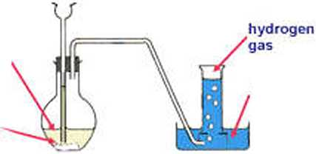
Put a few zinc granules into a conical flask and arrange the apparatus as shown. Add dilute hydrochloric acid using the dropping funnel. If the reaction is slow, add a few crystals of copper (II) sulphate.
Dil hydrochloric acid

Water
Zinc
granules
If the gas is required dry, it should be bubbled through concentrated sulphuric (VI) acid and collected by upward delivery or overwater method.
Discussion
- When zinc granules are added to dilute hydrochloric acid there is effervescence and hydrogen gas is evolved. A small amount of copper (II) sulphate crystals may be added to speed up the rate of the reaction i.e. it acts as a catalyst.

Zinc + Hydrochloric acid Zinc chloride + Hydrogen gas
Zn(s) + 2HCl(aq) ZnCl₂(aq) + H₂(g)

- Dry hydrogen gas is obtained by passing wet hydrogen through anhydrous calcium chloride or concentrated sulphuric (VI) acid.

- Nitric (V) acid is not used to prepare hydrogen gas because it is a strong oxidizing agent and thus the hydrogen produced is quickly oxidized to water. However very dilute nitric (V) acid liberates hydrogen with magnesium metal.
- Potassium, sodium, lithium and calcium react explosively with dilute acids hence must not be used.
- Magnesium could be used but it is expensive.
- Aluminium forms a protective layer of aluminum oxide, which should be washed using concentrated hydrochloric acid (Pickling) before the metal can react with dilute acids.
- Zinc is the most preferred because it reacts moderately with dilute acids.
- Impure iron gives a mixture of gases including the bad smelling hydrogen sulphide when reacted with dilute acids.
Physical properties of hydrogen gas.
- Is colorless (when pure) and odourless.
- It is lighter than air and that is why it is collected by upward delivery/downward displacement of air.
- It is sparingly soluble in water and that is why it can also be collected by overwater method/downward displacement of water.
Chemical properties of hydrogen gas.
- It is a neutral gas i.e. it has no effect on wet blue or red litmus papers.
- It reacts with chlorine gas to produce hydrogen chloride gas; a reaction that is catalyzed by sunlight.
Hydrogen + chlorine Hydrogen chloride.

- It is a reducing agent and removes oxygen from some metal oxides. In such a reaction, hydrogen gains oxygen and is said to be oxidized, while the metal oxide loses oxygen and thus is reduced.
Experiment : Hydrogen as a reducing agent.
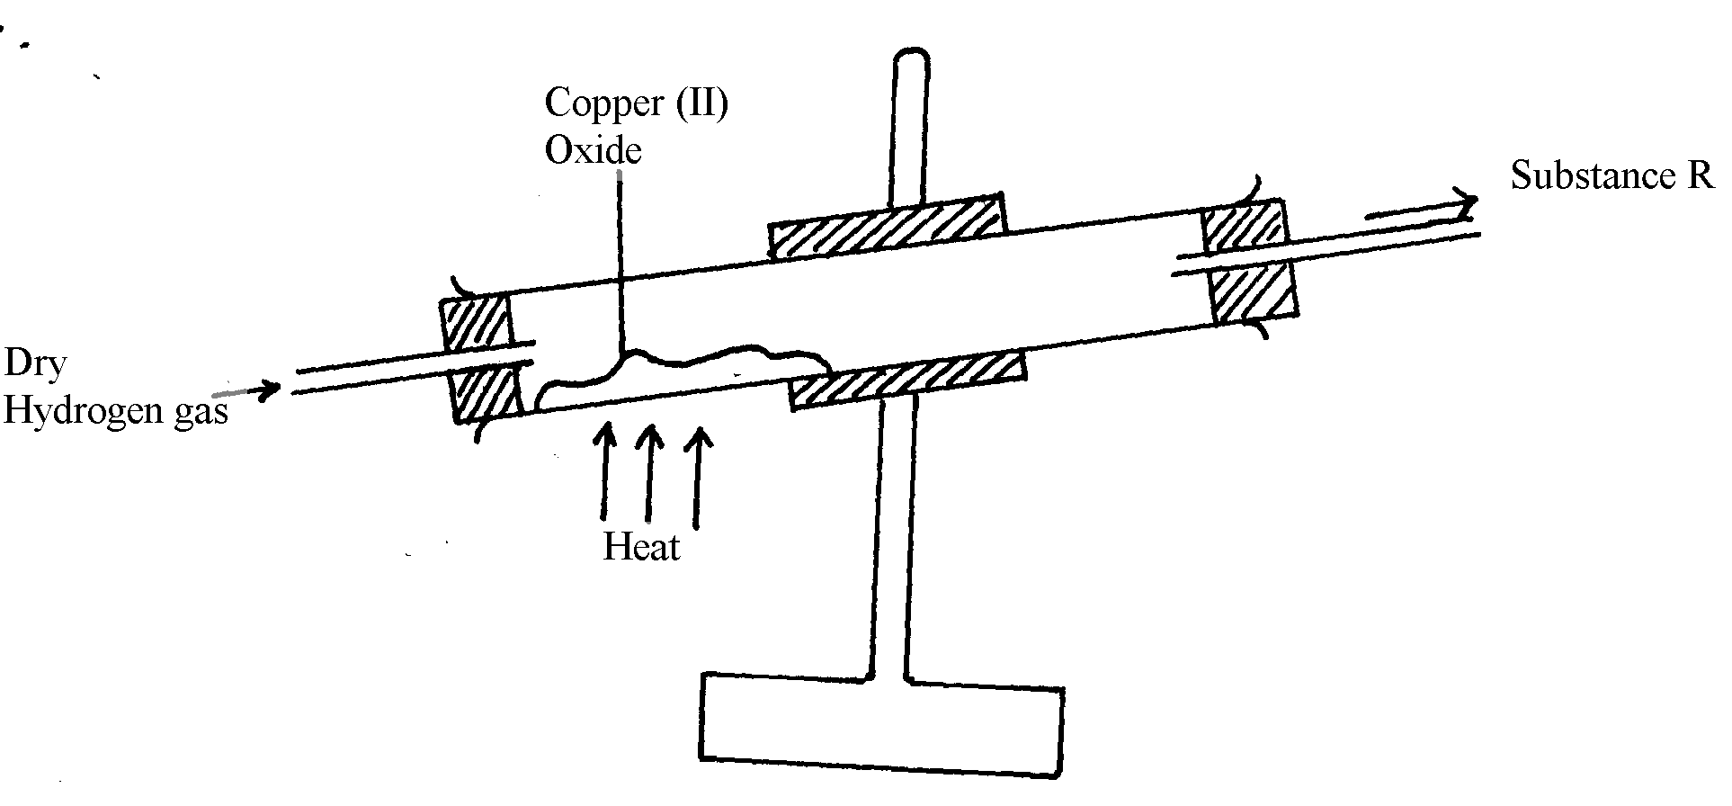
- Place a spatulaful of copper (II) oxide in a porcelain boat or on a piece of aluminium foil. Place the boat in a combustion tube. Set up the apparatus as shown:

- Pass dry hydrogen through the tube for some time to drive out the air from the apparatus.
- Collect a sample of the gas from the jet in a test tube and test it with a burning splint. Continue collecting and testing until a sample of the gas burns silently (without a ‘pop’ sound)
- Light the gas at the jet and start heating copper (II) oxide. Ensure a steady flow of hydrogen gas.
- Continue heating until there is no further change. Observe what happens.
- Allow the apparatus to cool as you continue passing the stream of hydrogen gas over the residue.
- Disconnect the apparatus and test the colorless liquid in the cooler parts of the combustion tube.

Discusion
- Air is driven out of the apparatus to ensure the hydrogen being burned at the jet is pure to avoid explosion.
- On passing a stream of dry hydrogen gas over hot copper (II) oxide, the black copper (II) oxide changes to a red-brown solid (Copper metal). At the same time a colorless liquid condenses and collects on the cooler parts of the combustion tube. The liquid turns anhydrous copper (II) sulphate from white to blue.
- Hydrogen combines with oxygen from the copper (II) oxide to form water which is the colorless liquid. The red-brown solid is copper metal.
- Hydrogen is oxidized to water while copper (II) oxide is reduced to copper metal.
reduction

Copper (II) oxide + Hydrogen copper metal + Water
(Black solid) (Colorless) (Red-Brown) (Colorless)

oxidation
CuO (s) + H₂(g) Cu(s) + H₂O(l)
Oxidation is the addition of oxygen to a substance
Reduction is the removal of oxygen from a substance.
Redox reaction is a reaction in which reduction and oxidation occurs simultaneously.
Hydrogen is a reducing agent while copper (II) oxide is an oxidizing agent.
- The supply of hydrogen gas is continued while the apparatus cools to avoid the re-oxidation of the hot metal by oxygen from air.
- Excess hydrogen gas is burned because its mixture with oxygen (air) is explosive when ignited. The excess gas is thus not allowed to escape into the air for safety reasons. Pure hydrogen burns quietly with a blue flame.
- Hydrogen can also reduce lead (II) oxide, mercury (II) oxide and silver (I) oxide and iron (II) oxide

Lead (II) oxide + Hydrogen Lead metal + Water
(Yellow-cold (Grey beads)
Orange-hot)
PbO (s) + H₂(g) Pb(s) + H₂O(l)
Iron (II) oxide + hydrogen Iron metal + Water
Fe₂O₃ (s) + 3H₂(g) Fe(s) + 3H₂O(l)
- Hydrogen will not reduce oxides of sodium, calcium, magnesium, aluminium or zinc because these metals have high affinity for oxygen than hydrogen.

- Hydrogen burns in air to form a colorless liquid which turns a white anhydrous copper (II) sulphate to blue. The liquid is water.

Hydrogen + Oxygen Hydrogen Oxide (Water)
O₂(g) + 2H₂(g) 2H₂O(l)
The set up below can be used to investigate the above properties of hydrogen:

USES OF HYDROGEN
- Hydrogen is used in large scale manufacture of ammonia in a process called Haber process oxygen to a substance
- Manufacture of margarine. Hydrogen is passed through liquid oil in presence of Nickel catalyst, the oil takes hydrogen and is converted to fats.(Hydrogenation)
- Is used in weather balloons because it is lighter than air.
- A mixture of hydrogen and oxygen burns to produce a very hot flame, the oxy-hydrogen flame, which has a temperature of about 2000ºC. The flame is used in wielding and for cutting metals.
- Used as rocket fuel and fuel cells.
Fixed proportions of Hydrogen and Oxygen when ignited explode violently producing a lot of energy/heat.This energy is used to power/propel a rocket to space.
- Manufacture of hydrochloric acid

QUESTIONS
1. (a) Hydrogen can reduce coppers Oxide but not alluminium oxide. Explain
- Aluminium is above hydrogen in the reactivity series of elements
(b) When water reacts with potassium metal the hydrogen produced ignites explosively
on the surface of water.
- What causes this ignition?
- The reaction is too exothermic that alot of heat is produced causing ignition of hydrogen in presence of oxygen
- Write an equation to show how this ignition occurs
K_{(s)} + H₂O_{(g)} KOH_{(aq)} + H_{2(g)}
H_{2(g)} + O_{2(g)} H₂O_{(g)}
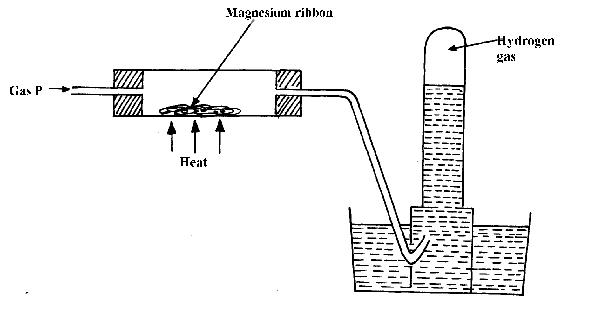
2. Gas P was passed over heated magnesium ribbon and hydrogen gas was collected as shown in the diagram below:

(i) Name gas P

(ii) Write an equation of the reaction that takes place in the combustion tube
(iii) State one precaution necessary at the end of this experiment
Ans : (i) Steam
(ii) Mg_{(s)} + H₂O_{(g)} MgO_{(s)} + H_{2(g)}
(iii) Gas P is passed through the combustion tube before heating is commenced
3. When hydrogen is burnt and the product cooled, the following results are obtained as shown in the diagram below:
Dry hydrogen
Liquid Y
Burning hydrogen
Ice cold water
Clamp
Clamp

(a) Write the equation for the formation of liquid Y
(b) Give a chemical test for liquid Y
Ans: a) 2H_{2(g)} + O_{2(g)} 2H₂O_{(l)}
b) – Turns anhydrous white paper copper (II) sulphate into blue. Or
- Turns anhydrous blue ^{√½} cobalt (II) chloride into pink.
4. Hydrogen can be prepared by reacting zinc with dilute hydrochloric acid.
a) Write an equation for the reaction.
- Zn(s) + 2HCl(aq) ZnCl₂(aq) + H₂(g)

b) Name an appropriate drying agent for hydrogen gas.
- Concentrated sulphuric (VI) acid or anhydrous calcium chloride
c) Explain why copper metal cannot be used to prepare hydrogen gas.
- Copper cannot displace hydrogen from its solution.
d) Hydrogen burns in oxygen to form an oxide.
(i) Write an equation for the reaction.
- 2H₂(g) + O₂(g) 2H₂O(l)
(ii) State two precautions that must be taken before the combustion begins and at the end of the combustion.
- Before: Pass hydrogen / through the tube before lighting 1 to drive off air.
- End: There should be a continuous flow of hydrogen after / putting off the flame
to avoid an explosion.
e) Give two uses of hydrogen gas.
-Filling balloons 1 - Manufacture of margarine.
- Manufacture of ammonia. - Conversion of coal to synthetic petrol.
f) When zinc is heated to redness in a current of steam, hydrogen gas is obtained. Write an equation for the reaction.
- Zn (s) + H₂O(g) ZnO(s) + H₂(g)
g) Element Q reacts with dilute acids but not with cold water. Element R does not react with dilute acids. Elements S displaces element P from its oxide. P reacts with cold water. Arrange the four elements in order of their reactivity, starting with the most reactive.
- S,½ P,  ½ Q,  ½ R, ½
h) Explain how hydrogen is used in the manufacture of margarine.
- It adds to unsaturated oils and hardens them
5. a) The set-up below is used to investigate the properties of hydrogen.
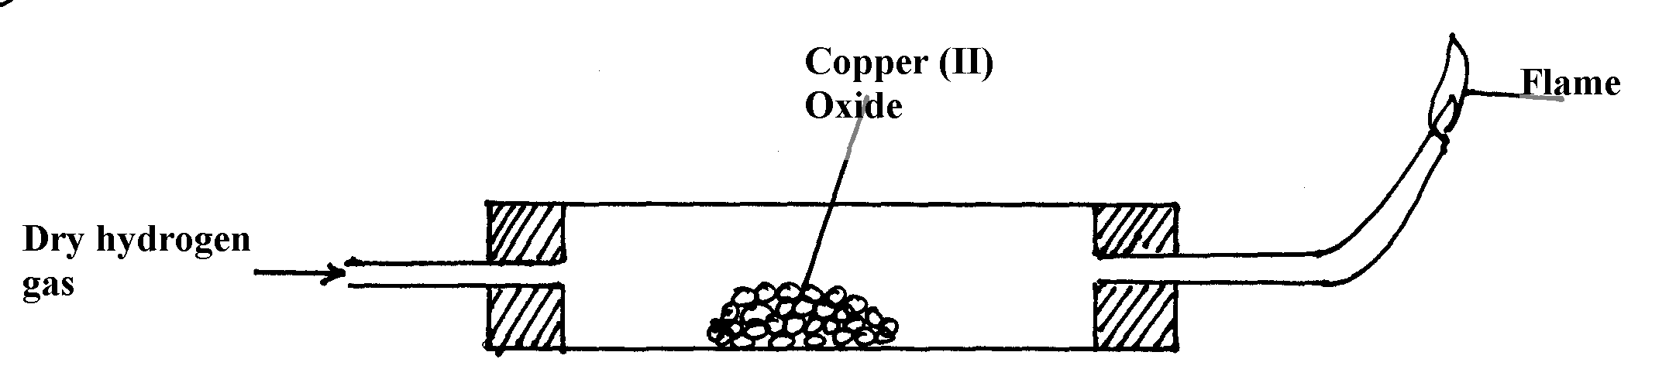

- On the diagram, indicate what should be done for the reaction to occur
- Heating of copper (ii) Oxide to be shown on the diagram
ii) Hydrogen gas is allowed to pass through the tube for some time before it is lit. Explain
- To drive out air because mixture of air and hydrogen is explosive when lit
iii) Write an equation for the reaction that occurs in the combustion tube
- CuO_{(g)} + H2_{(g)} Cu_{(g)} + H2O_{(g)}
iv) When the reaction is complete, hydrogen gas is passed through the apparatus until the cool down. Explain
- To prevent re-oxidation of hot copper by the atmospheric oxygen
v) What property of hydrogen is being investigated?
- Reducing agent
vi) What observation confirms the property stated in (v) above?
- Black copper (ii) Oxide turns to brown showing that copper (ii) Oxide has
been reduced to copper
vii) Why is zinc oxide not used to investigate this property of hydrogen gas?
- Zinc is more reactive than hydrogen and therefore cannot be reduced by hydrogen
6. The set up below was used to collect gas K, produced by the reaction between water and calcium metal.
o
o
o
o
o
o
o

Water
Calcium metal
Gas K

- Name gas K
- Hydrogen gas
(b) At the end of the experiment, the solution in the beaker was found to be a weak base. Explain why the solution is a weak base
- Calcium react with water forming calcium hydroxide solution
- Calcium hydroxide solution dissociates to produce calcium ion (Ca²+ions) and hydroxide

(OH⁻) ions responsible for basic properties.

7 .A colorless liquid was added anhydrous copper (II )sulphate which turned blue.
(a)Why it is wrong to conclude the liquid was pure water?
- Anhydrous copper (II) sulphate test for presence of water. Purity of water is determined from freezing/melting/boiling point.

(b)Write an equation for the reaction that take place with anhydrous copper(II)sulphate

- Anhydrous copper(II)sulphate + Water hydrated copper (II) sulphate
CuSO₄(s) + 5H₂O(l) CuSO₄.5H₂O(s)

(c)(i)Which other compound would achieve the same results as anhydrous copper(II)sulphate

- Anhydrous cobalt (II)chloride/CoCl₂.6H₂O

(ii)Write the equation for the reaction

- Anhydrous cobalt (II)chloride + Water hydrated cobalt (II)chloride
CoCl₂ (s) + 6H₂O(l) CoCl₂.6H₂O (s)

8. Metal B reacts with steam. Metal C reacts with cold water. Metal A does not react with water.
(a)Arrange the metals as they should appear in the reactivity series.

B
C
A
(b)A product residue in D which was brown/orange when hot but turned yellow on cooling during the reaction of metal B was formed. Gas E was also evolved. Identify

- Metal B Lead/Pb
- Residue D Lead (II) oxide/PbO
- Gas E Hydrogen/H₂

9 Study the set-up below and use it to answer the questions that follow;
Funnel
Candle
flame
Tube B
Tube C
Ice and salt mixture
Boiling tube
Calcium hydroxide
solution
Gases to
suction pump

Conc. H₂SO₄

- Explain why the candle will not continue to burn unless he suction pump is turned on.
- Suction pump causes a continuous flow of air into the apparatus from outside thus providing oxygen from the air which supports burning of the candle. Without the suction pump the candle will burn for a while and go off for lack of oxygen.
- The weight of the u-tube B increases considerably while the candle is burning. Give a reason for this.
- Concentrated Sulphuric acid is hygroscopic and therefore absorbed water formed from the burned candle thus making the weight of the u-tube increase.

- Is the burning of the candle the only reason for the increase in weight of B? Explain your answer.
- No. The incoming air contains some water vapour which also absorbed by the acid besides there is some carbon which will contribute to the weight increase.

- From the above, which element can you conclude is contained in the candle?
- Hydrogen.

- Which substance is absorbed by the Lime water in C?
- Carbon IV oxide/ CO₂ gas

- What observation would you make the Lime water in C?

White precipitate of calcium carbonate is formed
Ca(OH)_{2(aq)} + CO_{2(g)} CaCO_{3(s)}
- Which other element is therefore contained in the candle?
- Carbon
10(a) Name a gas that will reduce copper II Oxide.
- Hydrogen
- Others: ammonia, carbon II oxide

(b) Describe what you would see when the reaction occurs.
- The black copper II Oxide is reduced to a brown copper metal and drops of a colourless liquid are seen to condense on the colder areas of the combustion tube.

(c) Write an equation for the reaction.
- H_{2(g)} + CuO_{(s)} Cu_{(s)} + H₂O_{(g)}

(d) Will this reagent reduce magnesium oxide? Explain your answer
- Hydrogen won’t reduce magnesium oxide because magnesium metal is higher in the reactivity series than hydrogen therefore this reaction will not be feasible.
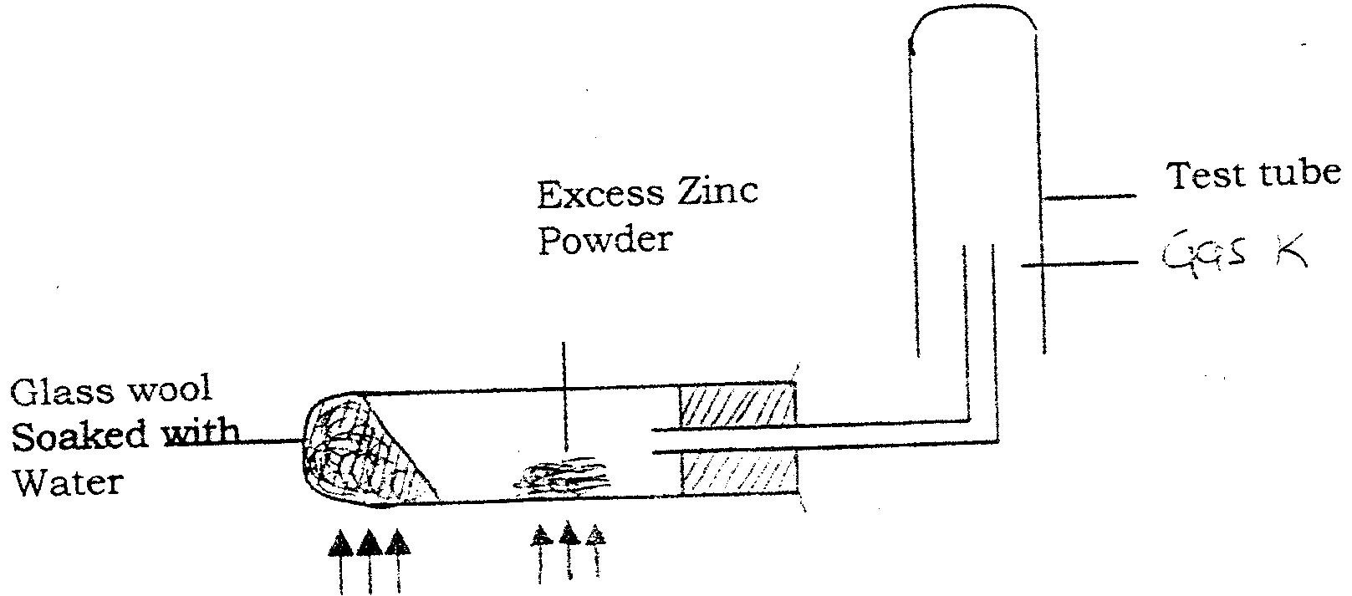
11

The above experiment was carried out to investigate the reaction between steam and zinc metal. Answer the question that follows.
- Why is the wet sand heated?
- To produce steam which will react with zinc metal.

- What would happen if the zinc powder was heated before heating the glass wool?
- Oxygen in air would oxidize zinc to zinc Oxide and no gas/Hydrogen would be produced.
iii) What property of gas K made it possible for it to be collected as shown in the diagram?
- It is less dense than air,
- What was to be observed if steam was passed over hot magnesium ribbon.
- Magnesium burned brightly in steam to form white magnesium oxide powder

- Name gas K – Hydrogen.
- How would you confirm its identity?
- It would burn with a ‘pop’ sound if a burning splint is brought near the mouth of the tube. This confirms beyond any doubts that the gas is hydrogen.

12. (i) How is hydrogen manufactured on a large scale? Give three industrial uses of the gas.
- It is produced as by-product in the cracking of oils.
- In the electrolysis of brine.
- In the action of steam on hydrocarbons such as methane in the presence of nickle catalyst at 800^{0C} to yield water gas. When this gas is treated with more steam, CO₂ and more hydrogen is formed. Then CO₂ is removed by dissolving it in water in pressure.

ii. Three Industrial uses of hydrogen
- Synthesis of Ammonia, hydrogen chloride and methanol.
- In the manufacture of margarine and cooking fats – hydrogenation process.
- In the oxy-hydrogen blow pipe and atomic hydrogen torch, used to produce high temperatures for welding etc.

(iii) Oxygen and nitrogen are obtained from air by fractional distillation. Why can this method be used for this purpose yet cannot be used to obtained hydrogen and oxygen from water?
Air is a mixture which can be separated by physical means – fractional distillation, water is a compound of oxygen and hydrogen and these two can’t be separated by distillation but by a chemical means like electrolysis.

13. You are given a clear liquid in a beaker. Explain how you would confirm that the liquid is pure water.
- A few drops of the liquid are added to white Copper II Sulphate. Which turns blue, showing the presence of water
- The determination of its b.p (100⁰C at sea level) shows that it is pure water. When evaporated to dryness, no residue is left. This also shows that the liquid is pure water.

