**AIR AND COMBUSTION**

* Air is a mixture of many gases which are physically combined and thus can be separated by a physical process/mean.
* Air is a mixture of many gases such as; nitrogen, carbon (IV) oxide, oxygen, water vapour and rare gases.
* Air also contains dust particles, smoke, pollutant gases whose proportion vary from place to place.

**The approximate composition of air components**

|  |  |
| --- | --- |
| **component** | **Percentage composition** |
| Nitrogen  Oxygen  Carbon (iv) oxide  Rare gases  Water vapour | **78.1**  **20.9**  **0.03**  **0.97**  **variable** |

**To determine the percentage of air that supports combustion**

* It can be determined by the following experiments
* Burning of candle in a fixed volume of air
* Burning of copper in a fixed volume of air
* Smouldering of phosphorous
* Rusting process

**Burning of candle in a fixed volume of air**

* Arrange the apparatus as shown below make and record the observation after the experiment.

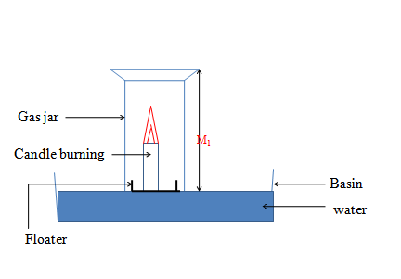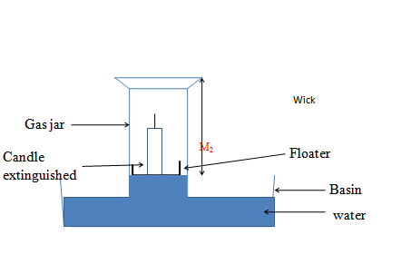

* Candle burns in air. In a closed system(vessel),the candle continues to burn using the part of air that support burning/combustion. This is called the **active part of air**.

The candle goes off when all theactive part of air is used up. The level of the water rises to occupy the space /volume occupied by the usedactive part of air ( a partial vacuum is created in the gas jar).

* Very dilute **sodium/potassium hydroxide** is used instead of water. Dilute Potassium/ sodium hydroxide absorb **Carbon (IV) oxide** gas that come out from burning/combustion of candle stick.
* Following are sample results for a similar experiment.

Height of air column before burning = 16.0cm

Height of air column after burning = 12.9cm

Height of air used during burning = 3.1cm

Percentage of air by volume used up=3.1x 100   
Height of air used 16

* Combustion or burning is a process in which a substance combines with oxygen with the production of heat.
* The part of air that supports combustion is active air. The active part is oxygen, which forms about 20% of dry air by volume.
* The part of air that remains in the gas jar does not support combustion. The component of air that is inactive is mainly nitrogen.
* The experimental result is lower than the theoretical value of the percentage of oxygen in air by volume. This is due to experimental error, which may result from:

i. The sodium hydroxide solution may not absorb all the carbon (IV) oxide gas.

ii. The candle may go off before all the oxygen is used up due to the build-up of carbon (IV) oxide levels.

* Dilute sodium hydroxide is preferably used instead of water to absorb carbon (IV) oxide that was initially in the gas jar and that which is produced during combustion.
* Heating causes expansion of gases therefore the apparatus should be allowed to cool before the final reading is taken.

**What proportion of air is used up when copper is heated in a fixed volume of air?**

* Pack copper turnings in a long hard glass tube.
* Connect the tube with two glass syringes as shown in figure below with one syringe containing a specific volume of air while the other is empty.
* Heat the copper turnings until they are red hot.
* Slowly pass the air from syringe A through the hot turnings to syringe B and back.
* Repeat this process while heating the copper turnings until the new volume of air in syringe A is constant.
* Allow the glass tube to cool and record the volume of the gas in syringe A.
* When copper metal is heated in air, the colour turns from red-brown metal to black. This is because it combines with oxygen to form black copper (II) oxide.

Copper metal + Oxygen Copper (II) oxide

(red-brown solid) (colourless gas) (black solid)

**2Cu(s) + O2(g) 2CuO(s)**

The following are sample results for the experiment:

Volume of air in syringe A before heating = 7.5cm3

Volume of air in syringe A after heating = 6.0cm3

Volume of air used up during heating = 1.5cm3

* About 20% by volume of air is used during combustion and the 80% of air left does not react with heated copper.
* The glass wool plug is used to stop the copper turnings from being sucked into the syringes.
* The air is passed repeatedly over heated copper to ensure that all oxygen in the syringes and tube is used up.
* The air is passed slowly to allow enough time of contact between the reactants.
* The gas left in the syringe does not react with copper. It is mainly nitrogen.
* The possible sources of error in this experiment include:

1. The air initially present in the tube is not accounted for.
2. There is possible leakage of air.
3. Not all the oxygen may have been used up.

**What percentage of air is used when iron filings rust?**

* Sprinkle some iron filings on the wet surface of a gas jar.
* Invert the gas jar in a trough of water.
* Read the volume of air column in the gas jar.
* Leave the set up for 48 hours. Read and record the volume of the air column.
* Record all your observations.

Trough

Gas jar

Damp iron fillings

Water

* The gas jar is made wet to ensure that the iron filings stick onto the wet surface.
* When iron filings are left for 48 hours in the measuring cylinder, a brown coating is formed on the filings.
* The brown coating is rust. Rust is a compound of iron and oxygen.
* During rusting, oxygen is used and therefore water rises up in the gas jar to replace the volume of air used during rusting.
* About 20% of air by volume is used up during rusting.

**Rusting**

Rusting is the corrosion of iron due to its reaction with atmospheric water vapour and oxygen. Rust is a porous material of hydrated iron (III) oxide

Iron + oxygen Iron(III) oxide

Iron (III) oxide + water hydrated Iron(III) oxide

**What are the conditions necessary for rusting?**

* **Water**
* **oxygen**

**Methods of Preventing Rusting**

* Rusting destroys machinery, equipment and roofs made iron. The basis of rust prevention is to keep iron out of direct contact with water and oxygen.
* The following methods are widely used to prevent rusting of iron.

1. Painting e.g. cars, roofs, marine vessels etc.
2. Coating with other metals. This can be done through galvanisation or electroplating.
3. Alloying: This involves the mixing of iron with one or more metals to produce a substance, which does not rust.
4. Oiling and greasing: This method is used in moving engine parts where other methods can not be used due to friction.
5. Sacrificial protection: In this arrangement, a more reactive metal such as zinc or magnesium is attached to the iron structure. The more reactive metal corrodes instead of iron. The method is applied in ships, water and oil pipes

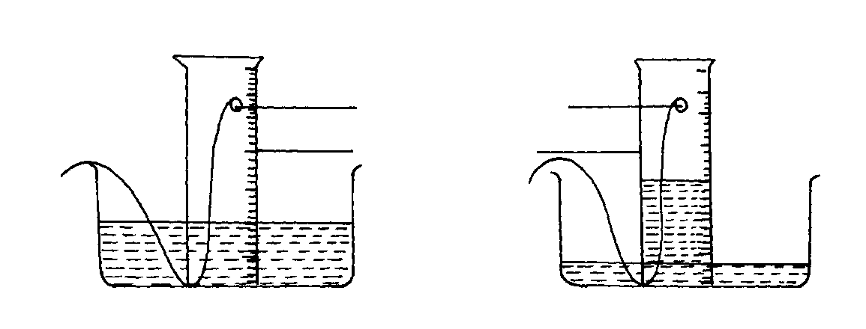**What percentage of air is used when white phosphorus smoulders?**

Phosphorus

Wire gas jar

Water

* Yellow and white phosphorus smoulder in air. This is because phosphorus reacts spontaneously with oxygen to form a mixture of oxides. This explains why phoshorous is stored under water as it does not react with water.

Phosphorous + oxygen phosphorous (III) oxide

Phosphorous + oxygen phosphorous (V) oxide

* The water level rises up the gas jar to occupy the space of oxygen used during smouldering of phosphorous.
* The difference in volume can be used to calculate the percentage of oxygen by volume in air.

**How can the presence of Carbon (IV) oxide in air be established?**

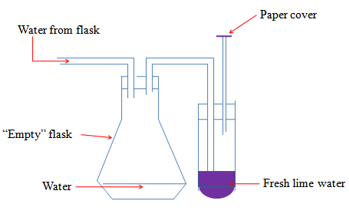

When a stream of air is passed through lime water, a white precipitate forms confirming the presence of carbon IV oxide in air.

* Water is allowed to flow into aspirator A to drive out air and bubble it through the calcium hydroxide solution.
* **What happens when water enters the flask?**

It forces the air from the flask into the lime water.

* **What is observed when the air is bubbled in the lime water**

A white precipitate is formed. The white precipitate dissolves on prolonged bubbling of air.

* **Identify the compound that form:**

1. **lime water**

Calcium hydroxide / Ca(OH)2

1. **white precipitate**

Calcium carbonate/ CaCO3

1. **when the white precipitate dissolves**

Calcium hydrogen carbonate/ CaHCO3

* **Write the chemical equation for the reaction that tale place when:**

**(i) White precipitate is formed**

Calcium hydroxide **+** carbon (IV) oxide Calcium carbonate + water

**Ca(OH)2(aq) + CO2 (g) CaCO3(s) + H2O(l)**

**(ii) White precipitate dissolves**

Calcium carbonate + water **+** carbon (IV) oxide Calcium hydrogen carbonate

**CaCO3(s) + H2O(l) + CO2 (g) CaHCO3(aq)**

* **State the chemical test for the presence of carbon (IV) oxide gas based on above two reactions:**
* Carbon (IV) oxide forms a white precipitate with lime water that dissolves in excess of the gas.
* **State the composition of carbon (IV) oxide gas by volume in the air.**

About 0.03% by volume

**How can the presence of water in air be established?**

* When a stream of air is passed through the U-tube containing white solid Anhydrous calcium chloride, the anhydrous calcium chloride absorbs water vapour from the air and becomes wet. It may form a colourless solution depending on the amount of moisture in the air.
* Anhydrous calcium chloride is said to be deliquescent. Other deliquescent substances are:
* Anhydrous iron (III) chloride
* magnesium chloride
* zinc chloride.

**Fractional Distillation of Liquefied Air**

Air can be separated into its constituent gases by fractional distillation.

AIR

Filter

**Step1**

Sodium hydroxide solution

**Step2 II**

Cool to -25oC

**Step 3 III**

Air compressed and expanded

Process **X**

**Step4**

Ar

-186oC

N2

-196oC

O2

(-183) -196 -186

* The air is first purified by passing it through filters to remove dust.
* The dust-free air is then passed through a solution of concentrated sodium hydroxide to remove carbon (IV) oxide gas.
* The remaining part of air is then cooled to -25°C to remove water vapour, which solidifies out as ice.
* The remaining part of air is then compressed to a pressure of 200 atmospheres and allowed to expand. Repeated compression and expansion of the air cools it to liquid at -200°C.
* The liquid air consists of oxygen, nitrogen and noble gases. These gases have different boiling points and hence are separated by fractional distillation process.
* Liquid oxygen boils at -183°C, nitrogen at -196°C and argon boil at -186°C.
* Nitrogen distils off first followed by argon and lastly oxygen.

**Oxygen**

* Oxygen exists freely in the atmosphere as a gas.
* Its chemical symbol is O.
* Two atoms of oxygen combine to form a molecule with a chemical formula of O2
* Oxygen is also found combined with other elements such as hydrogen in water and metals in metal oxides.
* It is the most active component in air.

**How is oxygen prepared in the laboratory?**

* Prepared in the laboratory by decomposition hydrogen peroxide. Hydrogen peroxide decomposes slowly to produce oxygen and water under normal conditions.
* Manganese (IV) oxide is added in small amount to speed up the rate of decomposition and thus it acts as a catalyst.

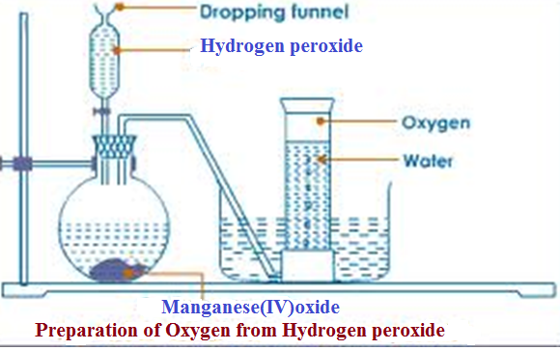

Hydrogen peroxide Water + Oxygen

2H2O2 (aq) 2H2O (l) + O2 (g)

Qn/

1. **What is observed when the hydrogen peroxide is added into the flask**

Rapid effervescence/bubbling/fizzing

1. **Describe the colour and smell of the gas**

Colourless and odourless.

**3. (a)Name the method of gas collection used.**

**-**Over water

-Down ward displacement of water

**(b)What property of Oxygen makes it to be collected using the method above**

-Slightly soluble in water

**4. What is the purpose of manganese (IV) oxide?**

Manganese (IV) oxide is **catalyst**.

* A catalyst is a substance that speeds up the rate of a chemical reaction but remain chemically unchanged at the end of the reaction.

**5. Write the equation for the reaction.**

2H2O2 (aq) 2H2O (l) + O2 (g)

**6. Lower a glowing splint slowly into a gas jar containing Oxygen gas. State what is observed.**

The glowing splint relights/rekindles

Oxygen relights/rekindles a glowing splint. This is the confirmatory test for the presence of Oxygen gas

* The first few bubbles of oxygen are not collectedbecause the gas is mixed with air which was originally in the flask.

**Physical properties of oxygen**

* Oxygen is a colourless, odourless gas
* Has a low boiling point of -183°C.
* It is slightly soluble in water and so it can be collected over water.
* Oxygen relights a glowing splint. This is the test for oxygen.
* Oxygen can also be prepared in the laboratory by:

1. Adding water to Solid Sodium Peroxide

Sodium peroxide + water Sodium hydroxide + Oxygen

**2Na2O2 (aq) + 2H2O (l) 4NaOH(aq) + O2 (g)**

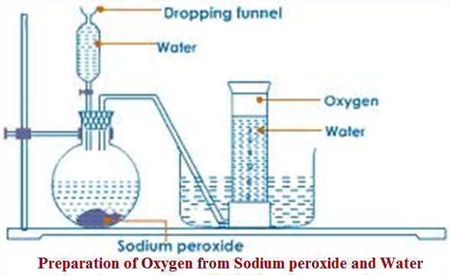

**Burning of Substances in Air**

* Many metals bum in air and in oxygen at different rates. They bum faster in oxygen than in air. Nitrogen is the component of air, which slows down the rate of burning. When metals bum in oxygen they form metal oxides.

Sodium + Oxygen sodium oxide

**4Na(s) + O2(g) 2Na2O(s)**

**Na2O(s) + H2O (l) 2NaOH(aq)**

Magnesium + Oxygen Magnesium oxide

**2Mg(s) + O2(g) 2MgO(s)**

Reactive metals such as sodium, calcium and magnesium react with nitrogen in the air to form nitrides.

Sodium + Nitrogen Sodium nitride

Calcium + Nitrogen Calcium nitride

Magnesium + Nitrogen Magnesium nitride

3Mg(s) + N2(g) Mg3N2 (s)

**When the nitrides react with water, ammonia gas is given out.**

Sodium nitride + Water Sodium hydroxide + Ammonia

Magnesium nitride + Water Magnesium hydroxide + Ammonia

**Mg3N2 (s) + 6H2O (l) 3Mg (OH)2 (aq) + 2NH3(g)**

* The reactions in which elements combine with oxygen are referred to as oxidation.
* The substance to which the oxygen is added is said to have been oxidised.
* The metals can be arranged in order of their rates of reaction with oxygen from the most reactive to the least reactive. This arrangement is referred to as a reactivity series of metals.
* Mercury, silver and gold are less reactive than copper and are not easily oxidised.

**The following is part of the Reactivity Series for some metals.**

Potassium

Sodium

Calcium

Magnesium

Aluminium

Zinc

Iron

Lead

Copper

Mercury

Silver

* When magnesium is burned in a closed crucible, most of oxygen inside is consumed. It is therefore necessary to allow air in so that burning can continue. The mass of the product is m than the original mass of magnesium. This shows that as it burn magnesium combines with air to form a new product.
* When substances bum in air, they combine with oxygen to fort* oxides. If the product is a solid there is increase in mass. When the product is gaseous there is decrease in mass. The decrease in mass is because the products, being gaseous escape into the air.

**Reaction of non-metals with oxygen**

* Most **non metals** burns in Oxygen/air to form an Oxide which when dissolved in water are **acidic** in nature. They turn blue litmus red.e.g. Carbon(IV)oxide/CO2 , Nitrogen(IV)oxide/ NO2 , Sulphur (IV)oxide/ SO2
* **Some non metals** burn in Oxygen/air to form an Oxide which in solution / dissolved in water is **neutral** in nature. e.g.

Carbon (II) oxide/CO, Water/ H2O.

**Carbon**

* Carbon burns in air and faster in Oxygen with a blue non-sooty flame forming Carbon (IV) oxide gas.
* Carbon burns in limited supply of air with a blue non-sooty flame forming Carbon (IV) oxide gas.
* Carbon (IV) oxide gas dissolves in water to form weak acidic solution of Carbonic (IV) acid.

Carbon + Oxygen Carbon (IV) oxide

(excess)

**C(s) + O2(g) CO2(g)**

Carbon + Oxygen Carbon (II) oxide

(limited)

**2C(s) + O2(g) 2CO(g)**

Carbon(IV)oxide + Water Carbonic(IV)acid

**CO2(g) + H2O (l) H2CO3 (aq)**

**Sulphur**

* Sulphur burns in air and faster in Oxygen with a blue non-sooty flame forming Sulphur (IV) oxide gas.
* Sulphur (IV) oxide gas dissolve in water to form weak acidic solution of Sulphuric (IV)acid.

Sulphur + Oxygen Sulphur(IV)oxide

**S(s) + O2(g) SO2(g)**

Sulphur (IV) oxide +Water Sulphuric (IV)acid

**SO2(g) + H2O (l) H2SO3 (aq)**

**Phosphorus**

* Phosphorus is stored in water. On exposure to air it instantaneously fumes then catch fire to burn in air and faster in Oxygen with a **yellow** flame producing dense white acidic fumes of Phosphorus (V) oxide gas.
* Phosphoric (V) oxide gas dissolves in water to form weak acidic solution of Phosphoric (V) acid.

Phosphorus + Oxygen Phosphorous (V) oxide

**4P(s) + 5O2(g) 2P2O5(s)**

Phosphorous (V) oxide + Water Phosphoric (V) acid

**P2O5(s) + 3H2O (l) 2H3PO4 (aq)**

**How do elements compete for combined oxygen?**

* Magnesium combines with oxygen more readily than copper. Therefore, magnesium removes combined oxygen in copper (II) oxide to form magnesium oxide.
* Copper is said to have been displaced by magnesium. Copper on the other hand does not remove combined oxygen from the oxides of magnesium, lead, zinc and iron.
* This is due to the fact that copper reacts with oxygen less readily than these metals. It is the least reactive.
* A more reactive metal removes combined oxygen from a metal oxide of a less reactive metal. More reactive metals displace less reactive metals from their oxides.
* Removal of oxygen from a substance is called reduction. When a metal oxide loses oxygen, it is said to have been reduced. The metal, which gains oxygen is said to have been oxidised.

**zinc + Copper (II) oxide zinc oxide + Copper**

In the above equation, zinc is oxidised while copper oxide is reduced. Both reduction and oxidation take place simultaneously.

A metal/element with higher affinity for oxygen is placed higher/on top of the one less affinity.

**The complete reactivity series of metals/elements**

Most reactive

|  |  |
| --- | --- |
| **Element/Metal** | **Symbol** |
| Potassium | K |
| Sodium | Na |
| Calcium | Ca |
| Magnesium | Mg |
| Aluminium | Al |
| **Carbon** | **C** |
| **Zinc** | **Zn** |
| **Iron** | **Fe** |
| **Tin** | **Sn** |
| **Lead** | **Pb** |
| **Hydrogen** | **H** |
| **Copper** | **Cu** |
| **Mercury** | **Hg** |
| **Silver** | **Ag** |
| **Gold** | **Au** |
| **Platinum** | **Pt**  **Least reactive** |

**Examples of redox reactions**

1. **Reaction of magnesium and copper (II) oxide**

* Magnesium is higher in the reactivity series than Copper. It has therefore higher affinity for Oxygen than copper.
* When a mixture of copper (II) oxide and Magnesium is heated, Magnesium reduces copper (II) oxide to brown copper metal and itself oxidized to Magnesium oxide. Magnesium is the reducing agent because it undergoes oxidation process. Copper (II) oxide is the oxidizing agent because it undergoes reduction process.
* The mixture should be cooled before opening the lid to prevent **hot** brown copper from being **re-oxidized** back to black copper (II) oxide.
* The reaction of Magnesium and Copper (II) oxide is a reaction

Reduction process

Oxidation process

Copper (II)oxide + Magnesium Magnesium oxide + Copper

(black) (white ash/solid) (brown)

**CuO(s) + Mg(s) MgO(s) + Cu(s)**

(Oxidizing Agent) (Reducing Agent)

1. Zinc (II)oxide + Magnesium Magnesium oxide + Zinc

(yellow when hot) (white ash/solid) (grey)

**ZnO(s) + Mg(s) MgO(s) + Zn(s)**

(Oxidizing agent) (Reducing agent)

1. Zinc (II)oxide + Carbon Carbon(IV) oxide gas + Zinc

(yellow when hot) (grey)

**ZnO(s) + C(s) CO2(g) + Zn(s)**

(Oxidizing agent) (Reducing agent)

Application

* The extraction of metals from their ores uses the concept of reduction. The ores that contain the metal oxides are reduced by more reactive metals. For example, Aluminium is used to reduce iron (III) oxide by the thermite process.

Carbon, a non-metal can remove combined oxygen from some metal oxides such as iron (III) oxide and copper (II) oxide.

**Carbon + Copper (II) oxide Carbon (IV) oxide I Copper**

The ability of carbon to reduce some metal oxides is applied in the extraction of metals such as copper and zinc from their ores.

Atmospheric Pollution

Human activities have changed the composition of air in some places.

* Gases such as carbon (IV) oxide, carbon (II) oxide, sulphur (IV) oxide and phosphorous (V) oxide, are examples of harmful substances emitted into the atmosphere mainly from the combustion of fossil fuels.
* These gases **cause pollution** of the atmosphere. For example, sulphur (IV) oxide dissolves in rain water and is converted to sulphurous acid**, which forms acid rain**

**Revision questions.**

1. **What is air?**

A – Air is a mixture of many gases such as N2 – 78%, O2 – 21%, 0.03%, and Noble gases 1%.

Water vapour, polluting gases and dust and smoke.

1. **Describe an experiment to show that Carbon dioxide is available in the atmosphere.**

Air in Air sucked out

Lime water

**Procedure**

Suck air through the apparatus as shown above for about five minutes. Make your observation as the sucking continues.

**Observation**

As the sucking of the air continues, lime water is found to turn milk as more air passes through it.

**Conclusion**

It is only Carbon dioxide that turns lime water milky or forms white precipitate of calcium carbonate.

Ca(OH)2(aq) + CO2(g) CaCO3(s) + H2O(l)

1. **Study the experiment below and answer this questions that follow.**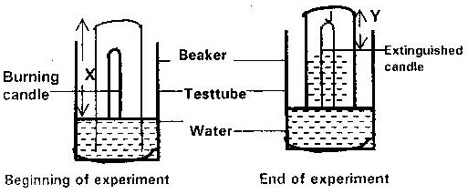

**a) Explain what would be observed if red and blue litmus papers were dipped into the**

* After burning of the candle the NaOH(aq) level in the jar rose and the candle went off.

1. **Why do you think the solution level rose inside the gas jar, filling only a part of it?**

The solution inside the gas jar rose to take up the space which was occupied by the active part of air.

1. **Why did the candle go out after burning only for a while?**

The candle went out because in a fixed amount of air only a part of it was used up called the ‘active air’ with the rest ‘Inactive air’ which doesn’t support combustion.

All oxygen was used up

1. **Why is there an increase in mass when a metal like magnesium is burned in air?**

* When magnesium is burned in air, it chemically combines with oxygen gas to form a compound called magnesium oxide which is heavier than the metal i.e. the white ash is heavier than the original piece of magnesium.

Thus when an element is heated or burnt in air, it combines with oxygen from air and gains in weight.

1. **(i) What is rust?**

Ans – Is hydrated Iron III Oxide (Fe2O3.XH2O)

**(ii) What are the conditions necessary for rusting?**

– Iron

1. Water

- Oxygen

**iii. List some methods used to prevent rusting.**

1. Painting - Chromium plating
2. Electroplating - Alloying
3. Galvanization -Anodizing
4. Oiling and greasing in plating
5. **On what basis are the methods used above designed?**

The methods for preventing rusting are based on the fact that Iron needs to be kept out of contact with air and water.

1. **What gases are a common pollutant in the atmosphere.**

Ans

* Sulphur dioxide
* Nitrogen chloride Gases
* Carbon monoxide

-Solids Solid particles – produced by inefficient combustion of fuels.

Smoke, consists of carbon, tar, salts.

These particles are very small and so, they can enter the lungs and be retained there.

* This promotes respiratory problems and increase the risk of lung cancer.

1. **What appropriate measures are being taken to reduce atmospheric pollution?**

Ans

1. Improvement of combustion of fuel in petrol and diesel engine.
2. Introduction of better processing of fuels to make them free from sulphur compounds.

(iii) Introduction of better and more efficient filter systems in industries.

(iv) Introduction of smokeless solid fuels or fuels like hydrogen.

1. **Write down a chemical equation to show how oxygen is prepared in the lab.**

(i) 2H2O2 MnO2 2H2O(l) + O2

(ii) 2KclO3(s) MnO2 2KCl(s) + O2(g)

1. **List the properties of oxygen gas.**

**Physical**

* Colourless & odourless & tasteless
* It is slightly denser than air
* It is slightly soluble in water
* BP – 1830C

**Chemical properties**

* Neutral to litmus
* Relights a glowing splint but doesn’t burn (test for oxygen) i.e. It isn’t combustible
* It forms oxides with metals and non-metals.

1. **What is the role of manganese (IV) oxide in the preparation of oxygen gas?**

* It simply speeds up the rate of decomposition of hydrogen peroxide to yield oxygen. Hence it is a catalyst.

1. **Fill the table below stating what happens in each column when elements are burnt in oxygen.**

|  |  |  |  |
| --- | --- | --- | --- |
| **Element** | **How it burns oxygen** | **Product** | **Colour of product in Litmus solution** |
| Sodium | Bright Golden yellow flame | Na2O2 | Blue |
| Sulphur | Bright blue flame | SO2 | Red |
| Phosphorus | White flame | P2O5 | Red |
| Carbon | Red glow | CO2 | Red |
| Iron | Yellow sparks | FeO | - |
| Magnesium | Bright white flame | MgO | Blue |
| Copper | Blue flame | CuO | - |
| Calcium | Bright red flame | CaO | Blue |

1. **Distinguish between acidic and basic oxides.**

* Acidic oxides are oxides of non-metals which dissolve in water to form acidic solutions while basic oxides are those of metals of which some dissolve in water to form alkaline solution which turn red litmus paper blue. It is important to note that not all basic oxides dissolve in water.

1. **An experiment on competition for oxygen was carried out and results were tabulated in the table below. Use information in the table to answer the questions that follow.**

|  |  |  |  |  |  |  |
| --- | --- | --- | --- | --- | --- | --- |
| Oxide  Element | MgO | CO2 | CuO | PbO | ZnO | Fe2O3 |
| Magnesium | No reaction | MgO + C | MgO + Cu | MgO + Pb | MgO + Zinc | MgO + Fe |
| Carbon | No reaction | CO | CO2 + Cu | CO2 + Pb | CO2 + Zn | CO2 + Fe |
| Lead | No reaction | No reaction | PbO + Cu | No reaction | No reaction | No reaction |
| Zinc | No reaction | No reaction | ZnO + Cu | ZnO + Pb | No reaction | ZnO + Fe |
| Iron | No reaction | No reaction | Fe2O3 + Cu | Fe2O3 + Pb | No reaction | No reaction |

1. **What is the best conclusion that can be drawn on the basis of the above results?**

* More active elements take oxygen from the less active ones.

1. **What is the order of reactivity of elements in this experiment?**

Mg

C Increasing

Zn reactivity

Pb

Fe

1. **What are the products formed where a reaction occurred?**

* An oxide of the more reactive element and the element of the less reactive of the two.

1. **If you were given an oxide copper how would you obtain copper metal from it?**

* I would simply heat the copper oxide with an element carbon to obtain the brown copper metal after reduction.

2CuO(s) + C(s) 2Cu(s) + CO(2) (g)

1. **List six commercial uses of oxygen.**

* Mixed with acetylene to form oxy-acetylene flame; used for cutting and welding of metals
* Mixed with hydrogen to form oxy-hydrogen flame; used for cutting and welding of metals
* Used in hospitals as an aid to patients with breathing difficult.
* Fuel – liquid oxygen is used to burn the fuel in some space rockets.
* Explosives – liquid oxygen mixed with charcoal and petrol is used as explosive in mines.

1. **Give the name of a metallic oxide (different in each case) which?**
2. On heating yields oxygen and a lower oxide of the same metal.

KMnO4

1. Is yellow when hot and white when cold.

ZnO

1. Is easily converted to a metal on heating.

HgO

1. Does not dissolve in water but a base.

Fe2O3 / CuO etc

1. Dissolve in water to form an alkali – Na2 O, CaO
2. **Pollution is a health hazard which is directly proportional to the level of industrialisation in developing countries. Give evidence to justify this proclamation.**

**The following are sources of pollutants.**

1. Exhaust gases and dust from industries such as; paper, sugar and cement industries.
2. Exhaust emissions from motor vehicles.
3. Some activities in the “Jua kali” industry such as burning tyres to get wires and threads.
4. Nuclear reactors have become an important source of energy. But radiation from nuclear stations can pose a great danger to the environment as was seen during the Chernobyl nuclear reaction disaster of 1986 in USSR.
5. Aerosols such as insecticides and perfume sprays containing chlorofluorocarbons (cfc) used as propellants. The CFC’s are gradually accumulating in the atmosphere and it has been proven that they react with the ozone layer depleting it. This means that man likely to be exposed to harmful radiations from the sun.
6. **What is water of crystallization.**
7. **Where is the competition for oxygen reaction applied industrially?**

* This type of reaction is applied in the extraction of some metal e.g. Lead, Iron, Zinc and Copper are below carbon in the activity series or are less reactive than carbon. These metal therefore are obtained by reducing their heated oxides with carbon (coke) or carbon monoxide.

1. **Carbon dioxide doesn’t support combustion, yet burning of magnesium ribbon introduced in jar of carbon dioxide continues to burn. Explain this, giving the chemical equation involved.**

* When a burning magnesium is introduced into a gas jar containing carbondioxide, the intense heat burning magnesium produces, decomposes the carbondioxide gas into carbon and oxygen. This oxygen now supports the continuous burning of magnesium.

2Mg(s) + CO2 C(s) + 2MgO(s)

Black white

specks solid

**Prediction questions**

1. In an experiment, a piece of magnesium ribbon was cleaned with steel wool. 2.4g of

the clean magnesium ribbon was placed in a crucible and completely burnt in oxygen.

After cooling the product weighed 4.0g

a) Explain why it is necessary to clean magnesium ribbon

b) What observation was made in the crucible after burning magnesium ribbon?

c) Why was there an increase in mass?

d) Write an equation for the major chemical reaction which took place in the crucible

e) The product in the crucible was shaken with water and filtered. State and explain the

observation which was made when red and blue litmus paper were dropped into the filtrate

2. In an experiment a gas jar containing some damp iron fillings was inverted in a water trough containing some water as shown in the diagram below. The set-up was left un-disturbed for three days. Study it and answer the questions that follow:

Water Trough

Inverted gas jar

Damp iron fillings

Water

(a) Why were the iron filings moistened?

b) State and explain the observation made after three days.

(c) State **two** conclusions made from the experiment.

d) Draw a labelled set-up of apparatus for the laboratory preparation of oxygen using

Sodium Peroxide

(e) State t**wo** uses of oxygen

3. In an experiment, a piece of magnesium ribbon was cleaned with steel wool. 2.4g of the clean magnesium ribbon was placed in a crucible and completely burnt in oxygen. After cooling the product weighed 4.0g

a) Explain why it is necessary to clean magnesium ribbon

b) What observation was made in the crucible after burning magnesium ribbon?

c) Why was there an increase in mass?

d) Write an equation for the major chemical reaction which took place in the crucible

e) The product in the crucible was shaken with water and filtered. State and explain the

observation which was made when red and blue litmus paper were dropped into the filtrate

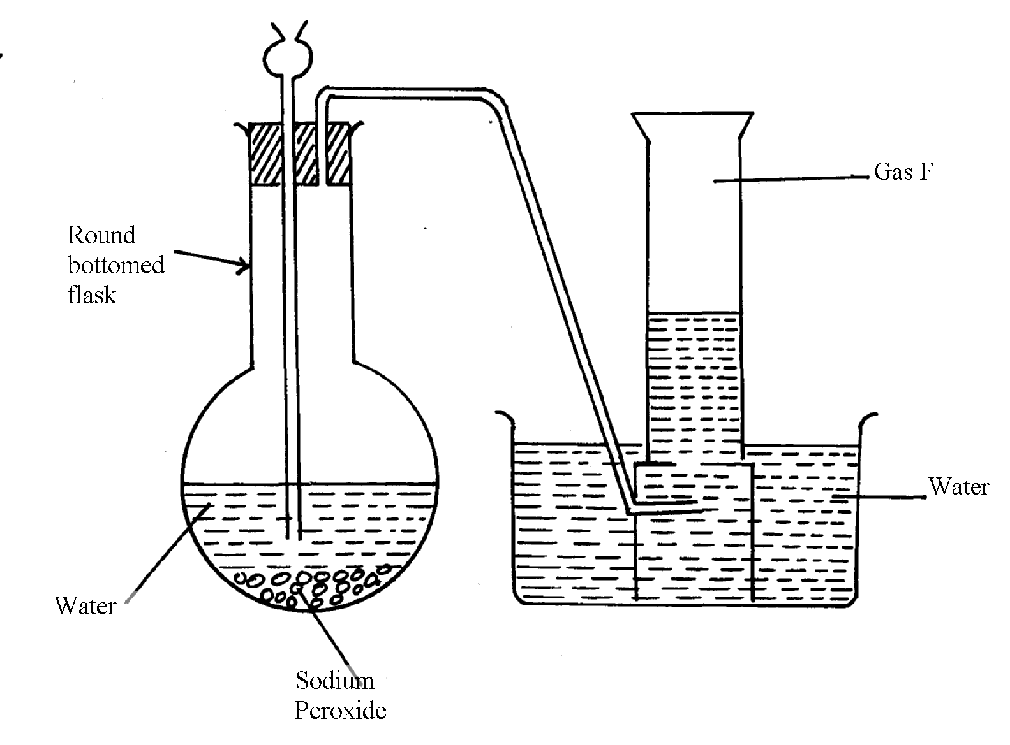**4. The set-up below was used to collect gas F produced by the reaction between sodium** peroxide and water

(i) Name gas **F**……………………………………………………………………………

(ii) At the end of the experiment, the solution in the round bottomed flask was found to be

a strong base. Explain why this was so

(iii) Which property of gas **F** makes it be collected by the method used in the set-up?

(iv) Give **one** industrial use of gas **F**

**5 . The set-up below was used to investigate properties of the components of air:**

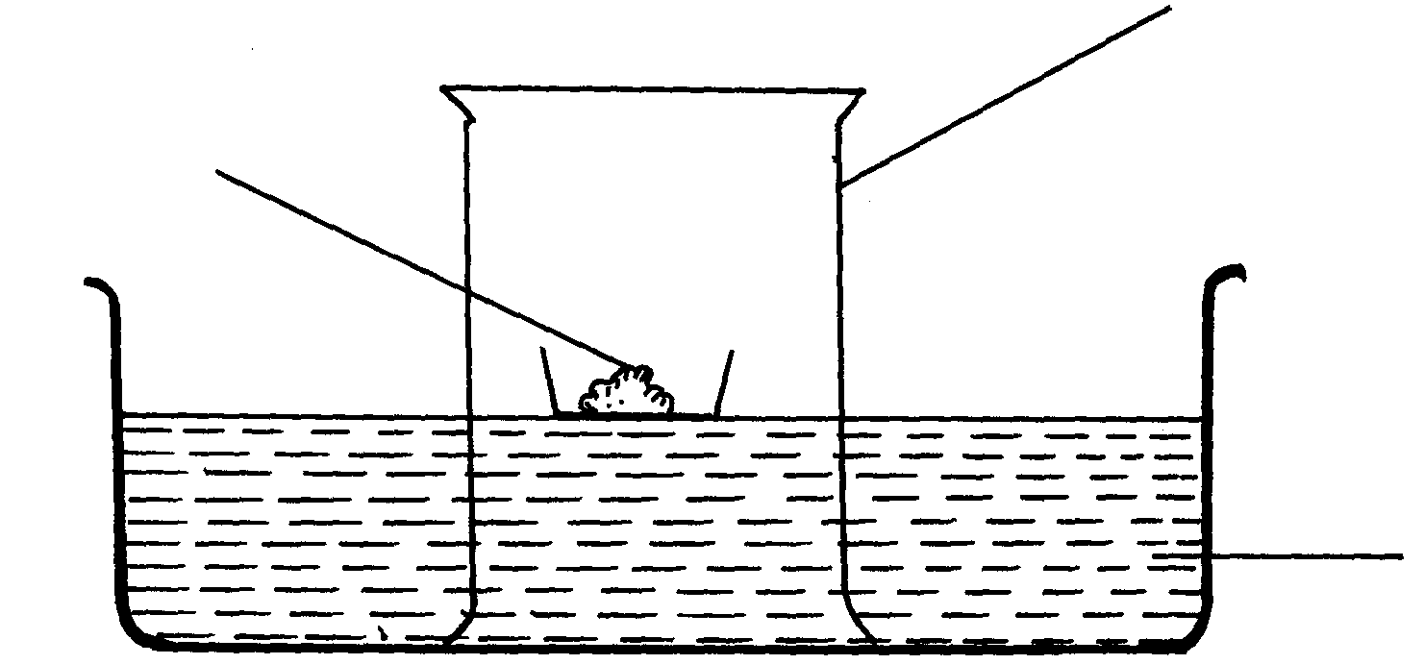

Phosphorous

Gas jar

Water

(i) State **two** observations made during the experiment

(ii) Write **two** chemical equations for the reactions which occurred

(iii) The experiment was repeated using burning magnesium in place of phosphorous.

There was greater rise of water than in the first case. Explain this observation

(iv) After the two experiments, the water in each trough was tested using blue and red litmus papers. State and explain the observations of each case.

(a) Phosphorous experiment

b) magnesium experiment

(v) Briefly explain how a sample of nitrogen gas can be isolated from air in the laboratory

6. (a) A group of students burnt a piece of Mg ribbon in air and its ash collected in a Petri dish.

The ash was found to comprise of magnesium Oxide and Magnesium nitride

(i) Write an equation for the reaction leading to formation of the magnesium nitride

(ii) A little water was added to the products in the Petri dish. State and explain the

observation made.

(iii) A piece of blue litmus paper was dipped into the solution formed in (b) above.

State the observation made.

**7. A form one class carried out an experiment to determine the active part of air. The diagram below shows the set-up of the experiment and also the observation made.**

(i) At the beginning (ii) observation at the end of the experiment

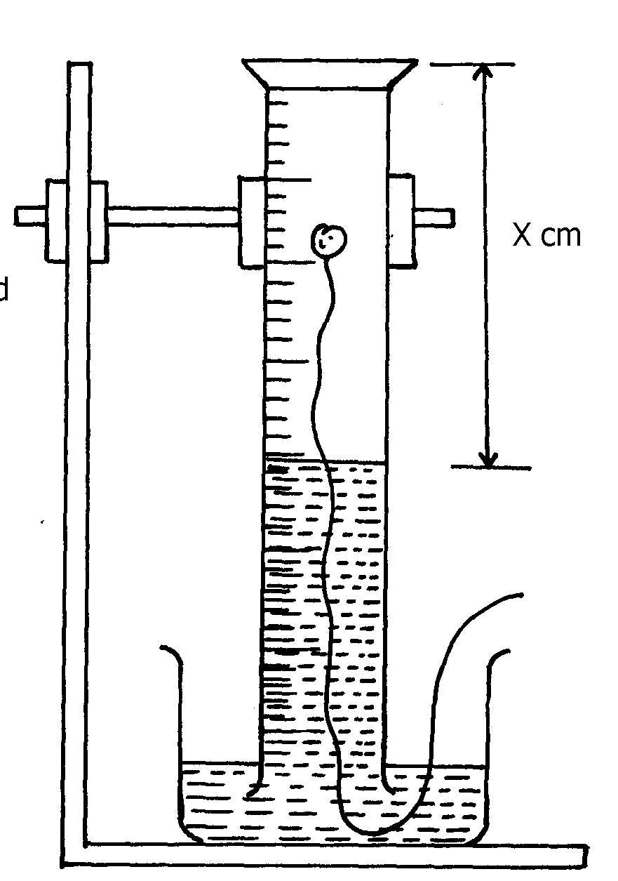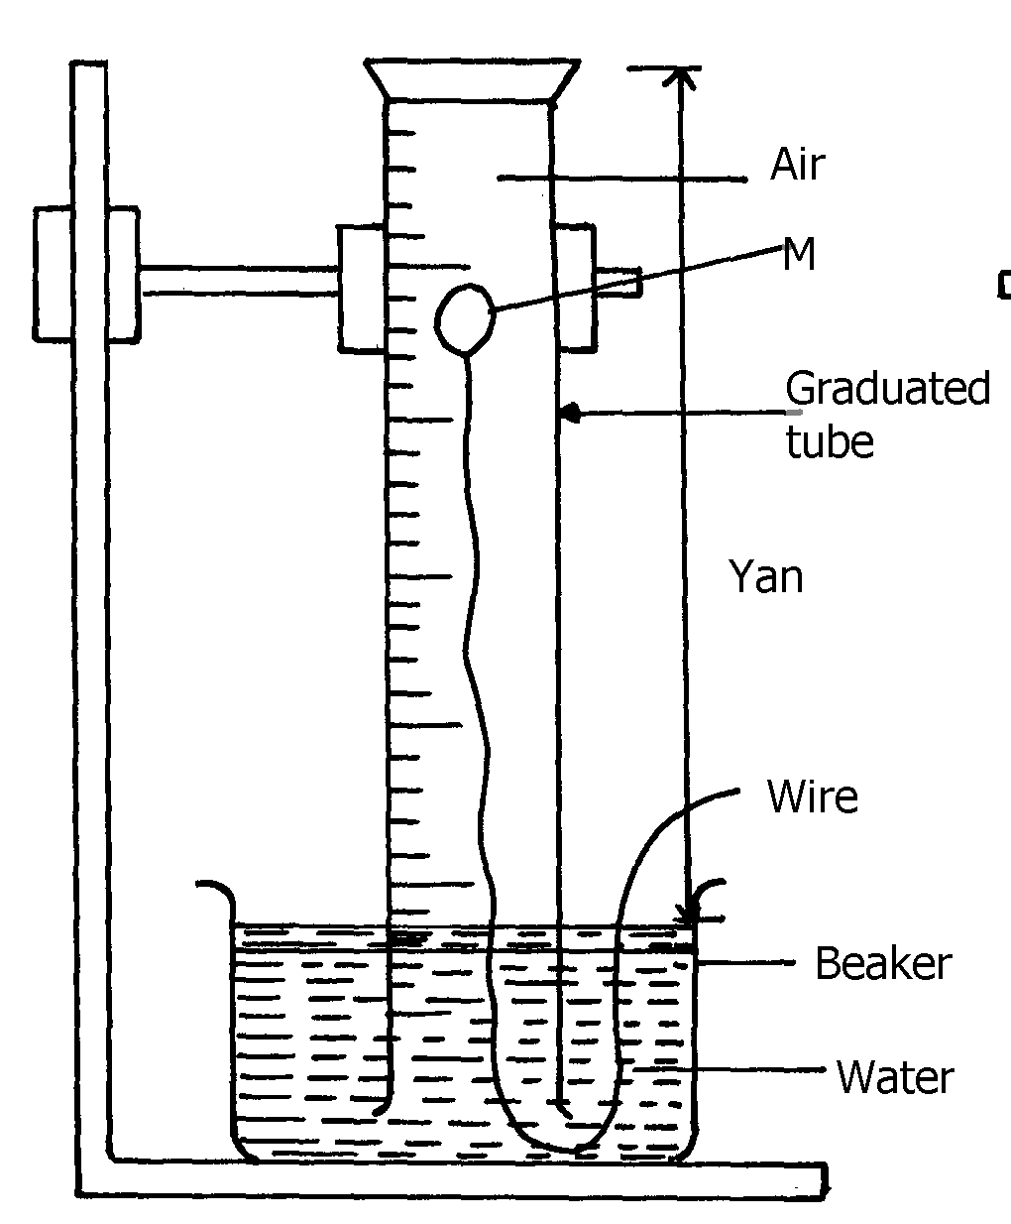

Air

id **A**

(a) (i) Identify substance **M** .

(ii) State **two** reasons for the suitability of substance **M** for this experiment

(b) Write the equation for the reaction of substance **M** and the active part of air

(c) (i) Using the letters **Y** and **X** write an expression for the percentage of the active part of air

(ii) The expression in **(c)(i)** above gives lower value than the expected. Explain

(d) (i) Explain the observation made when litmus paper is dipped into the beaker at the end of the experiment

(ii) Name the active part of air

(iii) Suggest another method that can be used to determine the active part of air

**8. A piece of phosphorous was burnt in excess air. The product obtained was shaken with a small amount of hot water to make a solution**

i) Write an equation for the burning of phosphorus in excess air

ii) The solution obtained in (b) above as found to have pH of 2. Give reasons for this

observation

**9. Study the set-up below and answer the questions that follow:-**

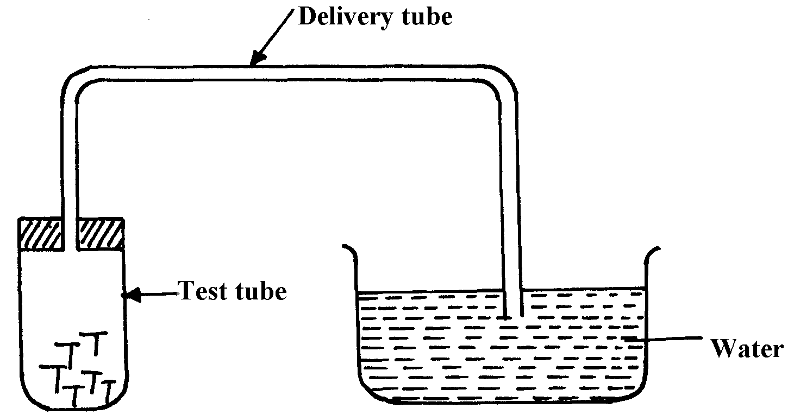

**Iron nails**

(a) State **two** observations that would be made after one week. Explain

(b) Write the equation of the reaction taking place in the test-tube

**10. Fe3O4 and FeO are oxides of iron which can be produced in the laboratory**

(a) Write chemical equation for the reaction which can be used to produce each of the oxides

(b) Wire an ionic equation for the reaction between the oxide, Fe3O4 and a dilute acid.

**11. Below is a list of oxides.**

MgO, N2O, K2O, CaO ans Al2O3

Select:-

a) A neutral oxide.

b) A highly water soluble basic oxide.

c) An oxide which can react with both sodium hydroxide solution and dilute hydrochloric acid.

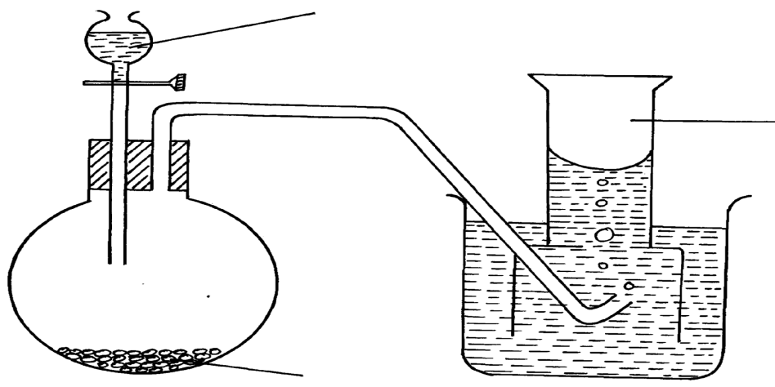**12. The diagram below shows students set-up for the preparation and collection of oxygen** **gas**

X

Oxygen gas

Sodium peroxide

(a) Name substance **X** used

(b) Write an equation to show the reaction of sodium peroxide with the substance named in **(a)**

**Answers to prediction questions**

***1.a) To remove any magnesium oxide coating from the surface of magnesium// To remove an oxide film on it***

***b) White solid which is magnesium oxide***

***c) Increase in mass was due to oxygen which combined with magnesium***

***d) 2Mg(s) + O2(g)  2MgO(s)***

***Penalize ½ for wrong or missing state symbols***

***e) The filtrate is magnesium hydroxide which is an alkaline***

***Red litmus paper changed blue, but blue litmus paper remained blue***

***2. (a) So that they may stick to the gas Jar to prevent them from falling into water when the***

***gas jar is inverted***

***(b) Iron filings turned to reddish brown because they reacted with oxygen in presence of moisture to form rust.***

***The level of water inside the gas jar rise so as to occupy the volume initially occupied***

***by part of air used up for rusting***

***(c) - Air is made up of two parts; - the active part that is necessary for rusting and the inactive part that is not used for rustinng - oxygen is the active part of air***

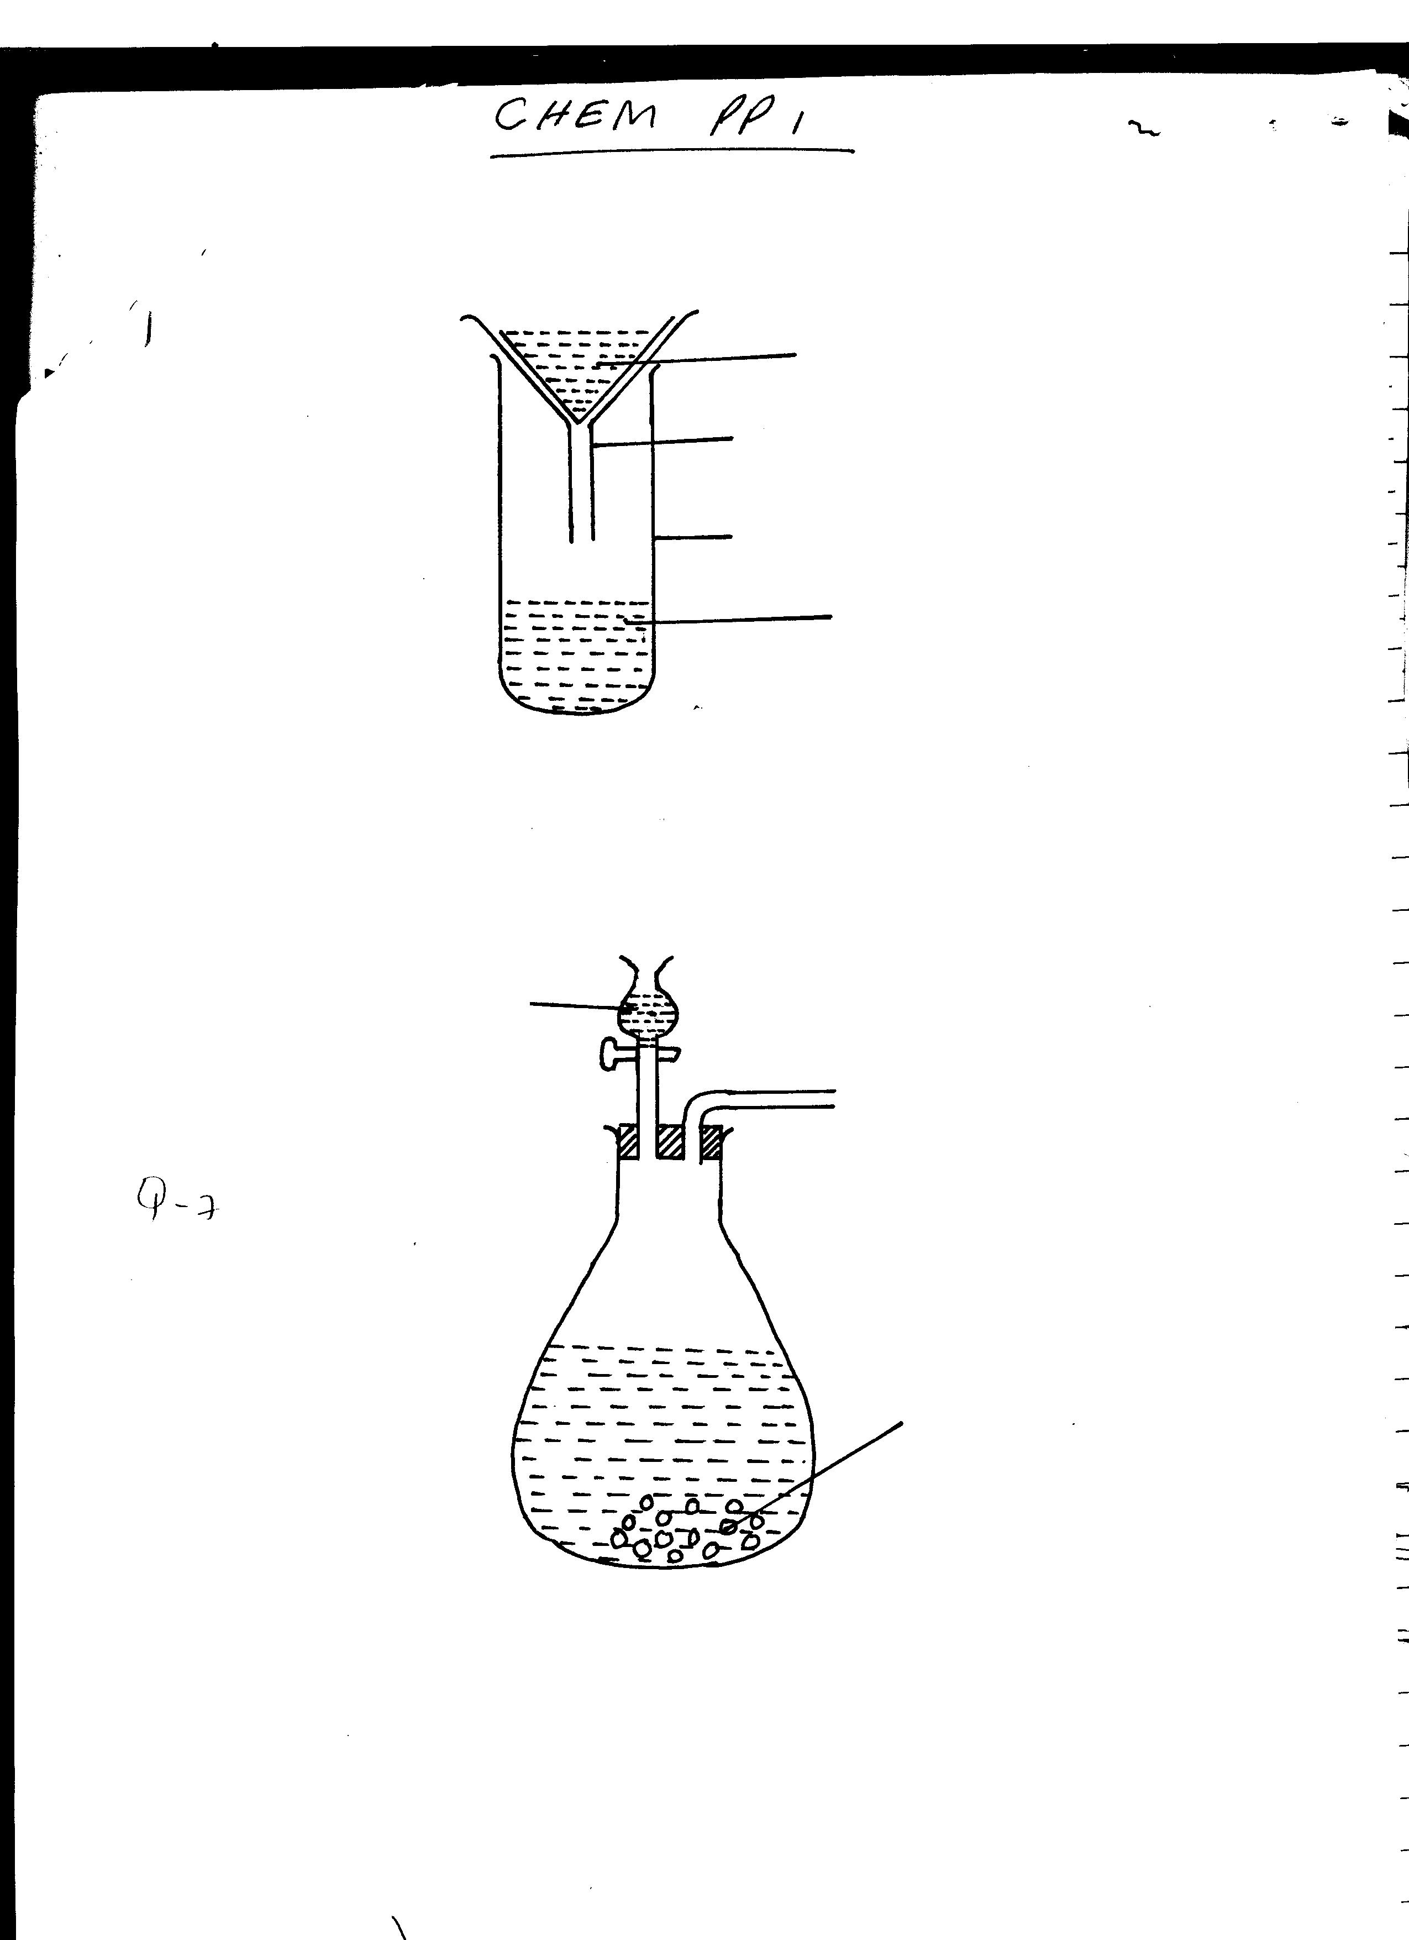

Waterr

Sodium Peroxide

Oxygen

***(d)***

***- Neat diagram-***

***- correct method of collection***

***3. a) To remove any magnesium oxide coating from the surface of magnesium// To remove any oxide film on it***

***b) White solid which is magnesium oxide***

***c) Increase in mass was due to oxygen which combined with magnesium***

***d) 2Mg(s) + O2(g) 2MgO(s)***

***Penalize ½ for wrong or missing state symbols***

***e) The filtrate is magnesium hydroxide which is an alkaline***

***Red litmus paper changed blue, but blue litmus paper remained blue***

***4. (i) Oxygen***

***(ii) Sodium hydroxide is a strong base***

***(iii) Slightly soluble in water***

***5. (i) White fumes form in the gas jar which disappear after sometime.***

***- The level of water rises in the gas jar.***

***(ii) P(s) + O2(g)  P2O5(s)***

***P2O(s) + 3H2O(l) 2H4PO4(aq)***

***(iii) Magnesium react with oxygen and nitrogen hence greater of fraction of air is used.***

***(iv) (a) Blue litmus changed to red as remained red. The solution was acid due to phosphoric***

***(b) Red litmus changed to blue as blue remained blue due to formation of basic magnesium hydroxide ammonia solution.***

***(v) – Pass air over conc. KOH / NaOH to absorb CO2***

***- Pass the remaining gases over hot copper solid which reacts with oxygen.***

***- Collect the remaining gas over water. The gas is mainly nitrogen.***

***6. a) i) 3Mg(s) + N2(g) Mg3N2(s) √1***

***ii) Gas with√1 choking irritating smell.***

***Mg3N2 reacts with water to form ammonia √1 gas.***

***iii) It remains blue. √½ Ammonia gas is alkaline. √½***

***7. (a) (i) Phosphorous***

***(ii) - Do not react with water when being inserted into the tube***

***- reacts with oxygen when exposed to air.***

***(b) 4P(s) + 3O2(g)  2P2O3(s)***

***or 4P(s) + SO2(g) 2P2O5(s)***

***(c) (i) Y – X x 100***

***y***

***(ii) – Wrong reading of volume***

***- Phosphorous can go off before complete combustion***

***(d) (i) – Red litmus paper no effect***

***- Blue litmus paper turns red due to formation of phosphoric acid/phosphorous (V) Oxide whish is an acidic oxide***

***(ii) – Oxygen***

***(iii) – Burning of candle***

***- Use of pyrogallol***

***- Rusting of iron fillings***

***8. i) P4(g) + 5O2(g)  2P2O5(s)***

***// P4(s) + 3O2(g) 2P2O3(g)  Anyone √ 1 mark***

***ii) Phosphorous (v) or (iii) oxide formed is an acidic Oxide which dissolves in water to***

***form a strong acidic solution of phosphoric acid whose PH is 2***

***9. (a) – Iron nails turns brown.***

🗸 ½

***- Water rises up the delivery tube/water level drops in the trough ( any ½mk)***

***Explanation: Oxygen has been used up in rusting of iron nails hence water rises up to take the place of oxygen***

🗸 1

***(b) 4Fe(s) + 3O2(g) + 2H2O(l) 2Fe2O3.2H2O(s)***

***(accept a balanced chemical equation)***

***10. a) FeCO3 (s) Fe O(s) + CO2(g)***

***Fe(s) + 4 H2O(g) Fe O4 (s) + 4H2 (g)***

***Or***

***2 Fe(s) + 202(g) Fe3 O4(s)***

***b) Fe3O4(s) + 8H+ (aq) 4H2O (l) + 2 Fe3+(aq) + Fe2+(aq)***

***11. a) N2O 1 (Nitrogen (I) oxide) – Denitrogen Oxide.***

***b) K2O 1 (Potassium oxide)***

***c) Al2O3 (Aluminium oxide)***

***12. a) water √1***

***b) 2Na2O2(S) + 2H2O (L)  4NaOH (aq) + O2(g) √1 mk***

***Penalize ½ - wrong missing state symbols***