**END TERM ONE, 2022**

**FORM 3 EXAM AGRICULTURE PAPER 2**

**NAME:………………………………………….ADMNO:………….CLASS: ………….**

**SECTION A (30 marks)**

*Answer all questions from this section*

1. State any four signs of parturition shown by a cow (2mks)

2) State the uses of the following tools and equipments (4mks).

(a)Secateurs

(b)Sickle

(c)Bolus gun

(d)Strip cup

3) State four maintenance practices carried out on a wheelbarrow (2mks).

4) Name the breed of rabbit which is white with one or more of the ears, paws or tail being black (1mk).

5) State four conditions considered in citing an apiary (2mks)

6) State four properties of a good vaccine (2mks)

7) State any four disadvantages of natural mating in livestock production (2mks)

8) Outline four roles played by proteins in livestock nutrition (2mks)

9) State any four benefits of steaming up in livestock (2mks)

10) Name four reasons for castrating male calves (2mks)

11) Name any four dairy breeds of goats (2mks)

12) List any four farm structures that are necessary for handling dairy animals (2mks)

13) Give four reasons why young rams should be docked (2mks)

14) State two roles of a drone bee (1mk)

15) Give two advantages of using wood in construction of farm buildings (2mks)

**SECTION B (20 MARKS)**

***Answer all questions from this section***

16. Below is a diagram illustrating a type of a hive

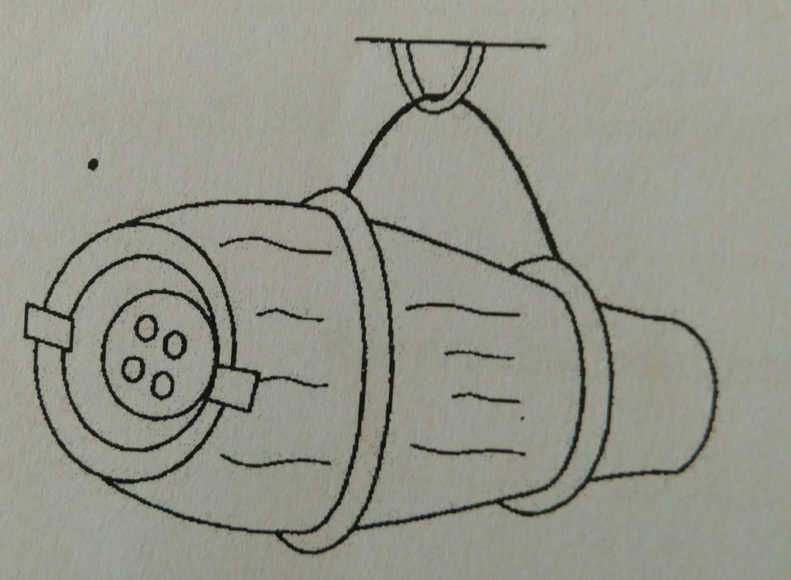

1. Identify the type of hive illustrated above(1mk)

b) Why is it necessary to keep it in a slanting position (1mk?)

1. State one disadvantage of the hive above (1mk)
2. Name any other two types of bee hives ( 1mk)
3. List down four factors causing the swarming of bees (2mks)
4. Name one type of disease affecting bees (2mks)

17. The diagrams below represent some farm tools and equipment

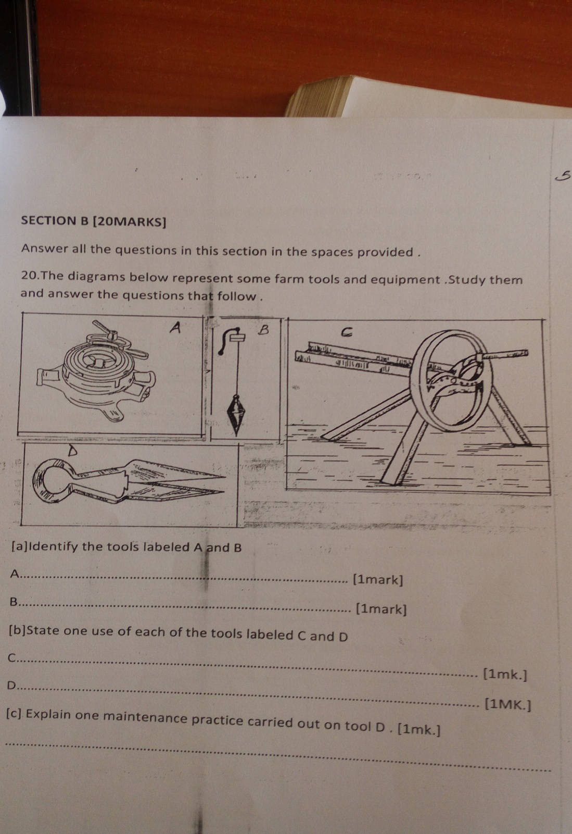

1. Identify the tools (2mks)
2. State the use of each of the tools labeled C and D (2mks)
3. State one maintenance practice carried out on tool D (1MK)
4. A ration containing 20% DCP is to be prepared the available maize contains 7% DCP and fish meal 62% DCP. Calculate using Pearson square method, the amount in kgs required to prepare 100 kg of the feed (5mks)
5. Apart from Pearson square method, name any other method that can be used to prepare rations (1mk)

19. The diagram below shows a certain practice carried on pigs.

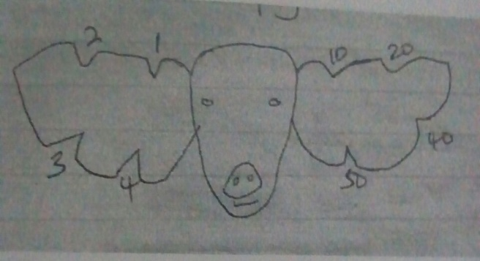

1. Identify the practice (1mk)
2. Name the tool used to carry out the practice above (1mk)

c) State any other two methods of identifying piglets (1mk)

**SECTION C (40marks)**

*Answer any two questions from this section*

20a) Describe six signs of furrowing in a sow (6mks)

1. Explain six benefits of the Kenya Top bar hive ( 6mks)
2. describe 8 factors considered when citing farm structures (8mks)

21. a) Describe five reasons for maintaining farm tools and equipments (5mks)

b) State five differences between ruminants and non-ruminants (5mks)

1. Describe the various methods of treating timber for construction (10mks)

22. a) Discuss five human factors influencing agriculture (10mks)

b) Explain any five post harvest practices on cereal crops (10mks)