**END TERM 1 EXAM, 2022**

**FORM THREE AGRICULTURE PAPER 1**

**NAME: …………………………………….……ADM NO: …….. CLASS: ……….**

**SECTION A (30 MARKS)**

***Answer all Questions in this section***

1. Give four advantages of practicing crop rotation (2mks)
2. Name any four records that should be kept by a poultry farmer (2mks)
3. Give two areas of study that make agriculture to be regarded as a science (1mk)
4. A farmer has the option of growing either wheat or maize in his one hectare of land. Wheat gives a return of sh 20000 while maize gives a return of sh.35000. What will be the opportunity cost? (1mk)
5. State any two conditions under which opportunity cost is zero
6. Give two practices that are commonly used in hardening seedlings in a nursery of kales (1mk)
7. Outline four advantages of tissue culture (2mks)
8. Name any four farming practices aimed at minimum tillage (2mks)
9. Outline four factors that determine the depth of planting (2mks)
10. State three factors that determine the quality of compost manure (1 ½mks)
11. Distinguish between under sowing and over sowing as used in pasture establishment (1mk)
12. State two disadvantages of shifting cultivation (1mk)
13. Name any four methods of treating seeds before planting (2mks)
14. Give four reasons why seeds may be preferred in crop propagation (2mks)
15. Differentiate between soil structure and soil texture (1mk)
16. State four reasons why burning of fields is discouraged in crop production (2mks)
17. Name three diseases that attack cabbage (1 ½ mks)
18. State four characteristics that make a crop suitable for green manure (2mks)
19. State four different types of irrigation that can be used by farmers (2mks)

**SECTION B (20 MARKS)**

***Answer all questions***

1. The diagram below illustrates some soil structures. Study it and answer the questions that follow.

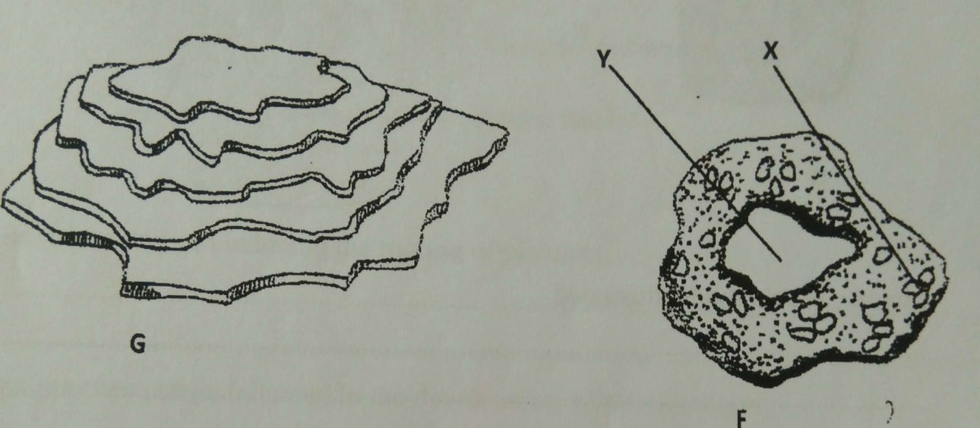

1. Identify the soil structures F and G (2mks)
2. Name the parts labeled X and Y in diagram F (1mk)
3. Sate two ways through which structure G influences crop production (2mks)
4. The diagram below illustrates a type of fruit. Study nit and answer the questions that follow.

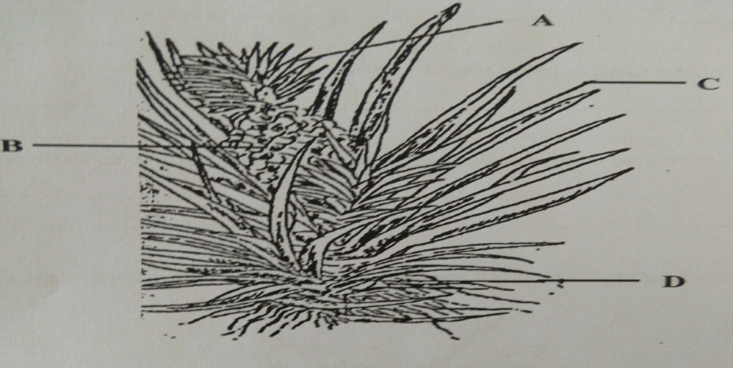

1. Identify the fruit (1mk)
2. Name the parts A-D ((4mks)
3. Name two crops propagated by the part labeled D (1MK)
4. The diagram below shows a method of layering. Study it and answer questions that follow

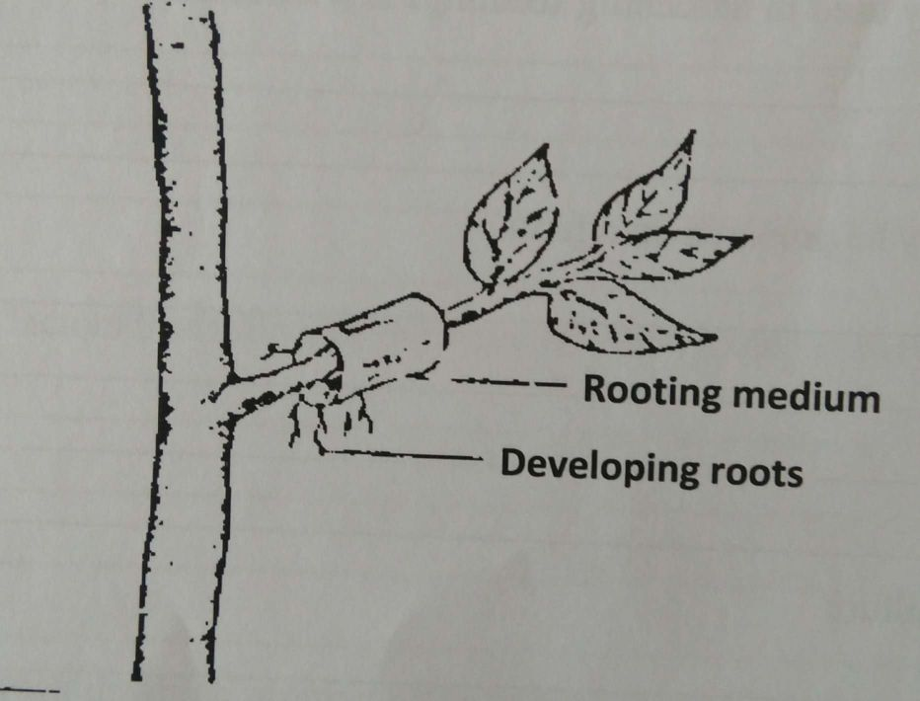

1. Identify the method of layering illustrated above (1mk)
2. State one circumstance in which this method of layering is recommended (1mk)
3. A maize farmer was advised to apply 150 kg CAN per hectare while topdressing the maize crop. CAN contains 21%N. calculate the amount of Nitrogen applied per hectare. (3mks)
4. The diagram below shows a seedling attacked by a certain pest.

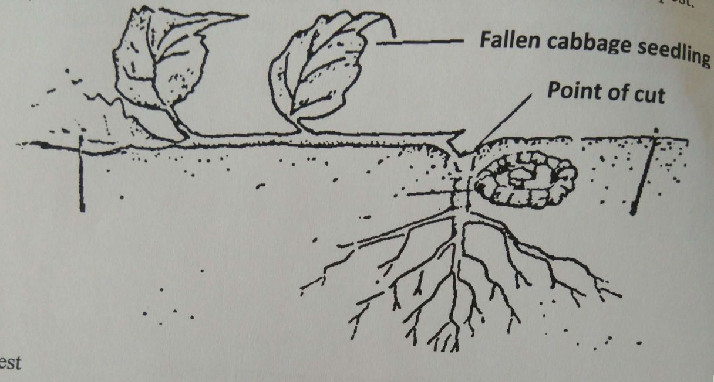

1. Identify the pest (1mk)
2. Name any two types of vegetable crops likely to be attacked by the pests (2mks)
3. State two methods of controlling the above pest (2mks)

**SECTION C (40 marks)**

***Choose any two questions from this section***

1. a)Outline the effects of wind on agricultural products (11mks)

b) Briefly mention the importance of soil organic matter (9mks)

26. a) Describe the advantages of using seeds as planting materials (5mks)

1. Give reasons for raising vegetable seedling through a nursery (5mks)
2. Outline the process of chemical water treatment for use in the farm (10mks)
3. a) Explain five factors that determine spacing to be used in crops (10mks)

b) Describe six management practices carried out on a nursery bed (6mks)

c) Explain four advantages of grafting (4mks)