**Name: …………………………………………………...............…… Adm no ……..….......... Class.................**

**231/1**

**BIOLOGY FORM THREE**

**END OF TERM ONE**

**TIME: 2 HOURS**

**INSTRUCTIONS TO CANDIDATES:**

* *Answer* ***ALL*** *the questions*
* *Answers should be written in the spaces provided*

1. (a) What is the formula of calculating linear magnification of a specimen when using a hand lens? (1mk)

(b) Give a reason why staining is necessary when preparing specimens for observation under the microscope (1mk)

..............………………………………………………………………………………………………...……………………………………………………………………………………………..….

1. State two functions of Golgi apparatus. (2mks)

..............………………………………………………………………………………………………...……………………………………………………………………………………………..….

..............………………………………………………………………………………………………...……………………………………………………………………………………………..….

3. State the importance of the following processes that take place in the nephrons of a human kidney

(1mk)

..............………………………………………………………………………………………………...……………………………………………………………………………………………..….

4. (a) Name a disease of the liver whose symptom is jaundice (1mk)

..............………………………………………………………………………………………………...……………………………………………………………………………………………..….

(b) State the causative agent of:

(i) Cholera (1mk)

..............………………………………………………………………………………………………...……………………………………………………………………………………………..….

(ii) Amoebic dysentry (1mk)

..............……………………………………………………………………………………………

5. The diagram below shows a section through a plant organ

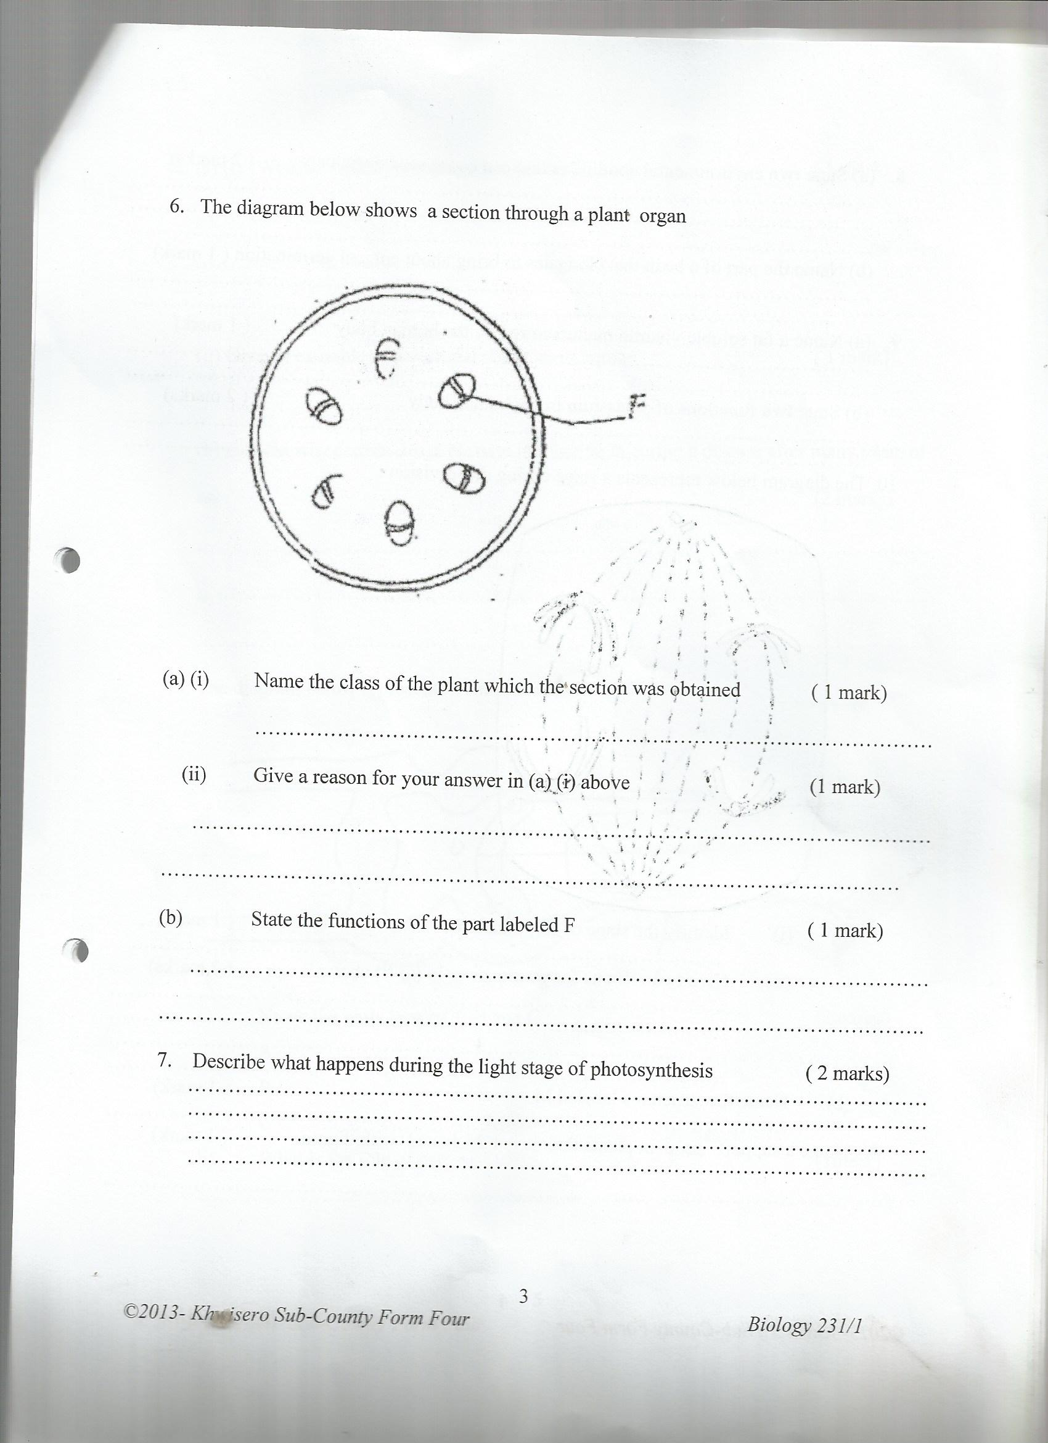

**F**

(i) Name the class of the plant which the section was obtained (1mk)

..............………………………………………………………………………………………………...……………………………………………………………………………………………..….

(ii) Give a reason for your answer in (a) (i) above (1mk)

..............………………………………………………………………………………………………...……………………………………………………………………………………………..….

iii) State the functions of the part labeled F (1mk)

..............………………………………………………………………………………………………...……………………………………………………………………………………………..….

6. Describe what happens during the light stage of photosynthesis (2mks)

..............………………………………………………………………………………………………...……………………………………………………………………………………………..….

..............………………………………………………………………………………………………...……………………………………………………………………………………………..….

7. Name a support tissue in plants that is not thickened with lignin (1mk)

..............………………………………………………………………………………………………...……………………………………………………………………………………………..….

8. (a) In which part of the cell do the following stages of respiration take place. (2mks)

(i) Glycolysis.........................................................................................................................

(ii) Kreb’s Cycle ....................................................................................................................

(b) In which of the two stages above is most energy produced? (1mk)

..............………………………………………………………………………………………………...……………………………………………………………………………………………..….

9. Explain why drug addicts are prone to HIV infection. (2mks)

..............………………………………………………………………………………………………...……………………………………………………………………………………………..….

..............………………………………………………………………………………………………...……………………………………………………………………………………………..….

10. (a) (i)A man’s urine gave positive reaction with Benedict’s solution. Name the disease he was suffering from. (1mk)

..............………………………………………………………………………………………………...……………………………………………………………………………………………..….

(ii)State **two** ways in which the symptoms of the condition in (a) above can be controlled. (2mks)

..............………………………………………………………………………………………………...……………………………………………………………………………………………..….

(b) Name the hormones involved in regulating glucose level in blood. (2mks)

..............………………………………………………………………………………………………...……………………………………………………………………………………………..…...............……………………………………………………………………

11. (a) Name **two** structures for gaseous exchange in aquatic plants. (2mks)

..............………………………………………………………………………………………………...……………………………………………………………………………………………..…. ..............……………………………………………………………………………………………

(b) What is the effect of contraction of the diaphragm muscles during breathing in mammals? (3mks)

..............………………………………………………………………………………………………...……………………………………………………………………………………………..….

..............………………………………………………………………………………………………...……………………………………………………………………………………………..….

12. An experiment was set up in the experiment as shown below.

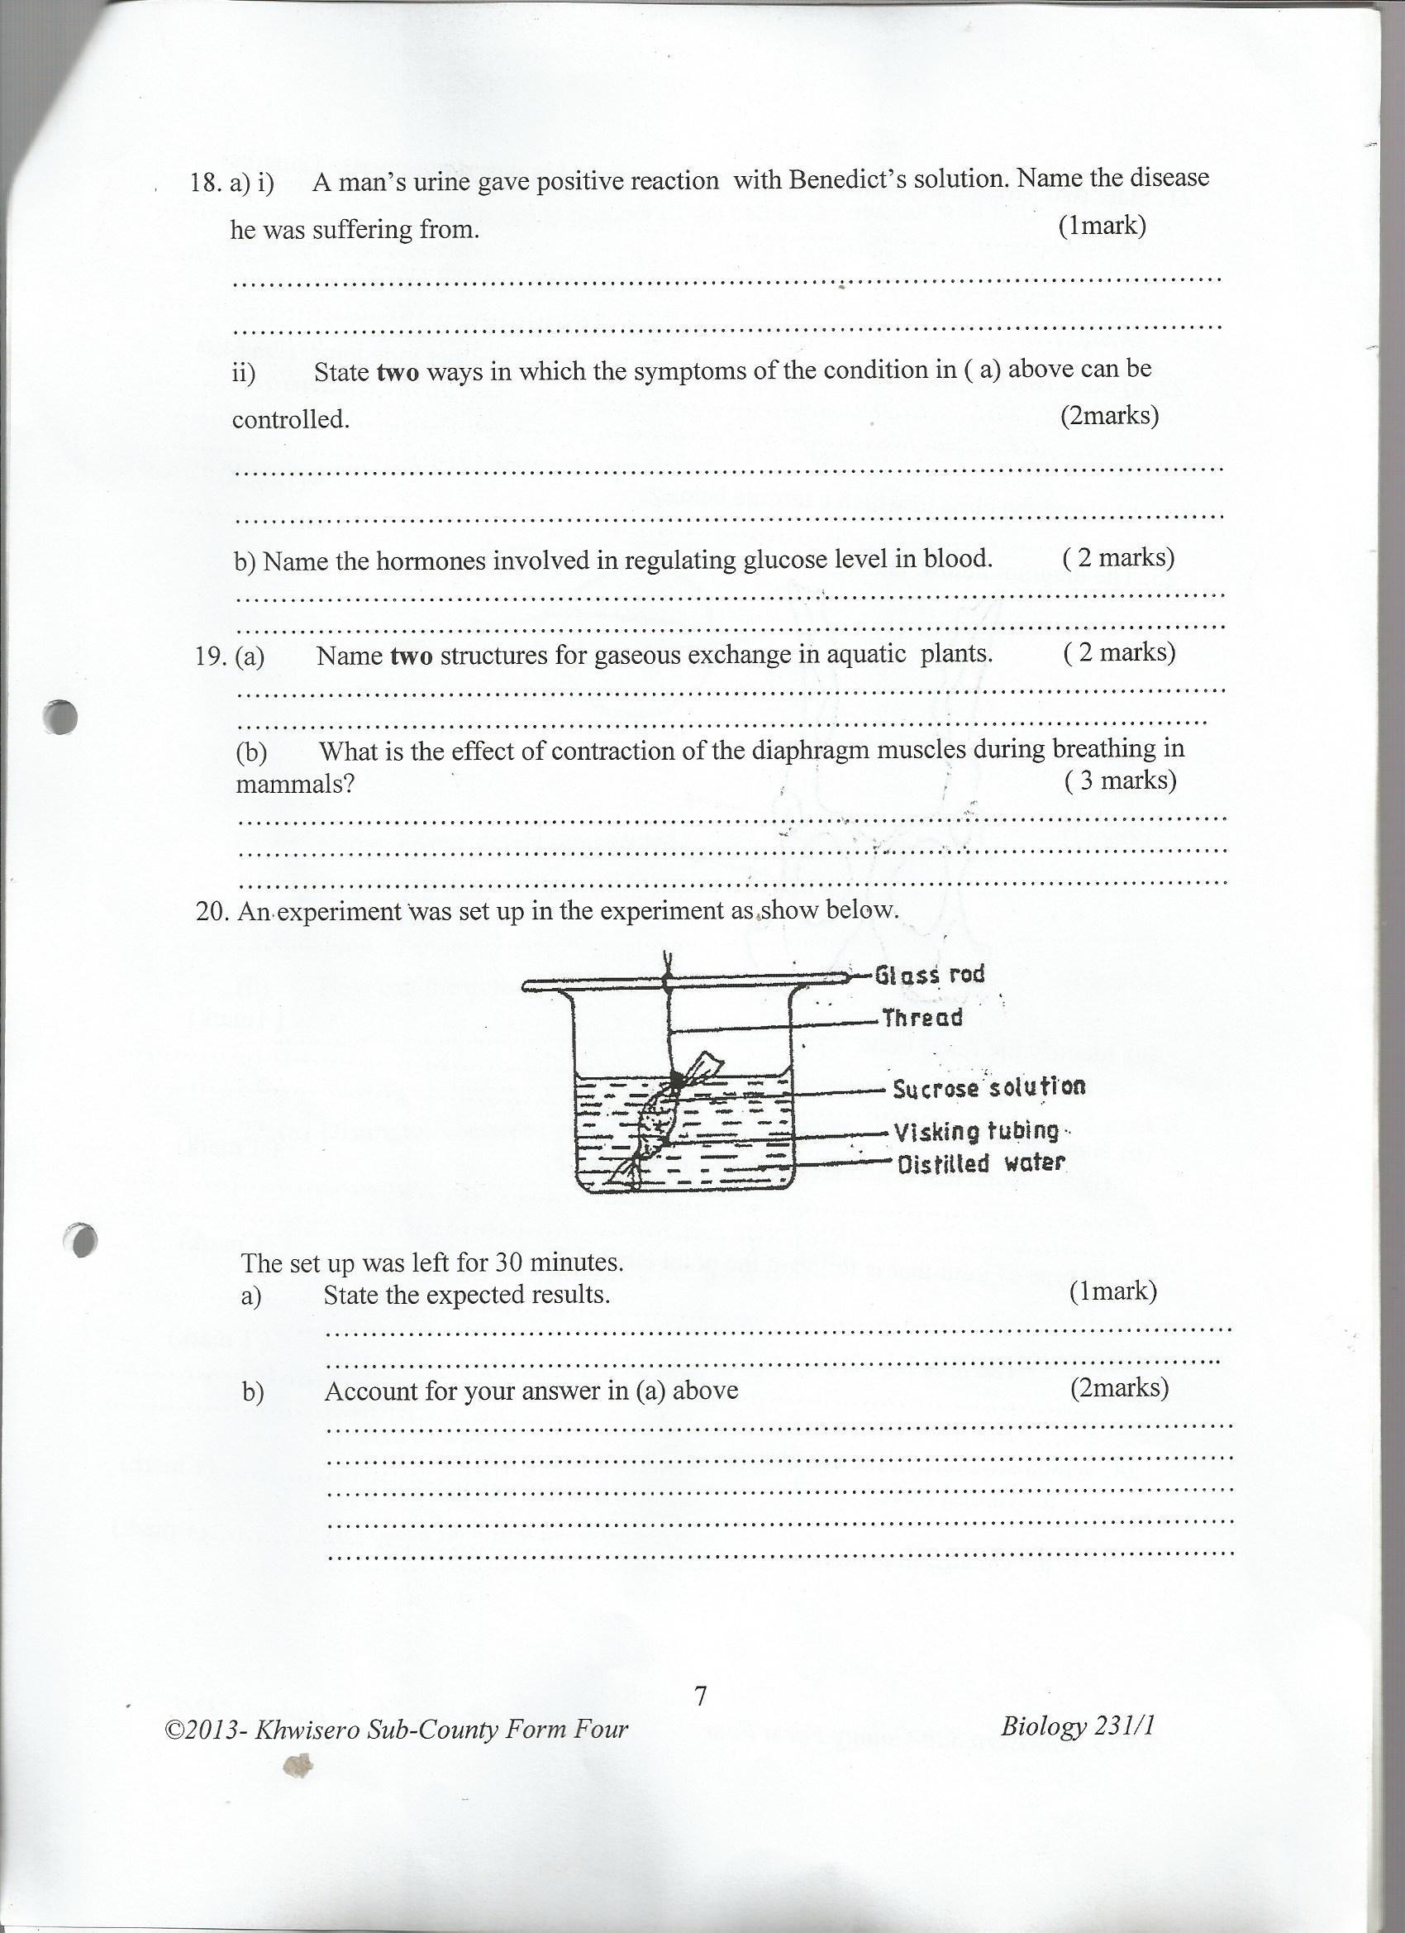

The set up was left for 30 minutes. State the expected results. (1mk)

..............………………………………………………………………………………………………...……………………………………………………………………………………………..….

b) Account for your answer in (a) above (2mks)

..............………………………………………………………………………………………………...……………………………………………………………………………………………..….

..............………………………………………………………………………………………………...……………………………………………………………………………………………..….

13. State **two** structural modifications of nephrons found in desert mammals (2mks)

..............………………………………………………………………………………………………...……………………………………………………………………………………………..….

..............……………………………………………………………………………………………

14.(a) State **two** characteristics of Monera that are not found in other kingdoms (2mks)

..............………………………………………………………………………………………………...……………………………………………………………………………………………..….

..............……………………………………………………………………………………………

(b) Name the class to which a termite belongs (1mk)

..............………………………………………………………………………………………………...……………………………………………………………………………………………..….

15. (a) Distinguish between population and community (2mks)

..............………………………………………………………………………………………………...……………………………………………………………………………………………..….

..............……………………………………………………………………………………………

(b) Name the method that can be used to estimate the population size of the following organisms

(i) Fish in a pond .............................................................................................................(1mk)

(ii) Black jack in a garden ................................................................................................(1mk)

16. Explain how an increase in temperature affects the rate of active transport. (2 marks)

..............………………………………………………………………………………………………...……………………………………………………………………………………………..….

..............………………………………………………………………………………………………...……………………………………………………………………………………………..….

17. Give the synthesis role of smooth endoplasmic reticulum. (1 mark)

..............………………………………………………………………………………………………...……………………………………………………………………………………………..….

18. State **two** functions of bile juice in the digestion of food. (2 marks)

..............………………………………………………………………………………………………...……………………………………………………………………………………………..….

..............……………………………………………………………………………………………

19. Name the features that increase the surface area of small intestines (2 marks)

..............………………………………………………………………………………………………...……………………………………………………………………………………………..….

..............……………………………………………………………………………………………

20. Explain what happens when there is oxygen debt in human muscles (2 marks)

..............………………………………………………………………………………………………...……………………………………………………………………………………………..….

..............………………………………………………………………………………………………...……………………………………………………………………………………………..….

21. State **two** ways in which the root hairs are adapted to their function (2 marks)

..............………………………………………………………………………………………………...……………………………………………………………………………………………..….

..............……………………………………………………………………………………………

22. Name **two** factors that affect transpiration and absorption at any given time (2 marks)

..............………………………………………………………………………………………………...……………………………………………………………………………………………..….

..............……………………………………………………………………………………………

23. State **two** functions of blood in a human body. (2 marks)

..............………………………………………………………………………………………………...……………………………………………………………………………………………..….

..............……………………………………………………………………………………………

24. State **two** differences between open and closed circulatory systems (2 marks)

..............………………………………………………………………………………………………...……………………………………………………………………………………………..….

..............……………………………………………………………………………………………

25. State **two** ways in which the leaf is suited to gaseous exchange (2 marks)

..............………………………………………………………………………………………………...……………………………………………………………………………………………..….

..............………………………………………………………………………………………………...……………………………………………………………………………………………..….

26. State **four** ways in which respiratory surfaces are suited to their function. (4 marks)

..............………………………………………………………………………………………………...……………………………………………………………………………………………..….

..............………………………………………………………………………………………………...……………………………………………………………………………………………..….

27. What are the **three** end products of anaerobic respiration in plants (3 marks)

..............………………………………………………………………………………………………...……………………………………………………………………………………………..….

..............………………………………………………………………………………………………...……………………………………………………………………………………………..….

28. What is oxygen debt? (1 mark)

..............………………………………………………………………………………………………...……………………………………………………………………………………………..…. ..............……………………………………………………………………………………………

29. Explain what happens to excess amino- acids in the liver of humans (3 marks

..............………………………………………………………………………………………………...……………………………………………………………………………………………..….

..............………………………………………………………………………………………………...……………………………………………………………………………………………..….

30. (a) What is homeostasis? (2 marks)

..............………………………………………………………………………………………………...……………………………………………………………………………………………..….

..............……………………………………………………………………………………………

b) Name **three** processes in the human body in which homeostasis is involved (3marks)

..............………………………………………………………………………………………………...……………………………………………………………………………………………..….

..............………………………………………………………………………………………………...……………………………………………………………………………………………..….

31. (a) Explain the term binomial nomenclature (2 marks)

..............………………………………………………………………………………………………...……………………………………………………………………………………………..….

(b) State the importance of classification. (3 marks)

..............………………………………………………………………………………………………...……………………………………………………………………………………………..….

..............………………………………………………………………………………………………...……………………………………………………………………………………………..….

32. State two external features found in the class Mammalia only. (2 marks)

..............………………………………………………………………………………………………...……………………………………………………………………………………………..….

..............………………………………………………………………………………………………...……………………………………………………………………………………………..…