**MARKING SCHEME Bio PAPER 1 F3**

1. (a) What is the formula of calculating linear magnification of a specimen when using a hand lens? (1mk) magnification = drawing length

Actual length

(b) Give a reason why staining is necessary when preparing specimens for observation under the microscope (1mk)

To make the specimen to be visualized clearly

2. State two functions of Golgi apparatus. (2mks)

Packaging and transportation of glycoproteins

Formation of lysosomes

Secretion of synthesized proteins and carbohydrates

3. State the importance of the following processes that take place in the nephrons of a human kidney

Ultra filtration (1mk)

Remove the soluble substances both useful and waste products from the blood stream.

Selective reabsorption (1mk)

To obtain the useful substances that had been ultra filtrated and leave the waste products.

4. (a) Name a disease of the liver whose symptom is jaundice (1mk)

Jaundice

(b) State the causative agent of: (1mk)

(i) Cholera (1mk)

Vibrio cholerae

(ii) Amoebic dysentry (1mk)

Entomoeba histolytica

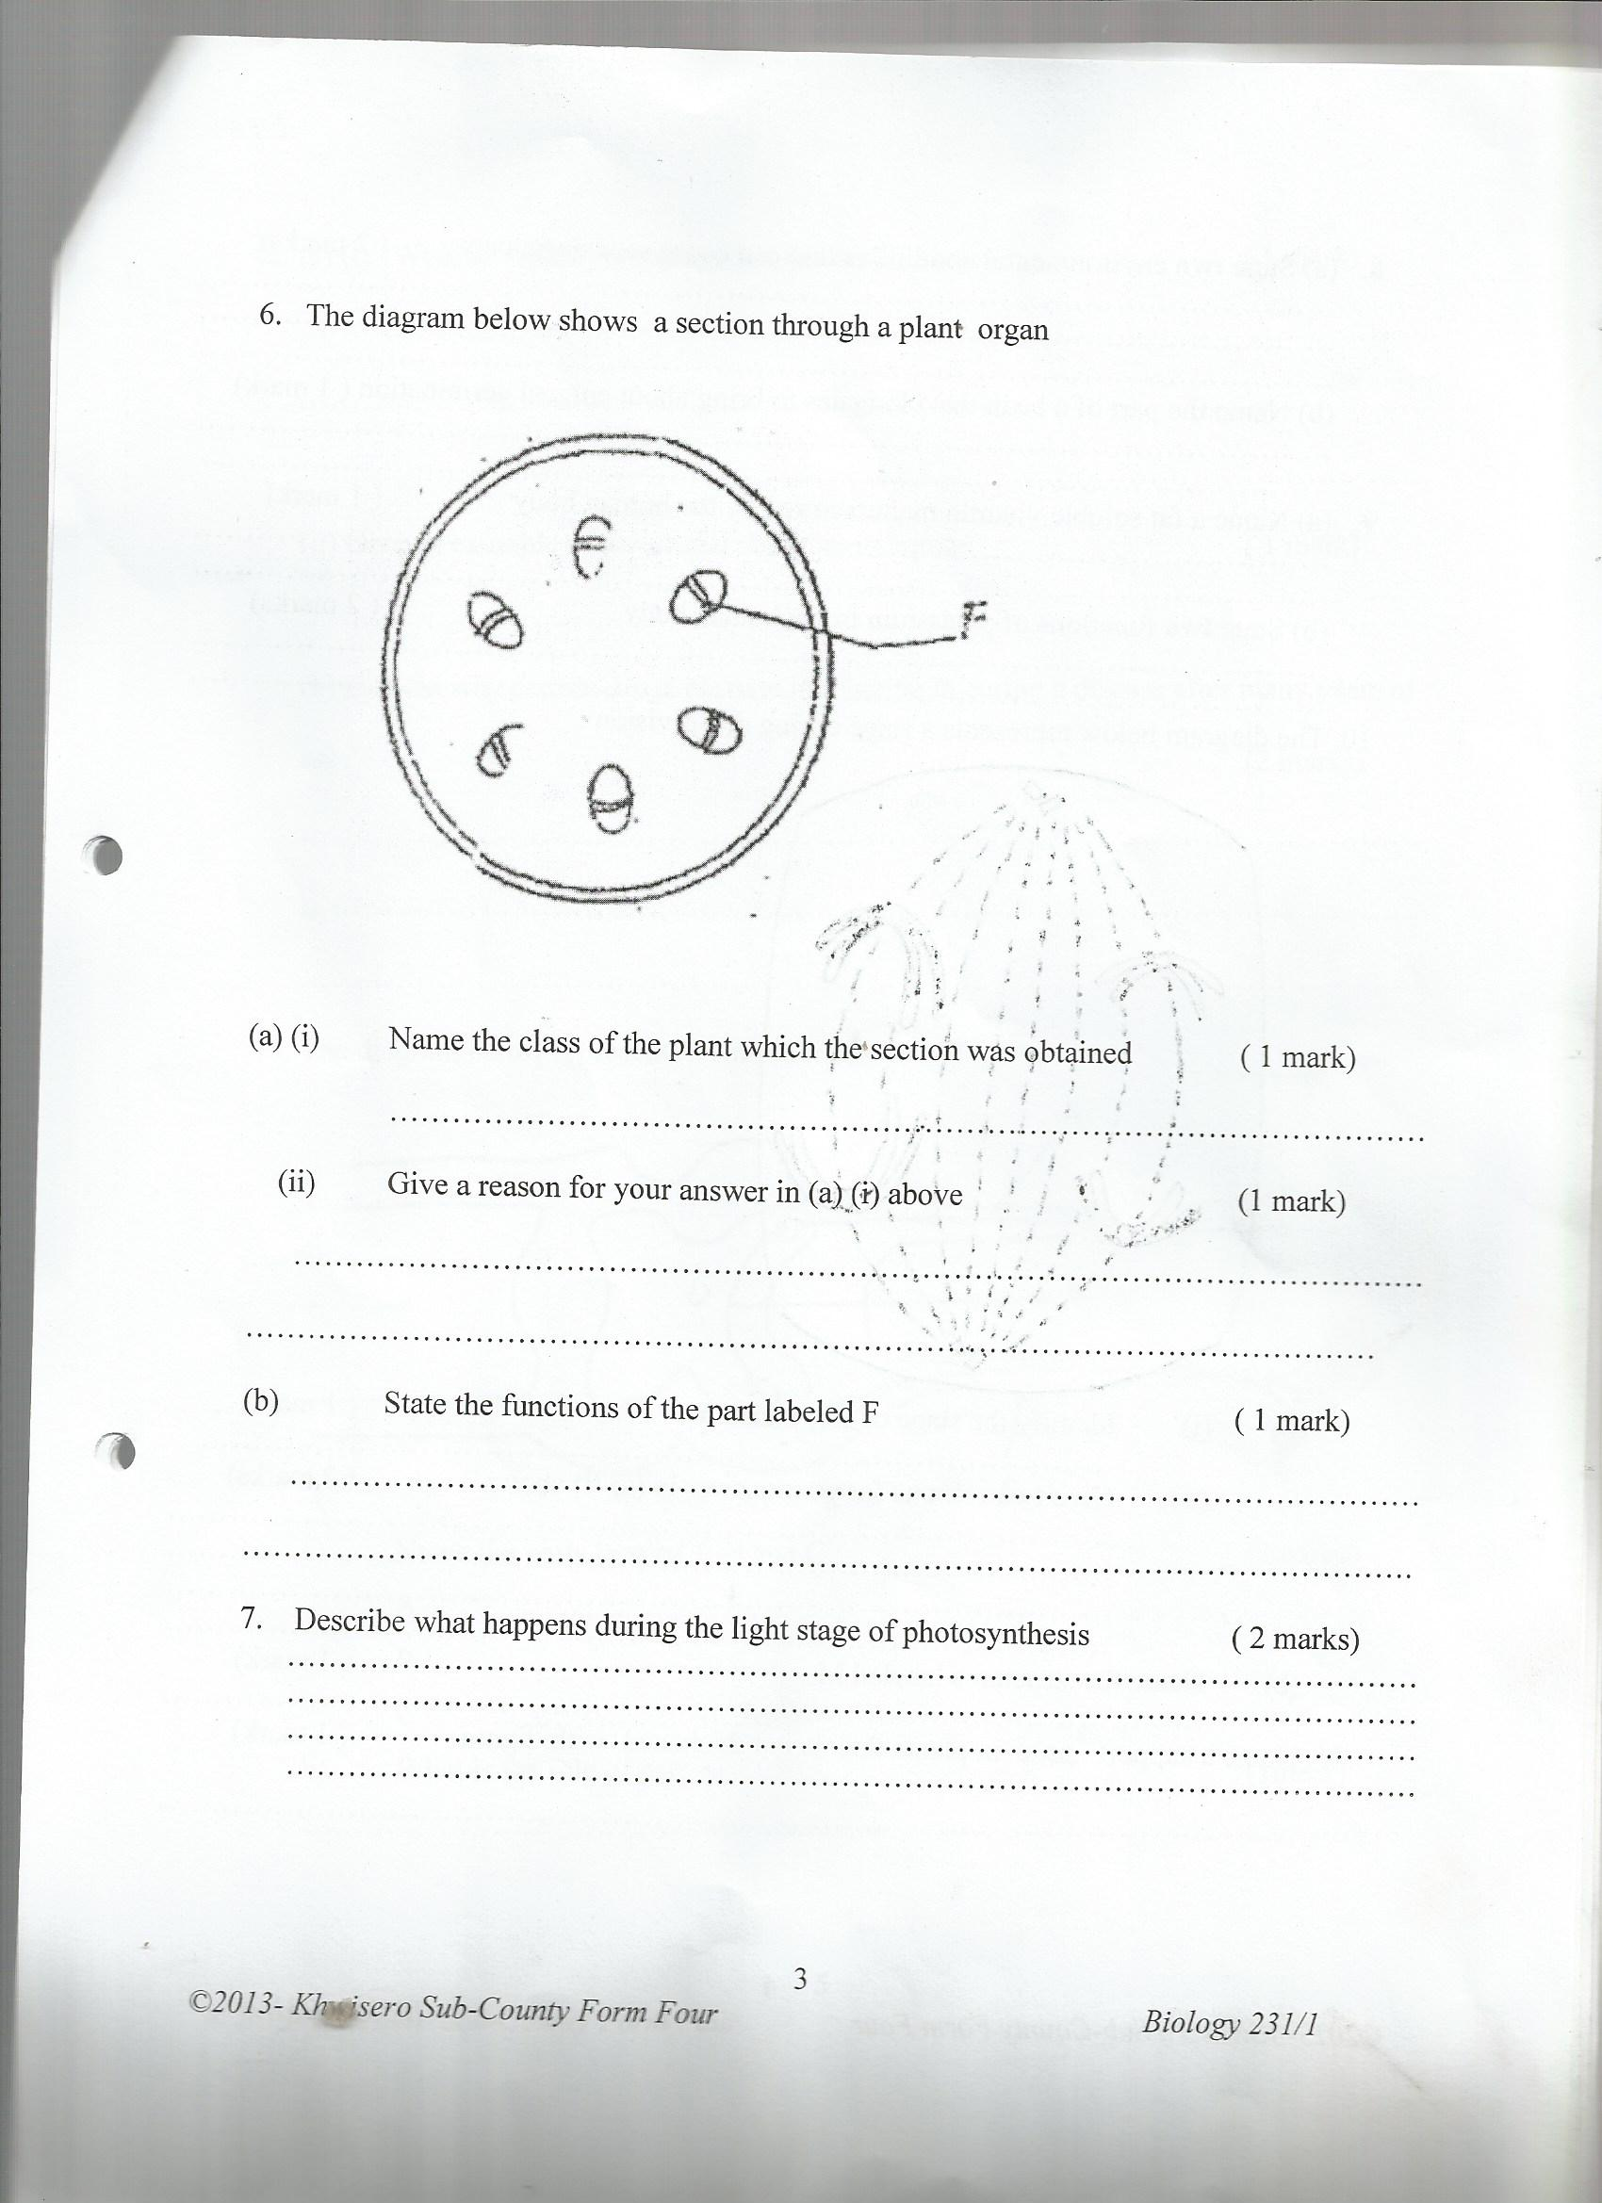5. The diagram below shows a section through a plant organ

**F**

(i) Name the class of the plant which the section was obtained (1mk)

Class dicotyledonae

(ii) Give a reason for your answer in (a) (i) above (1mk)

Vascular bundles are arranged in a ring around the pith

Has cambium between the xylem and phloem tissues

iii) State the functions of the part labeled F (1mk)

Responsible for secondary growth

6. Describe what happens during the light stage of photosynthesis (2mks)

Take place in the grana of the chloroplast. Light is absorbed and used to split water molecules into hydrogen ions and oxygen, photolysis. Energy is formed and is stored in form of ATP

7. Name a support tissue in plants that is not thickened with lignin (1mk)

Parenchyma

8. (a) In which part of the cell do the following stages of respiration take place. (2mks)

(i) Glycolysis

Cytoplasm

(ii) Kreb’s Cycle

Mitochondria

(b) In which of the two stages above is most energy produced? (1mk)

Krebs cycle

9. Explain why drug addicts are prone to HIV infection. (2mks)

Some of the drugs are administered by use of needles which are shared among the drug users

10. (a) (i)A man’s urine gave positive reaction with Benedict’s solution. Name the disease he was suffering from. (1mk)

Diabetes mellitus

(ii)State two ways in which the symptoms of the condition in (a) above can be controlled. (2mks)

Avoid alcohol

Avoid foods rich in sugar

Administration of insulin injection

(b) Name the hormones involved in regulating glucose level in blood. (2mks)

Insulin

Glucagon

11. (a) Name two structures for gaseous exchange in aquatic plants. (2mks)

Stomata

Pneumatophores

(b) What is the effect of contraction of the diaphragm muscles during breathing in mammals? (3mks)

When the diaphragm muscles contract, the diaphragm flattens, the ribcage moves upwards and outwards causing an increase in the volume of the thoracic cavity.

12. An experiment was set up in the experiment as shown below.

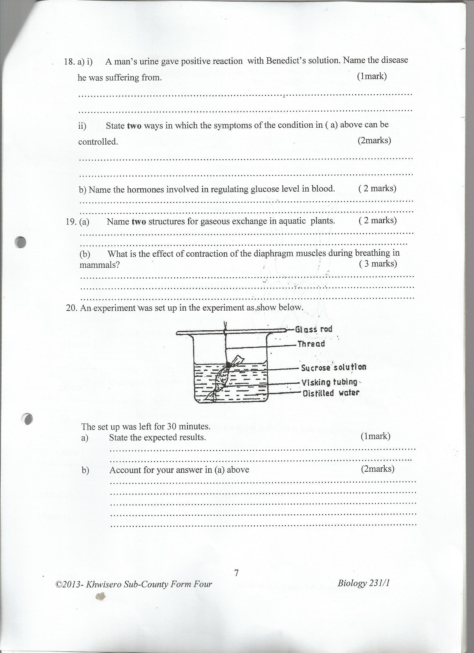

The set up was left for 30 minutes.

State the expected results. (1mk)

The volume of water in the beaker decreases

The visking tubing increases in size

b) Account for your answer in (a) above (2mks)

water molecules moved from the beaker where they are highly concentrated to the visking tubing where they are lowly concentrated. The visking tubing is a semi-permeable membrane. It allows water molecules which are small to pass through but does not allow sucrose molecules which are large to pass through.

13. State two structural modifications of nephrons found in desert mammals (2mks)

Long loop of henle

Long proximal convoluted tubules

Long collecting tubules

14.(a) State two characteristics of Monera that are not found in other kingdoms (2mks)

prokaryotic

Unicellular and microscopic

(b) Name the class to which a termite belongs (1mk)

Class insecta

15. (a) Distinguish between population and community (2mks)

Population is the total number of organisms belonging to a particular species in a habitat while community refers to organisms of different species living and interacting within a habitat.

(b) Name the method that can be used to estimate the population size of the following organisms

(i) Fish in a pond (1mk)

Capture recapture method

(ii) Black jack in a garden (1mk)

Line transect

16. Explain how an increase in temperature affects the rate of active transport. (2 marks)

An increase in temperature activates respiratory enzymes, rate of respiration increases, hence energy needed for active transport rate increases; temperatures above 40°C denature respiratory enzymes, thus no respiration hence no energy and rate of active transport is low or stops.

17. Give the synthesis role of smooth endoplasmic reticulum. (1 mark)

Synthesis if lipids

18. State two functions of bile juice in the digestion of food. (2 marks)

Emulsification / breaking down of fats into (tiny) droplets creating alkaline medium for digestive enzymes/ neutralizing acidic chime (from the stomach)

19. Name the features that increase the surface area of small intestines (2 marks)

Villi- microvilli

20. Explain what happens when there is oxygen debt in human muscles (2 marks)

Muscles respire anaerobically; resulting in accumulation of lactic acid in the tissue; causing fatigue/ muscle crumps.

21. State two ways in which the root hairs are adapted to their function (2 marks)

- Absence of cuticle to allow diffusion of water

- Thin walled to reduce distance of diffusion

- Elongated to increase surface area for absorption of water and mineral salts

- Presence of large vacuole to increase concentration gradient between cell

sap and soil water

22. Name two factors that affect transpiration and absorption at any given time (2 marks)

Wind; light, atmosphere pressure, humidity; temperature

23. State two functions of blood in a human body. (2 marks)

- Regulation of the body temperature

- Regulation of pH of fluids

- Defense against disease – causing organism/ pathogens/ infection.

- Prevent excessive bleeding by enhancing clotting/ prevent excessive loss of blood

-Transport of substances eg O2

24. State two differences between open and closed circulatory systems (2 marks)

|  |  |
| --- | --- |
| Open | Closed |
| Blood flows in haemocoel/sinuses  Blood cavity/coelum directly in contact with cells  Blood flows under low pressure  Lacks pigment for transport of o2 and co2 | Blood confined in vessels  Blood flows at high pressure  Blood has pigment for transport of o2 and co2 |

25. State two ways in which the leaf is suited to gaseous exchange (2 marks)

Broad/ flat leaf (lamina) to provide large surface area or absorption of gases

Thickness: allow gases to pass though fast

Presence of stomata for efficient diffusion of gases

Presence of air spaces for easy diffuses

26. State four ways in which respiratory surfaces are suited to their function. (4 marks)

Thin membrane to allow faster diffusion of gases

Moist to enable the diffusion of the gases in solution form

Highly vascularised

Large surface rea

27. What are the three end products of anaerobic respiration in plants (3 marks)

Alcohol, carbon dioxide and energy;

- accept Ethanol, C2H5OH/CH3H2OH.

28. What is oxygen debt? (1 mark)

It is the state when human body undergoes anaerobic respiration producing lactic

acid. Oxygen has to be taken into the body to break the lactic acid

29. Explain what happens to excess amino- acids in the liver of humans (3 marks

The amino acids are broken into amino group (NH2) and carboxyl group (COOH).

The amino group combines with hydrogen forming highly toxic ammonia.It immediately combines with carbon (iv) oxide forming urea that is less toxic.

- The carboxyl group converted to carbohydrates and then oxidized or converted into neutral fats and deposited on the parts of the human

30. (a) What is homeostasis? (2 marks)

Ability of organism to maintain a stable/ constant internal/ tissue fluid

b) Name three processes in the human body in which homeostasis is involved (3marks)

Gaseous exchange; Thermoregulation; Osmoregulation; regulation of blood sugar; regulation of pH of tissue fluid.

31. (a) Explain the term binomial nomenclature (2 marks)

Binomial nomenclature is a system of naming organisms by giving them two scientific names; the genetic and the specific names.

(b) State the importance of classification. (3 marks)

It makes it easy to identify an organism

- It is easier to describe an organism as it is based on characteristics

of the organism

- Large number of organisms is divided into smaller groups

depending on characteristics

- The whole world uses the same groupings, so that everyone

understands each other.

32. State two external features found in the class Mammalia only. (2 marks)

presence of mammary glands

body covered with fur or hair